# INTRODUCTION

TABLEAU is a BI tool which is used to analyse data (data visualization and data analytics). Below are the different products that Tableau offers:

1. **Tableau Desktop:** To build visualisations and dashboards. It can view, interact and edit workbooks. One can create and edit the reports, stories and dashboards.
2. **Tableau Server:** A secure way to share dashboards that have primarily been authored in Tableau Desktop. After publishing your dashboard to Tableau Server, it can be shared across departments, throughout your business. Tableau Server is privately managed by client/customer.

If you have edit access to Tableau server you can create new worksheets, dashboards, and storyboards on Tableau server. You can create a new workbook on published data and start creating your workbook from scratch.

But there will be few limitations like you can connect server-based workbooks to the only server published data and you cannot create user-defined fields like Groups, Sets, Calculated fields, Parameters and Combined Fields on Tableau server. in recent versions on Tableau, you can create calculated fields on Server.

1. **Tableau Online:** Tableau online a sharing tool that is hosted in [SasS (Software as a Service)](http://pediaa.com/difference-between-iaas-paas-and-saas/#SaaS) cloud version. It’s a hosted version of Tableau Server. This allows you to skip the hardware install / maintenance of Server, and it's always up to date.
2. **Tableau Public:** A huge Tableau server, which hosts a public gallery of users built by people around the world. All data and workbooks are public - so you can download any workbook you see, and dig in to learn some awesome tricks from other users. Its free of cost and comes with limited functionality. We cannot create extracts on Tableau Public and we cannot save files to desktop locally.

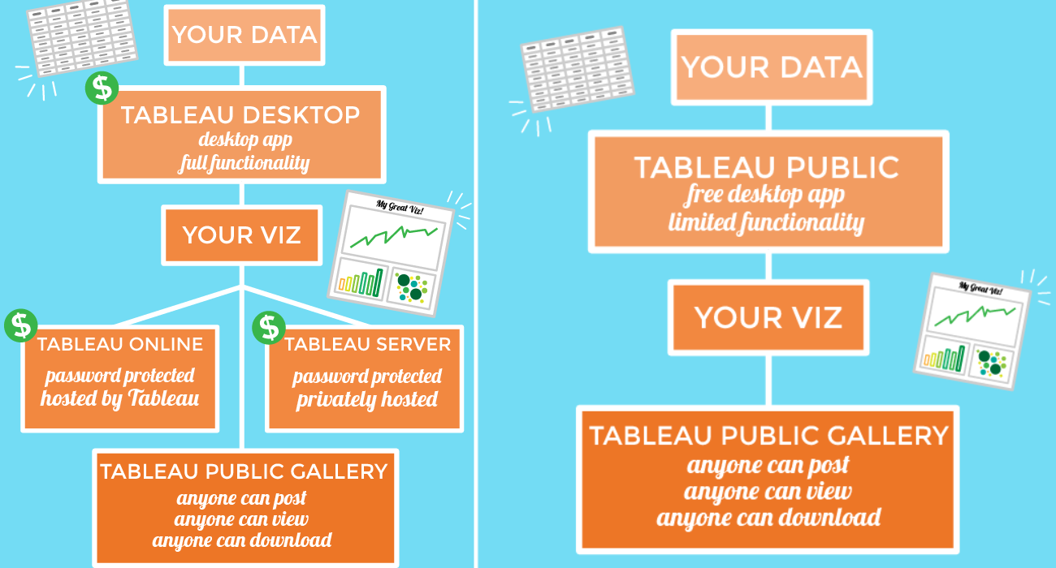

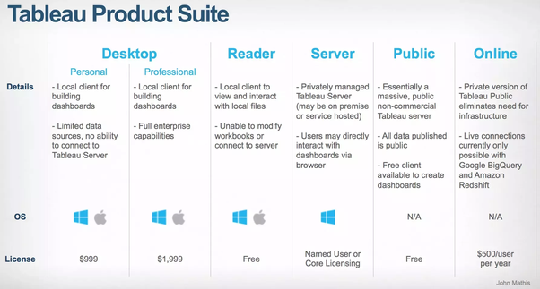

## TABLEAU DESKTOP

Although most of the dashboard authoring and publishing functionality in Tableau Desktop is now available in Tableau Server/Online, there remain a few key differences:

1. Tableau Desktop is a client-based tool with software you need to install.
2. Tableau Server and Tableau Online are browser-based tools (no software installed).
3. Tableau Server has most of the functionality required to create data sources, dashboards and workbooks, but is still missing the ability to create and modify dashboard actions.
4. The Cluster and Forecast options in the Analytics pane are not available in Tableau Server/Online. At this time, these options are only available in Tableau Desktop.
5. With Tableau Server, you have a Username which is assigned a Site Role and a set of permissions. The functionality available to you depends on the Site Role and the permissions granted (usually by the Tableau Server Administrator).

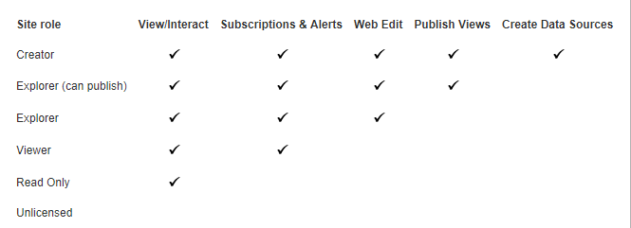

1. The mechanisms for saving and publishing are slightly different between Tableau Server/Online and Tableau Desktop, but the results are the same. With Tableau Desktop you can publish workbooks/dashboards/worksheets to Tableau Server/Online or you can save them as a packaged workbook (twbx). Packaged workbooks can be opened in Tableau Reader or Tableau Desktop. In Tableau Server you save your worksheets to projects and folders defined in Tableau Server or you can download and save them as a packaged workbook. (NOTE: Download and Save are permissions that are sometimes not granted to prevent unauthorized downloading of workbooks and data.)
2. Even though you can now create a new data source now in Tableau Server and Tableau Online, the number of "connectors" is limited. In 2018.2 of Tableau Online, there are only 10 different connectors whereas in Tableau Desktop there are over 70. (Likely Tableau will be adding to the list of connectors with every release).

Tableau Online and Tableau Server are complementary products that provide a way to publish, share, and distribute Tableau workbooks and data sources.

Both Tableau Online and Tableau Server require Tableau Desktop Professional Edition for publishing workbooks (views and dashboards) and data sources.

The 2018 release removes many of the limitations that existed in the Tableau Server and Tableau Online web authoring environments. One of the biggest changes is the ability to create new data sources in Tableau Online and Tableau Server, a capability previously only possible in Tableau Desktop. Being able to do this right from a browser provides a true end-to-end web authoring experience.

Tableau server and online now allow users to connect to new data sources.

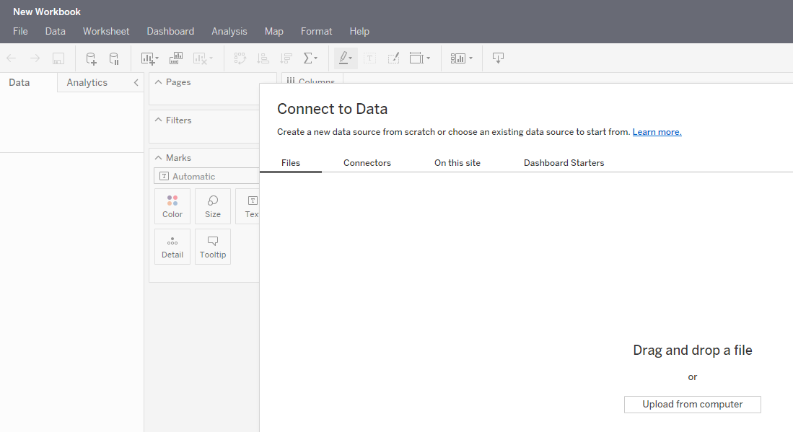

## TABLEAU ONLINE

* Hardware and systems maintained by Tableau, outside of your firewall.
* You can purchase and maintain multiple sites, configure users and permissions.
* Supports live data connections to Amazon Redshift, Google BigQuery, as well as to SQL-based sources hosted on cloud platforms. For a complete list, see Allow Direct Connections to Data Hosted on a Cloud Platform in the Tableau Online Help.
* Scheduled refreshes for published data: For complete information, see Keep Data Fresh in the Tableau Online Help.
  + For extracts of cloud-based data sources, you can schedule refresh tasks directly on Tableau Online.
  + For extracts of data sources that you maintain on your local network, or for Oracle data hosted in the cloud, you can schedule refresh tasks using the Online sync client that comes with Tableau Desktop. Schedules can be as frequent as every 15 minutes. [Note: Tableau Bridge is the Online sync client plus live query functionality. Bridge was released with Tableau version 10.3, at which point it replaced the sync client]
  + You can also update extracts manually using Tableau Desktop, or automate updates using a command-line utility. Select a pre-configured schedule or create a custom schedule.
* Authenticate users through TableauID (email address and password) or configure a site for single sign-on using SAML.
* No guest access; all users accessing views and dashboards published to Tableau Online must be authenticated.
* Custom branding: upload your company logo.

## TABLEAU SERVER

* You install the software and maintain the systems on your own hardware, inside or outside your company firewall.
* You can create and maintain multiple sites at no additional cost, configure users and permissions.
* You can schedule refresh tasks for published extracts. Select a pre-configured schedule or create a custom schedule.
* Can be configured for local authentication, Active Directory integration, trusted authentication, or single sign-on using SAML or Kerberos.
* Provides Core Licensing option, which allows guest access.
* Supports live connections to your local data sources and to Google BigQuery and Amazon Redshift. Supports published extracts.
* Custom branding: change the logo and the company name that appears in various web browser locations and tooltips.

## WAYS TO DISTRIBUTE VISUALIZATIONS

Tableau workbooks can be shared with other in many ways which varies insecurity, interactivity and data freshness, some of them are:

1. PDF files: These are static in nature as they are snapshots taken at particular instance of time.
2. Tableau Reader: Tableau reader is used to interact and view packaged workbooks.
3. Tableau Desktop: It can view and edit workbooks. If the packaged workbook does not contain the data source then the recipient should have access to the underlining data sources in order to view the visualizations.
4. Tableau Online or Server: Workbooks can also be published to Tableau Online or Server. These workbooks are secure, fully interactive and can be scheduled to have data refreshes or maintain a live connection to data source.

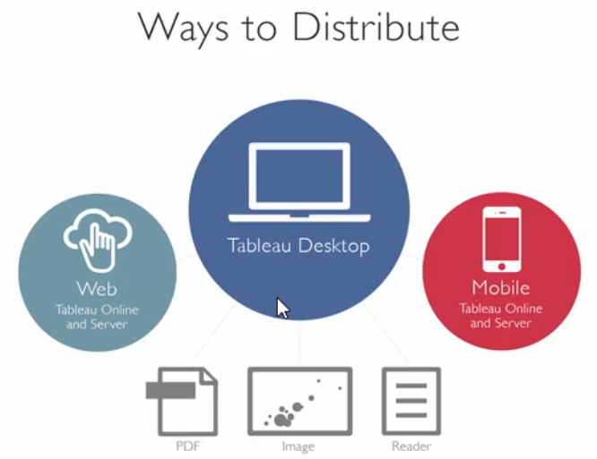

# DATA VISULIZATION VS DATA ANALYTICS

When we are trying to make sense out of the data, where do we begin?

Two popular approaches of analysing data include data visualization and visual analytics. Each plays an important role in data exploration.

Data exploration usually starts with a question. A data visualization is a graphical depiction of data, such as dashboard or report.

## ASKING ‘WHAT’

Data visualizations present views of data that answer “what” such as, “What are our sales and profits, for different regions, and different months or years?” They are good for answering a finite set of questions, and can be static or provide some level of interactivity for investigating those questions.

## ASKING ‘WHY’

Answering “what” is the first step in exploring data. The next step is asking “why.” To dig deeper, you need to be able to ask why and why again. When you need to learn more about what the data is telling you, you need visual analytics.

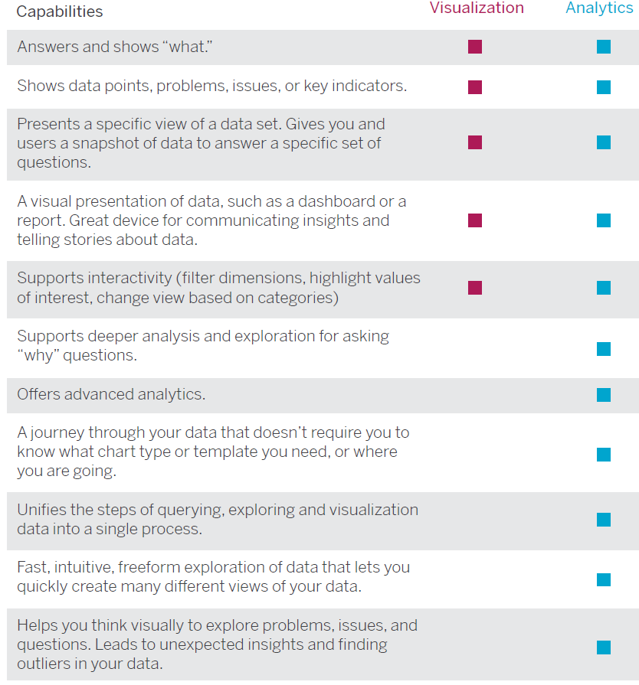

# TABLEAU BASICS

Below figure shows the terminology used for various elements present on the Data Pane.

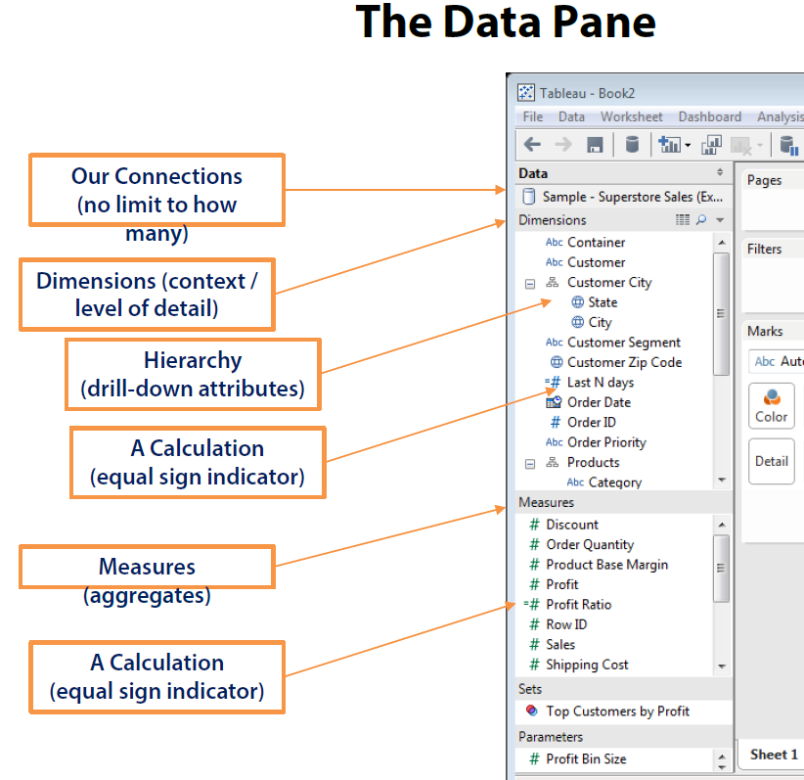

## VIEW TERMINOLOGY

This figure shows the terminology used for various elements available on the tableau worksheet object.

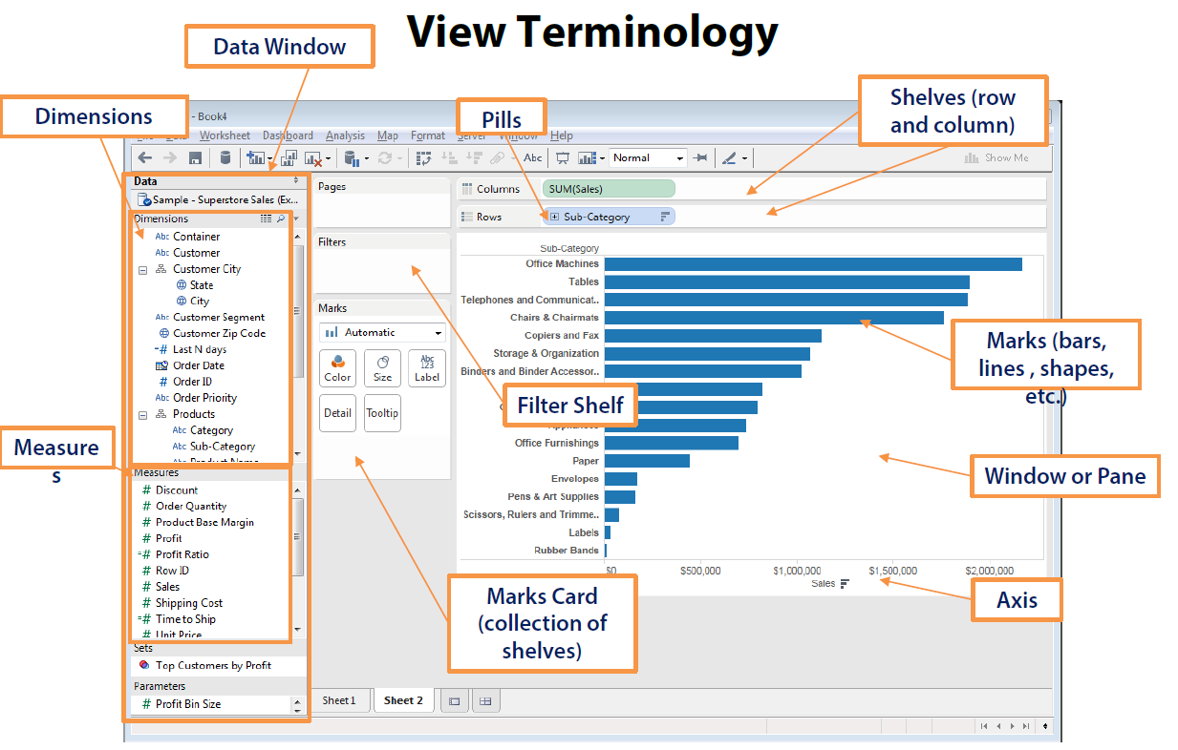

## DATA TERMINOLOGY

Below figure shows the various data types present on the Data Pane under Dimensions.

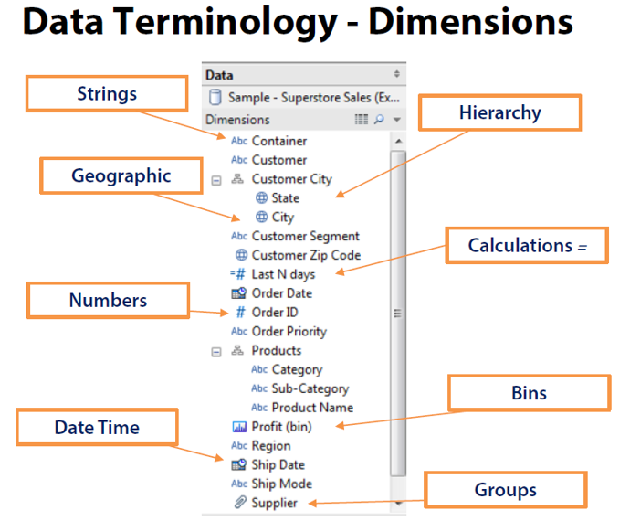

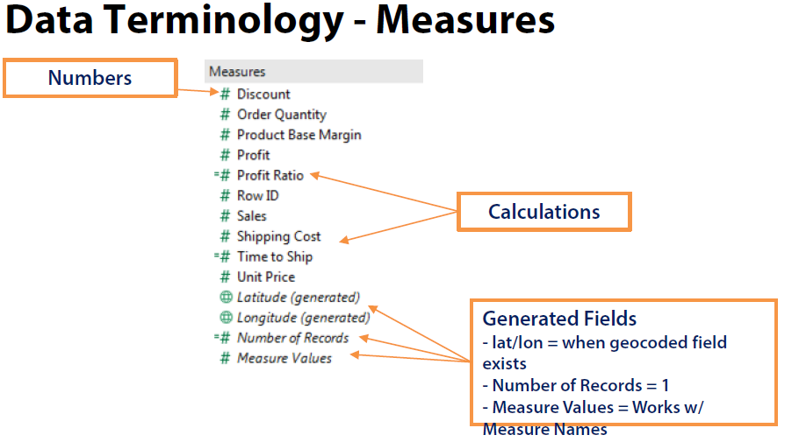

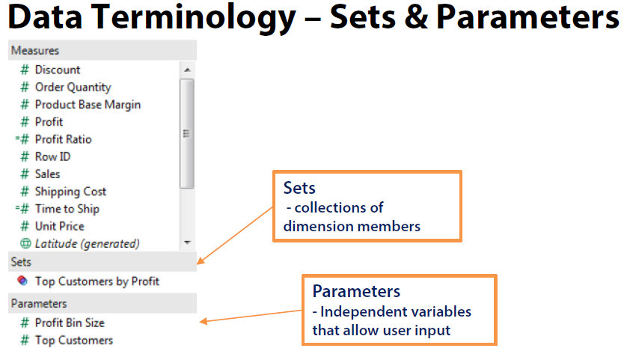

## FILE TYPES

You can save your work using several different Tableau specific file types: workbooks, bookmarks, packaged data files, data extracts, and data connection files. Each of these file types are described below.

* **Workbooks (.twb)**

Tableau workbook files have the .twb file extension. Workbooks hold one or more worksheets, plus zero or more dashboards and stories.

* **Bookmarks (.tbm)**

Tableau bookmark files have the .tbm file extension. Bookmarks contain a single worksheet and are an easy way to quickly share your work.

* **Packaged Workbooks (.twbx)**

Tableau packaged workbooks have the .twbx file extension. A packaged workbook is a single zip file that contains a workbook along with any supporting local file data and background images. This format is the best way to package your work for sharing with others who don’t have access to the original data. These workbooks can be shared with users having tableau reader or Tableau desktop.

* **Extract (. hyper or. tde)**

Depending on the version the extract was created in; Tableau extract files can have either the. hyper or .tde file extension. Extract files are a local copy of a subset or entire data set that you can use to share data with others, when you need to work offline, and improve performance.

* **Data Source (.tds)**

Tableau data source files have the .tds file extension. Data source files are shortcuts for quickly connecting to the original data that you use often. Data source files do not contain the actual data but rather the information necessary to connect to the actual data as well as any modifications you've made on top of the actual data such as changing default properties, creating calculated fields, adding groups, and so on.

* **Packaged Data Source (.tdsx)**

Tableau packaged data source files have the .tdsx file extension. A packaged data source is a zip file that contains the data source file (.tds) described above as well as any local file data such as extract files (. hyper or. tde), text files, Excel files, Access files, and local cube files. Use this format to create a single file that you can then share with others who may not have access to the original data stored locally on your computer.

## REPOSITORY LOCATION

You can specify a new location for the Tableau repository if you are not using the default location in your Documents folder. For instance, if you are required to have your data on a network server instead of on your local machine, you can point Tableau at the remote repository.

* Select File > Repository Location.
* Select a new folder that will act as the new repository location in the Select a Repository dialog box.
* Restart Tableau so that it uses the new repository.

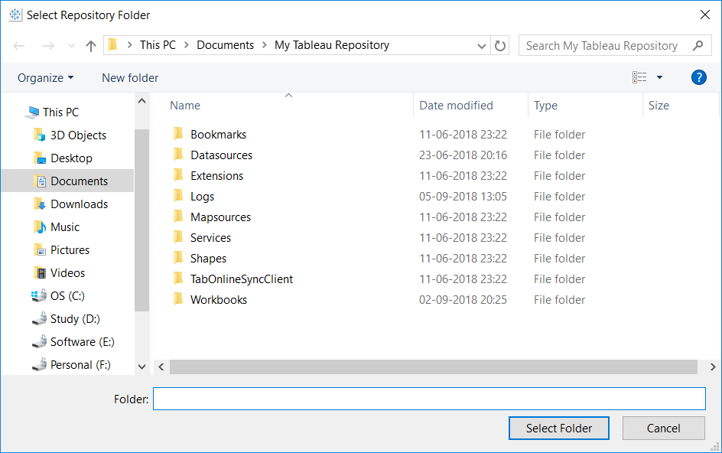

Changing the repository location does not move the files contained in the original repository. Instead, Tableau creates a new repository where you can store your files.

## DATA TYPES

Tableau supports below data types. The data type of a field is identified in the Data pane by one of the icons shown below.

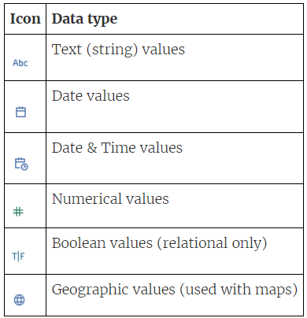

CHANGING DATA TYPE

Sometimes Tableau incorrectly interprets the data type of a field. For example, Tableau might interpret a field that contains dates as an integer data type, rather than a date data type.

We can change the data type for a field that was part of the original data source (as opposed to a calculated field created in Tableau) on the Data Source page.

* Click the data type icon for the field (as shown in the table above).
* Choose a new data type from the drop-down list:

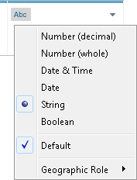

## BEFORE IMPORTING DATA

Look at the data provided

* Check for nulls (use alias if necessary, to replace null literals).
* Check for missing values.
* Check data for extra headers (use interpreter if necessary).
* Check the data type in data source and data type created by tableau.

# CONNECT & PREPARE DATA

Before you can build a view and analyze your data, you must first connect Tableau to your data. Tableau supports connecting to a wide variety of data, stored in a variety of places. The data sources available under Saved Data Sources are files with tds extension.

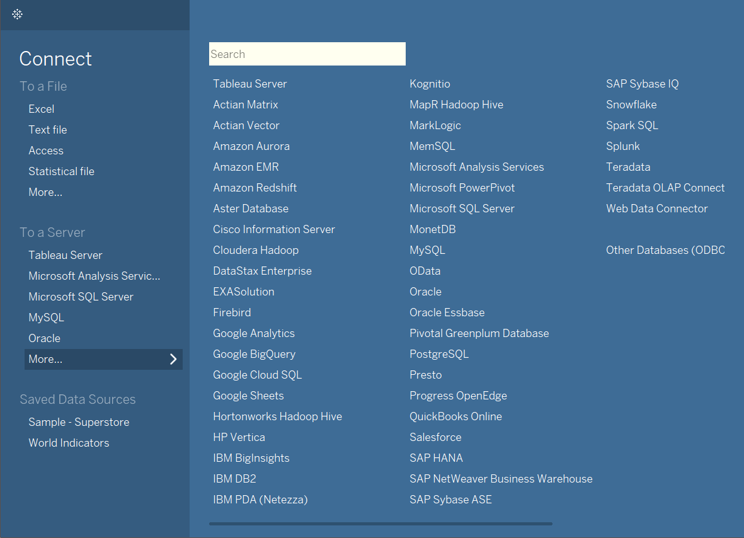

Although the look of the page and the options available vary depending on the type of data that you are connected to, the data source page generally consists of four main areas: left pane, canvas, data grid, and metadata grid.

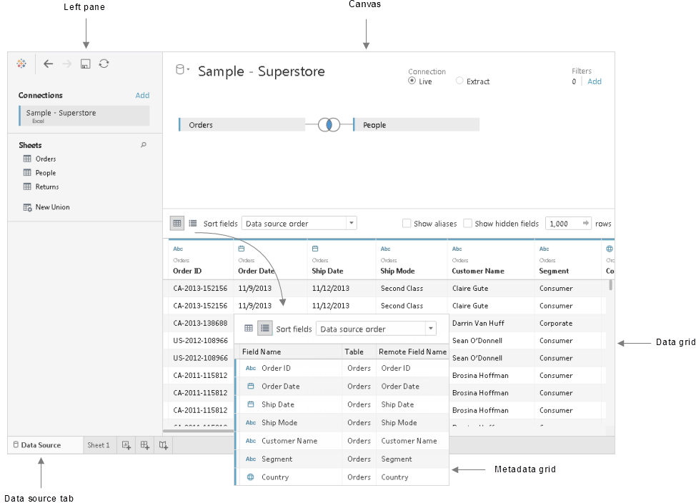

Note: Clicking on ‘Add’ will add a connection to same data source which is used for cross database join. To add an entirely new data source we should click on New Data Source.

To connect to an extract, click on Connect to a file and then choose other files option and then choose the extract file.

## IMPORTING REQUIRED COLUMNS

Once we connect to a data source, we can fetch required columns from data source by writing a Custom SQL Query (this option is available with RDBMS and older version of excel).

If Custom SQL Query option is not available for the connection type then we create extract and can hide the columns which are not required.

## CONNECTION TYPES

There are TWO types of data connections in Tableau. LIVE and EXTRACT (IN-MEMORY).

1. Live connection allows us to work with live data. Live connection is for high volume data. When connecting to multidimensional objects (like cube) we can use only Live connection.

There are no standard rules to decide on which connection to choose. Depending on the situation and resources, we must choose the connection type that helps to provide responsive report.

In general, high volume data and frequently changing data may be eligible for LIVE connection.

Low volume data and less frequently changing data may be eligible for EXTRACT connection.

1. Extracts are saved subsets of data that you can use to improve performance or to take advantage of Tableau functionality not available or supported in your original data. When we extract data, we import some or all of our data into the Tableau’s data engine.

After you create an extract, you can refresh it with data from the original data. When refreshing the data, you have the option to

* Either do a full refresh, which replaces all of the contents in the extract.
* Or you can do an incremental refresh, which only adds rows that are new since the previous refresh.

Extracts are advantageous for several reasons:

* **Supports large data sets**

You can create extracts that contain billions of rows of data.

* **Help improve performance**

When you interact with views that use extract data sources, you generally experience better performance than when interacting with views based on connections to the original data.

* **Support additional functionality**

Extracts allow you to take advantage of Tableau functionality that's not available or supported by the original data, such as the ability to compute Count Distinct.

* **Provide offline access to your data**

Extracts allow you to save and work with the data locally when the original data is not available. For example, when you are traveling.

* **Fast to create**

If you're working with large data sets, creating and working with extracts can be faster than working with the original data.

To create an extract of a data source, select Extract as shown below:

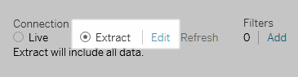

Click Add to define one or more filters to limit how much data gets extracted based on fields and their values.

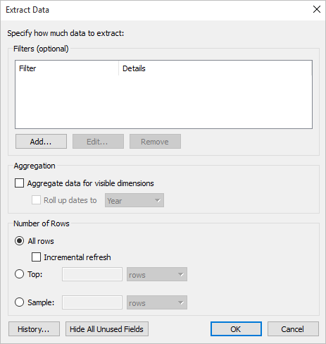

Select Aggregate data for visible dimensions to aggregate the measures using their default aggregation. Aggregating the data consolidates rows, can minimize the size of the extract file, and increase performance.

When you choose to aggregate the data, you can also select Roll up dates to a specified date level such as Year, Month, etc. The examples below show how the data will be extracted for each aggregation option you can choose.

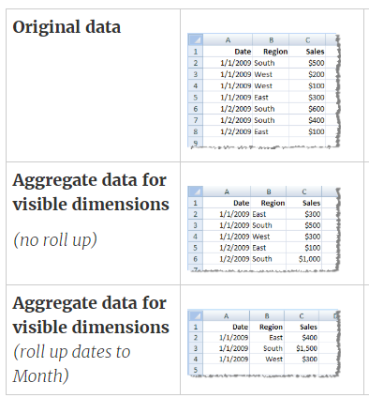

## ADDING NEW DATA TO EXTRACT

To add more data for an already created extract, you can choose the option Data → Extract → Append Data from File. In this case, browse the file containing the data and click OK to finish. Of course, the number and datatype of columns in the file should be in sync with the existing data.

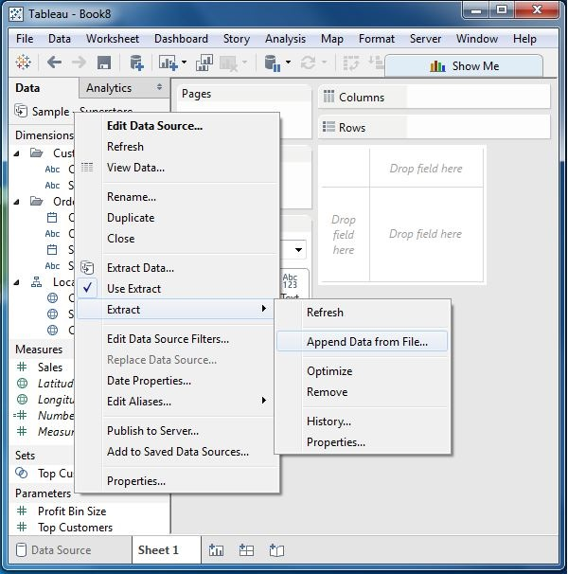

## LIVE vs EXTRACT

While connecting to datasources in tableau, some of the analysis options (Median, CountD etc) will not be available if we use a live connection. But if we use an extract instead then all the analysis options are available.

## METADATA

The metadata grid displays the fields in your data source as rows so that you can quickly

* Examine the structure of your Tableau data source.
* Renaming fields (Aliases).
* Hiding multiple fields at once if not required.
* Change data type of fields if required.
* Create Groups.
* Create Calculated fields.
* Create Bins (if numeric field).
* Split (or custom split) the column field (String type).

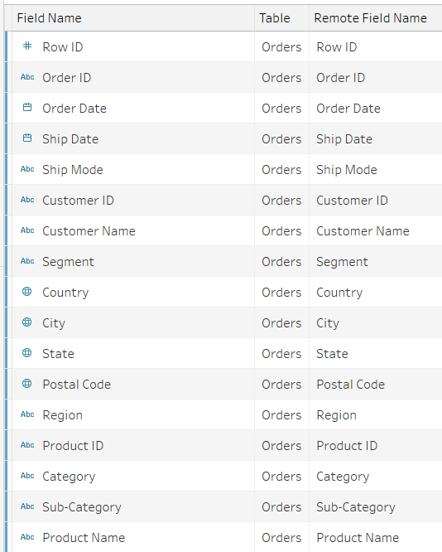

We can change metadata for a field as shown below

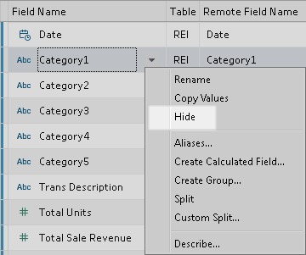

Below figure shows the type of data sources in the Data pane.

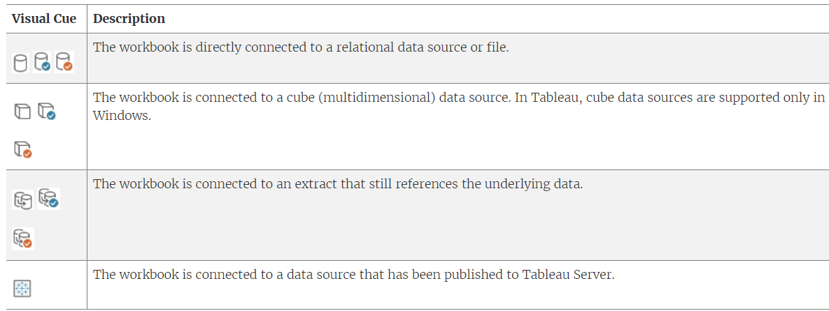

## EDIT DATA SOURCE

At any time during your analysis you can edit the data source used in the workbook.

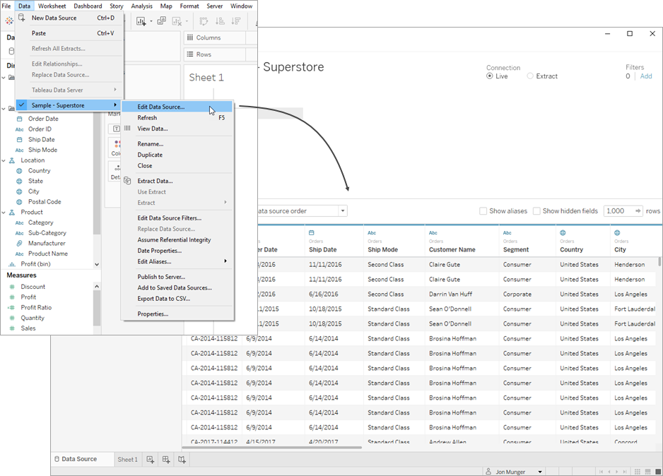

You might want to edit the data source to:

* Join Your Data
* Connect to a Custom SQL Query
* Use a Stored Procedure

## SORT COLUMN

Sort columns in the grid and metadata grid by selecting a sort option from the Sort fields drop-down list. Sort the columns by table or data source order.

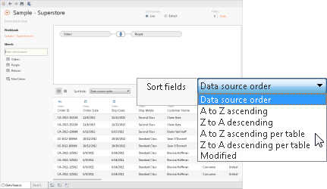

A Modified sort state can occur when some tasks cause new columns to be added to the grid.

## SORT ROWS

Sort rows by clicking the sort button. Click the sort button once to sort rows in ascending order, click the sort button again to sort rows in descending order, and then click the sort button a final time to clear the sort.

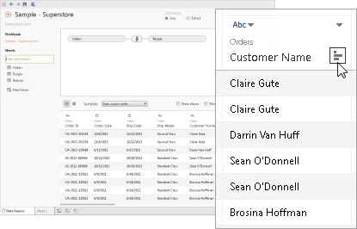

## CHANGE FIELD NAMES

Double-click the name of the column to rename the field.

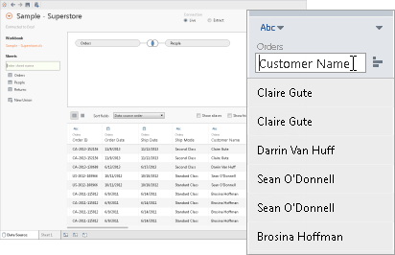

## RESET FIELD NAMES

If you've renamed a field, click the column drop-down menu, and then select Reset Name to revert back to the original name of the field. You can also select multiple columns and perform the same action.

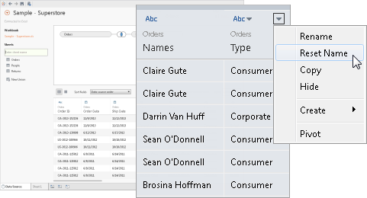

## NEW CALCUALTIONS

Create new calculations, groups, or bins based on existing fields in the data source. Click the column drop-down arrow and select one of the respective options.

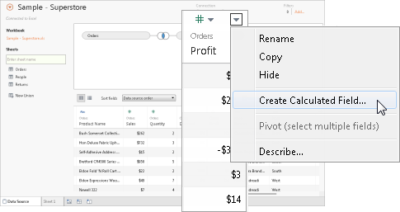

## DATASOURCE LOCATION

Change the Location of the Data Source

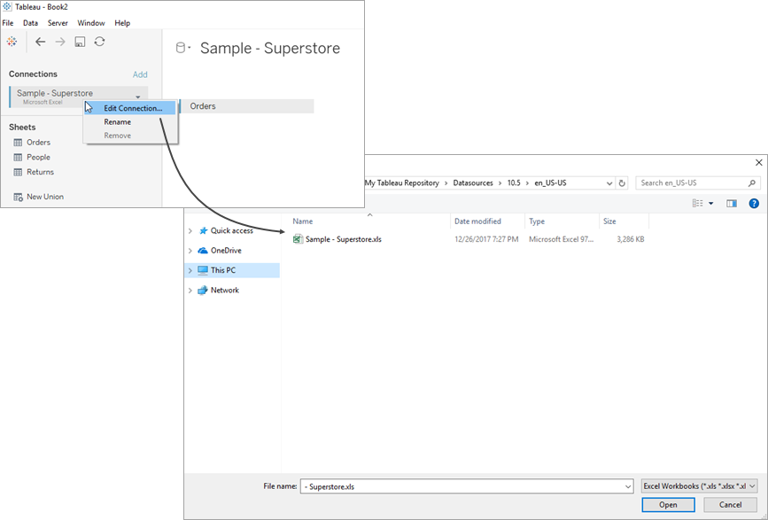

## REPLACE FIELD REFERENCES

When you successfully connect to a new data source, all worksheets in the workbook that previously referred to the original data source now refer to the new data source. If the new data source does not have the same field names as the original workbook, the fields become invalid and are marked with an exclamation point. You can quickly resolve the problem by replacing the field’s references.

For example, say you have a workbook connected to a data source that contains a Customer Name field. Then you edit the data source to point to a new data source that has all the same data but instead of Customer Name, the field name has been changed to Name. The Customer Name field remains in the Data pane but is marked as invalid. To make the field valid, you can replace the references, which means you can map the invalid field to a valid field in the new data source (for example, Customer Name corresponds to Name).

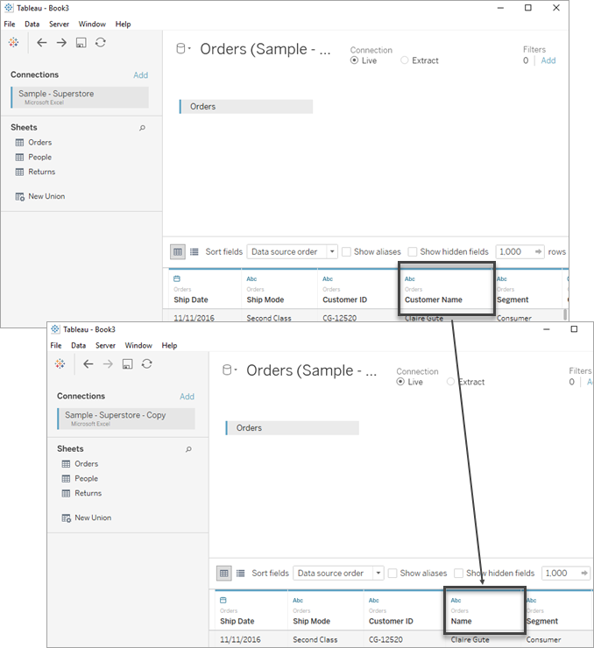

To replace field references

* Right-click (control-click on a Mac) the invalid field in the Data pane and then select Replace References.
* In the Replace References dialog box, select a field from the new data source that corresponds to the invalid field.

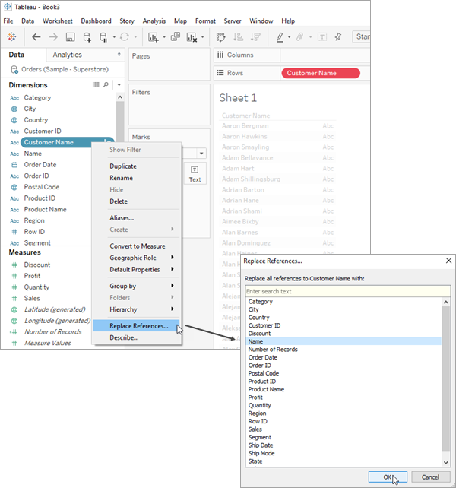

## RENAME THE DATA SOURCE

When you connect to a data source, you are given the option to give it a name for use in Tableau Desktop.

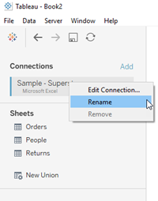

## REFRESH DATA SOURCES

If you are connected to a data source that has been modified, you can immediately update Tableau Desktop with the changes by selecting a data source on the Data menu and then selecting Refresh.

## REPLACE DATA SOURCES

There are times when you may want to update a workbook or sheet to use a different data source. Rather than rebuild your workbook using a new data source, you can replace the data source.

When you publish a data source to Tableau Server or Tableau Online, the current workbook in Tableau Desktop will automatically connect to the published data source, and automatically close the local data source. So, it is not necessary to replace the data source when you publish a data source.

You can only replace one data source with another data source when both data sources are relational data sources, or when both data sources are cube (multidimensional) data sources. In Tableau, cube data sources are supported for Windows only.

Source can be replaced using below options available under Data Menu in the worksheet:

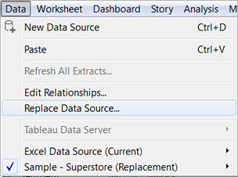

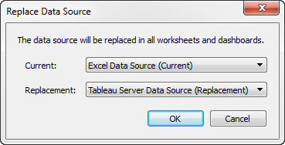

## EXPORT DATA SOURCES

If you’ve created a data connection that you might want to use with other workbooks or share with colleagues, you can export (save) the data source to a file. You might want to do this also if you’ve added joined tables, default properties, or custom fields—such as groups, sets, calculated fields, and binned fields—to the Data pane.

You can save a data source to either of the following formats:

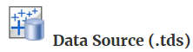 contains only the information you need to connect to the data source, including the following:

* Data source type
* Connection information specified on the data source page; for example, database server address, port, location of local files, tables
* Groups, sets, calculated fields, bins
* Default field properties; for example, number formats, aggregation, and sort order

Use this format if everyone who will use the data source has access to the underlying file or database defined in the connection information.

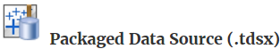 contains all information in the data source (.tds) file, as well as a copy of any local file-based data or extracts.

A packaged data source is a single zipped file. Use this format if you want to share your data source with people who do not have access to the underlying data that is defined in the connection information.

## SAVE A DATA SOURCE

* In Tableau Desktop, open the workbook that has the connection to the data you want to save as a file.
* At the top of the Data pane, right-click (Control-click on Mac) the name of the data source, and then select Add to Saved Data Sources.
* Enter a file name, select the file type (.tds or .tdsx), and then click Save.

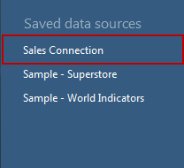

If you specified a different location, you can connect to the data source by selecting File > Open and navigating to it.

## CLOSE DATA SOURCES

You can close a data source at any time. Doing so does not modify the data source. Instead, it disconnects Tableau from the data so that you can no longer query it. Additionally, the data source is cleared from the Data pane and all open worksheets associated with the data source are cleared. If you accidentally close a data source, use the Undo button to reopen it. Close a data source by doing one of the following:

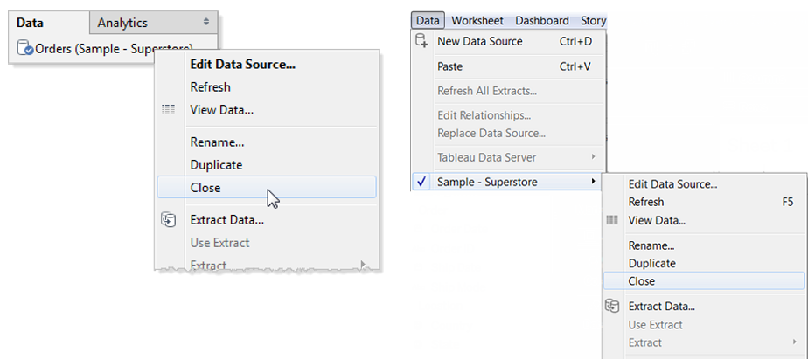

## PIVOT DATA

Sometimes, analysing data that is stored in a crosstab format can be difficult in Tableau. When working with Microsoft Excel, text file, Google Sheets, and .pdf data sources, you can use the pivot your data from crosstab format into columnar format. If you are working with other data sources, you can Pivot using custom SQL

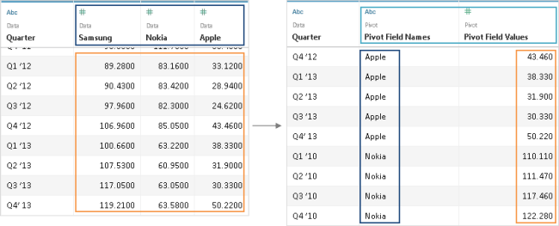

After you have set up the data source, in the grid, select two or more columns. Click the drop-down arrow next to the column name, and then select Pivot. New columns called "Pivot field names" and "Pivot field values" are created and added to the data source. The new columns replace the original columns that you selected to create the pivot.

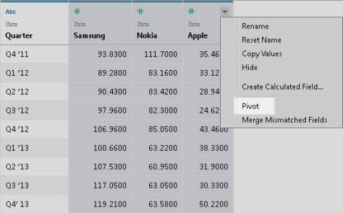

We can add more columns to Pivot as shown below

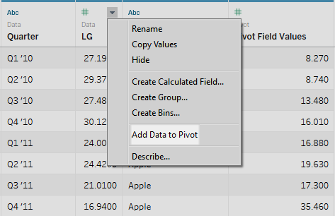

# DATA INTERPRETER

Data Interpreter can give you a head start when cleaning your data. It can detect things like titles, notes, footers, empty cells, and so on and bypass them to identify the actual fields and values in your data set.

It can even detect additional tables and sub-tables so that you can work with a subset of your data independently of the other data.

After Data Interpreter has done its magic, you can check its work to make sure it captured the data that you wanted and identified it correctly. Then, you can make any necessary adjustments.

After you select the data that you want to work with, you might also need to do some additional cleaning steps like pivoting your data, splitting fields, or adding filters to get the data in the shape you want before starting your analysis.

Turn on Data Interpreter and review results as shown below:

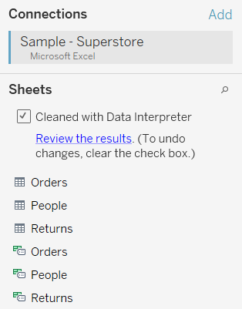

# CUSTOM SQL QUERY

For most databases, you can connect to a specific query rather than the entire data set. Because databases have slightly different SQL syntax from each other, the custom SQL you use to connect to one database might be different from the custom SQL you might use to connect to another. However, using custom SQL can be useful when you know exactly the information you need and understand how to write SQL queries.

For Excel and text file data sources, this option is available only in workbooks that were created before Tableau Desktop 8.2 or when using Tableau Desktop on Windows with the legacy connection. To connect to Excel or text files using the legacy connection, connect to the file, and in the Open dialog box, click the Open drop-down menu, and then select Open with Legacy Connection.

To write a custom SQL query

* After connecting to your data, double-click the New Custom SQL option on the Data Source page.
* Type or paste the query into the text box.

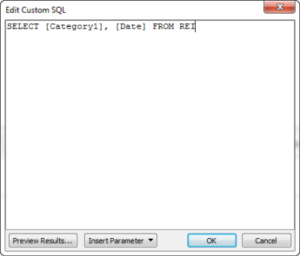

Below is an example:

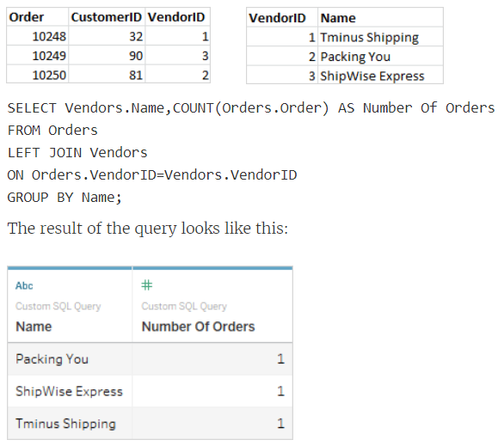

We can also use parameters to make the query dynamic as shown below in the figure

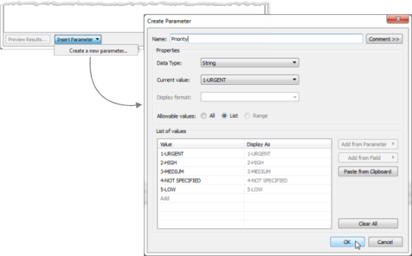

After you finish editing the connection, the new parameter is listed in the Parameters area at the bottom of the Data pane and the parameter control displays on the right side of the view. As you select different values, the connection updates.

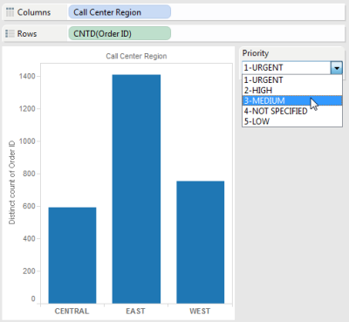

Note: If you are using an extract, you must refresh the extract in order to reflect changes to the parameter. Publishing a data source that uses Custom SQL parameters includes the parameters. The parameters are transferred to any workbooks that connect to the data source.

When we drag and drop dimensions and measures onto the various shelves and mark cards, the data to the viz is fetched via a SQL statement to data source as sown below

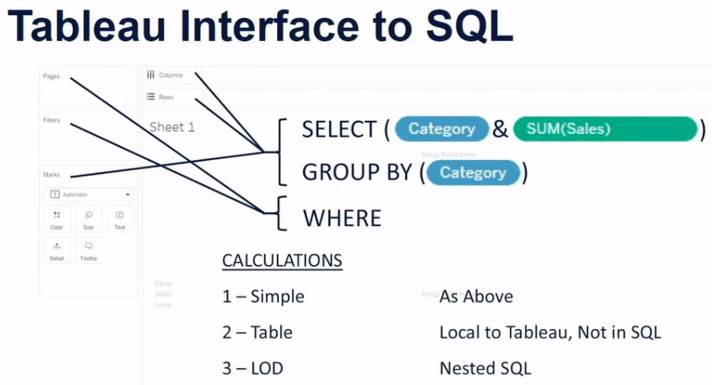

# ORDER OF OPERATION

The Tableau order of operations includes all the elements in the following illustration. Filters are shown in blue; other operations, which are mostly calculations, are shown in black.

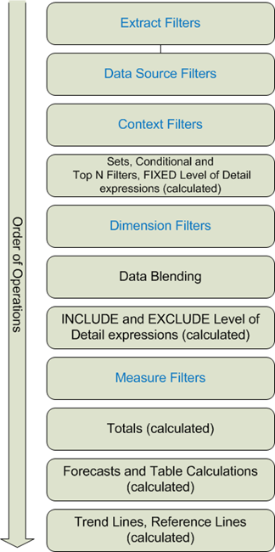

# ORGANIZE THE DATA PANE

You can reorganize the items in the Data pane from its default layout using folders or through sorting.

## GROUP FIELDS IN FOLDERS

To make data sources with many fields easier to work with, you can organize the Data pane items into folders. Items like fields, parameters, and sets can be grouped into folders.

* When you connect to a single table in your data source, grouping by folder is enabled by default.
* When you connect to a data source with multiple tables, grouping by table is enabled.
* When the Group by Data Source Table option is selected, the dimensions and measures are grouped according to the database table they belong to. This is especially useful when you have several joined tables.
* "Group by" options are only available for relational data sources—not for multidimensional (cube) data sources.

Since we are connected to a datasource with multiple tables, we get below view:

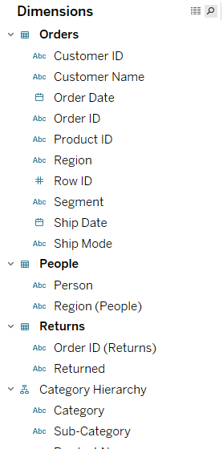

View changes when ‘Group by’ Folder is selected

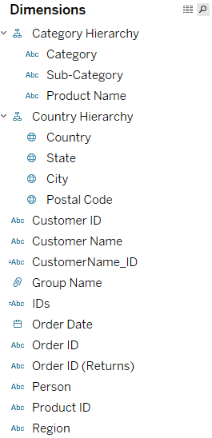

We can also group fields into folders

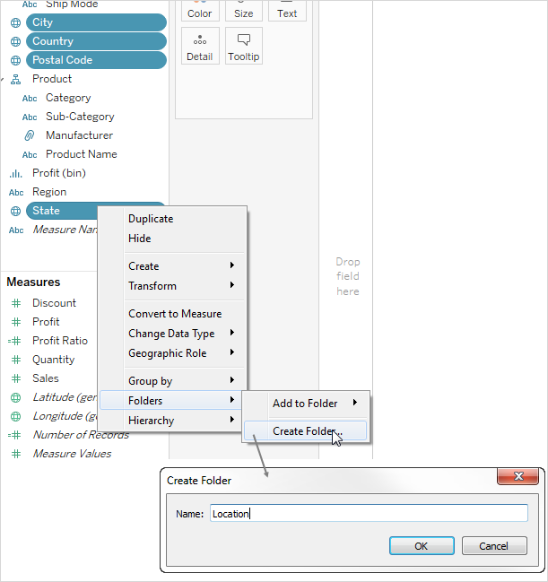

After you create a folder structure, you can drag fields from one folder to another or duplicate a field you want to have available in more than one folder.

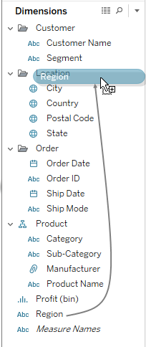

## SORT FIELDS

When organizing the Data pane with or without folders, you can have Tableau sort the items. These Sort by options are also located in the Data pane menu.

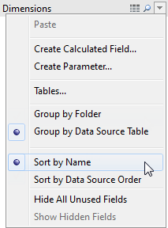

Sort by Name – lists the dimensions and measures in alphabetical order according to their field aliases.

Sort by Data Source Order – lists the dimensions and measures in the order they are listed in the underlying data source.

## FIND FIELDS

You can search for fields, folders and hierarchies in the Data pane.

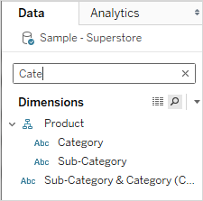

## RENAME FIELDS

You can rename fields in the Data pane

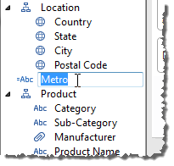

## REVERT TO THE DEFAULT FIELD NAME

If the field you renamed was from the original data source you can click the field name in the Data pane and hold the mouse button down until the field name is shown in the box. At the right of the edit field is a small circular arrow that you can click to restore the original data source field name:

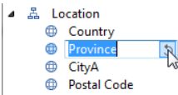

## COMBINE FIELDS

Combine fields to create a cross product of members from different dimensions. You can combine dimensions if you want to encode a data view using multiple dimensions.

For example, the selections shown below will produce a new field that consists of the Category and Sub-Category dimensions.

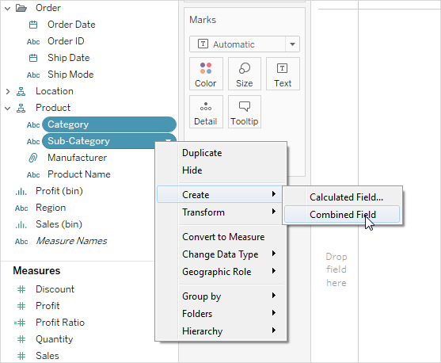

The two dimensions are combined into a new dimension.

When you use the new field in a view, a header is created for each combination of the two original dimensions. For example, the view below shows the members of the combined Category and Sub-Category fields.

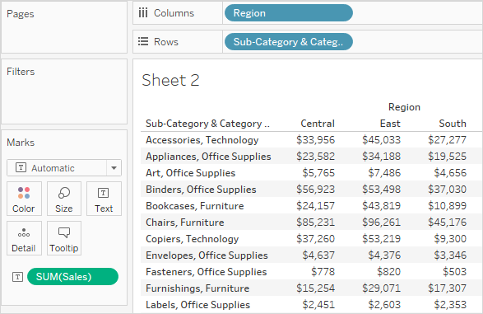

## HIDE OR UNHIDE FIELDS

You can selectively hide or show fields in the Data pane.

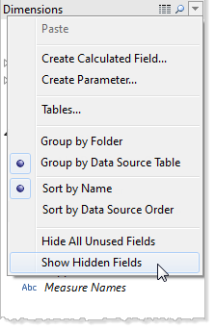

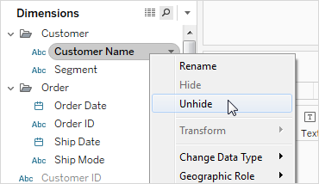

Hiding fields can be a good way to decrease the size of a data extract file because hidden fields are automatically excluded from the extract.

## CREATE ALIASES

You can create aliases (alternate names) for members in a dimension so that their labels appear differently in the view.

Aliases can be created for the members of discrete dimensions only. They cannot be created for continuous dimensions, dates, or measures.

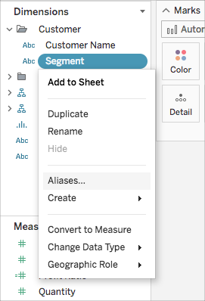

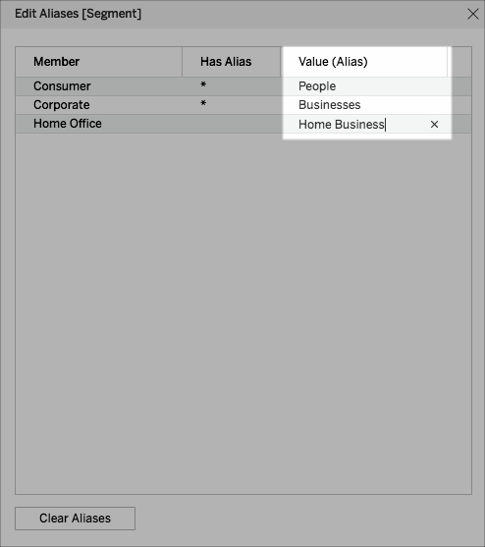

When you add the field to the view, the alias names appear as labels in the view. For example,

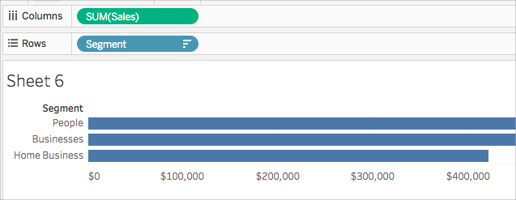

# COMBINE YOUR DATA

In general, there are three methods for combining data in Tableau.

## UNION

Union is a method for appending values (that is, rows) from multiple tables. You can union tables if they have the same columns. To union data, you must use text tables or Excel tables from the same connection. That is, you cannot union tables from different databases.

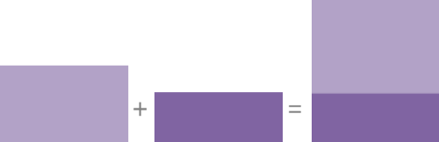

If your data source supports union, the New Union option displays in the left pane of the data source page after you connect to your data. You can also refer to the following list to verify that your data source supports union:

* A unioned table can be used in a join.
* A unioned table can be used in a join with another unioned table.
* The fields generated by a union, Sheet and Table name, can be used as the join key.
* If a named range is used in union, null values display under the Sheet field.
* The field generated from a merge can be used in a pivot.
* The field generated from a merge can be used as a join key.
* The data type of the field generated from a merge can be changed.
* Union tables from within the same connection. That is, you cannot union tables from different databases.

## JOIN

Joining is a method for combining tables related by common fields (that is, common columns). The result of combining data using a join is a virtual table that extends horizontally by adding columns of data.

Tableau supports joins between tables in the same database and between tables in different databases, which is also known as a cross-database join.



When joining tables, the fields that you join on must have the same data type. If you change the data type after you join the tables, the join will break.

Below figure shows the join types available in tableau:

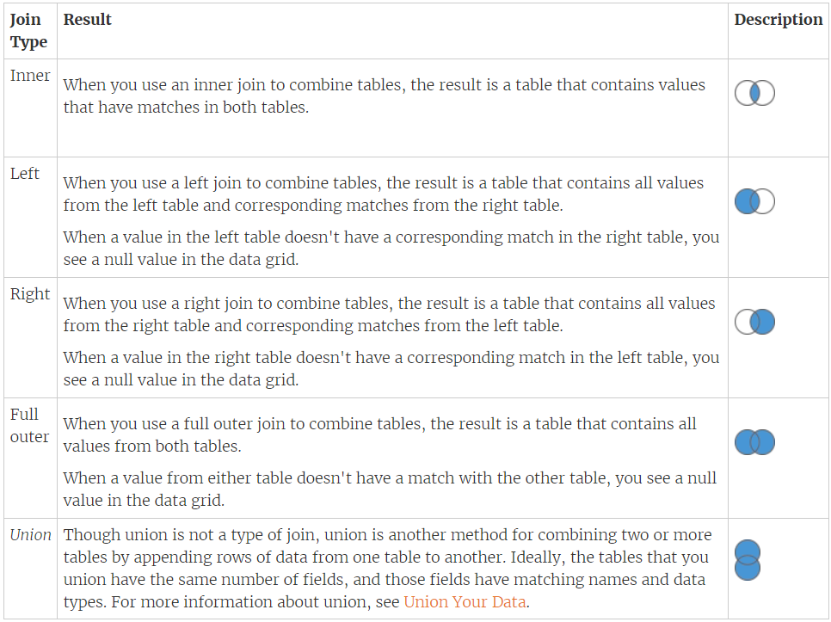

## CROSS DATABASE JOINS

Cross database joins are useful when we try to join tables from different type of data sources. For example. Joining excel sheet and txt file.

## DATA BLENDING

Data blending is also another method that lets you combine data. When you use data blending to combine your data, you combine data in what is called a primary data source with common fields from one or more secondary data sources.

Blending occurs when you are building your view from primary datasource and you need a field from secondary data source on the same view. Then you get the required filed by defining the relationship between the two datasources and blending takes place.

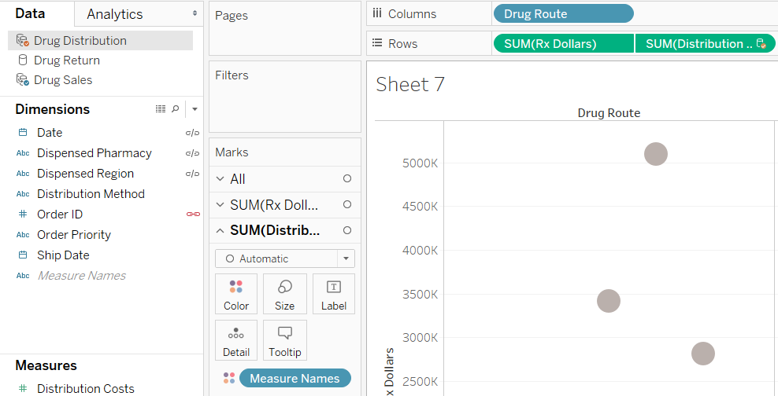

Data blending is useful when you want to join data but the databases, you're using don’t allow joins—for example, data in cube data sources.

Data blending is also useful when the data sources you’re working with contain data that's at different levels of detail. This means, when one data set captures data using greater or lesser granularity than the other data set. For example, when you want to combine a data source that has daily transactional data with a table that contains quarterly data.

As with joins, the result of combining data using data blending is a virtual table that extends horizontally by adding columns of data.

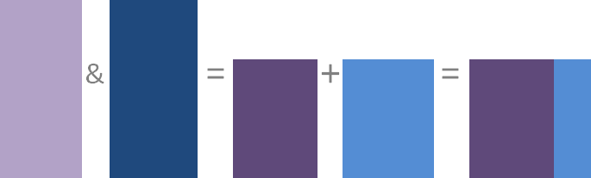

Data blending is useful under the following conditions:

* You want to combine data from different databases that are not supported by cross-database joins.
* Data is at different levels of detail.

Use data blending instead of joins under the following conditions:

* **Data needs cleaning**

If your tables do not match up with each other correctly after a join, set up data sources for each table, make any necessary customizations (that is, rename columns, change column data types, create groups, use calculations, etc.), and then use data blending to combine the data.

* **Joins cause duplicate data**

Duplicate data after a join is a symptom of data at different levels of detail. If you notice duplicate data, instead of creating a join, use data blending to blend on a common dimension instead.

* **You have lots of data**

Typically joins are recommended for combining data from the same database. Joins are handled by the database, which allows joins to leverage some of the database’s native capabilities. However, if you're working with large sets of data, joins can put a strain on the database and significantly affect performance. In this case, data blending might help. Because Tableau handles combining the data after the data is aggregated, there is less data to combine. When there is less data to combine, generally, performance improves.

Note:

* When you blend on a field with a high level of granularity, for example, date instead of year, queries can be slow.
* Cube (multidimensional) data sources must be used as the primary data source. Cube data sources cannot be used as a secondary data source.
* When connecting to extract files in a multi-connection data source (for example we have a live connection to SQL Database and extract of an excel), make sure that the connection to the extract (.tde or .hyper) file is the first connection. This preserves any customizations that might be a part of the extract, including changes to default properties, calculated fields, groups, aliases, etc.
* If you need to connect to multiple extract files in your multi-connection data source, only the customizations in the extract in the first connection are preserved.

TOTALS IN BLENDING

Suppose we have blended two datasources, primary datasource having Orders details and second datasource having details whether the Order has been returned or not. Now we have to find how many orders in the primary datasource has been retuned and how many have been delivered then we can use below calculated fields for same:

Create a calculated field as below to find out whether an order has been returned or not:

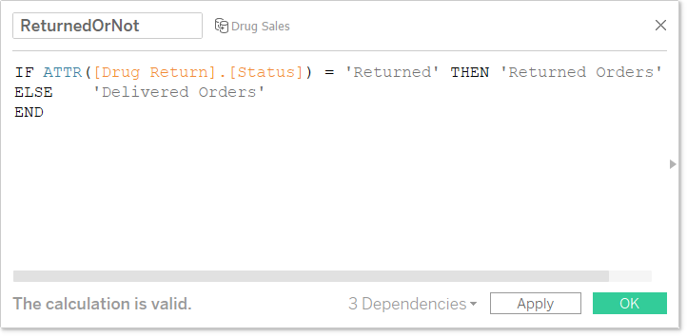

Drop OrderID, above created field and count field on the view

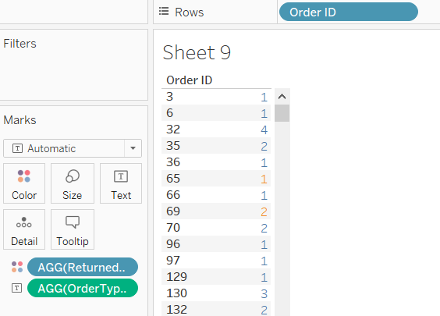

Currently it shows individual count, change it to Windows_Sum of count and view will change as below

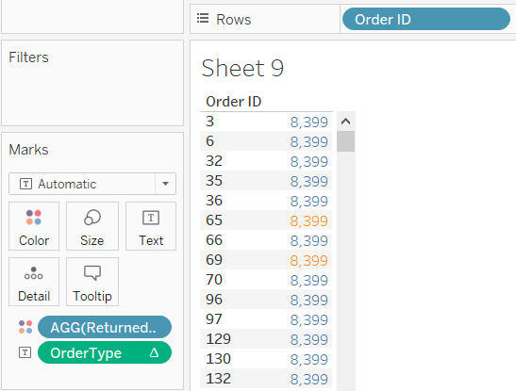

Now to get the count for delivered and retuned orders just untick ‘**Ignore in Table Calculations**’ properties for calculated field ReturnedOrNot as below. It will tell tableau to take into consideration partitions while calculating the count of records. Please note that if this option is unchecked only aggregation functions can be used (like sum etc) we cannot use Total ()

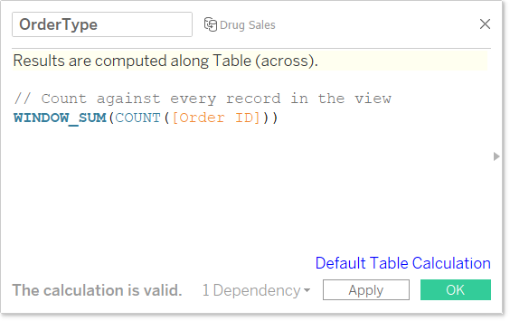

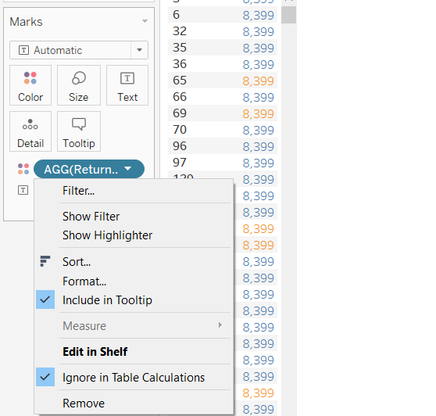

And the view will change as below:

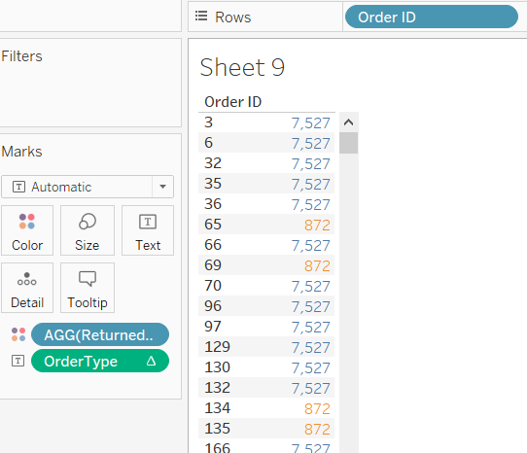

If you want count only against 1 record then use below calculated field

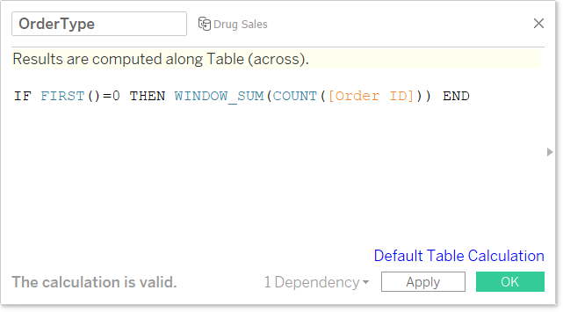

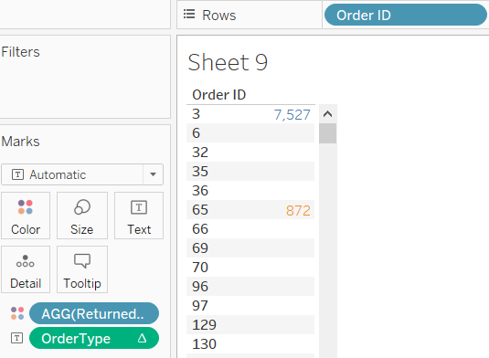

The below calculated field will return the total of count irrespective of the partition

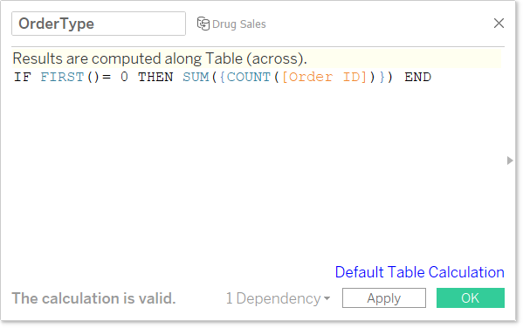

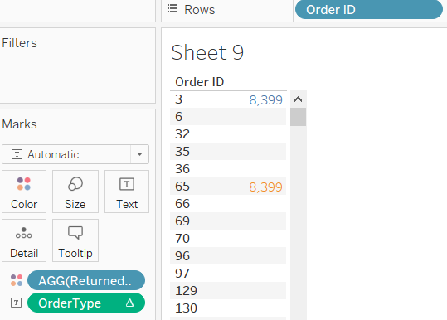

## KNOW YOUR DATA

If your data comes from one table, you can connect to your data, drag a table onto the canvas to create the data source, and then start building your view.

If your data comes from multiple tables in the same database, you can connect to your data and then combine the tables in Tableau.

* Union
* Join
* Data blending

When your data is stored in tables from different databases, you can choose from the following methods to combine data:

* Data blending – supports one connection per data source, and one data source per database (or Excel or text file)
* Cross-database join – allows two or more connections per data source

## JOIN VS BLENDING

Data blending simulates a traditional left join. The main difference between the two is when the join is performed with respect to aggregation.

When you use a left join to combine data, a query is sent to the database where the join is performed. Using a left join returns all rows from the left table and any rows from the right table that has a corresponding row match in the left table. The results of the join are then sent back to and aggregated by Tableau.

For example, suppose you have the following tables. If the common columns are User ID and Patron ID, a left join takes all the data from the left table, as well as all the data from the right table because each row has a corresponding row match in the left table.

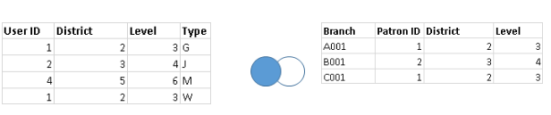

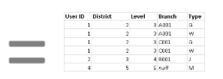

When you use data blending to combine data, a query is sent to the database for each data source that is used on the sheet. The results of the queries, including the aggregated data, are sent back to and combined by Tableau. The view uses all rows from the primary data source, the left table, and the aggregated rows from the secondary data source, the right table, based on the dimension of the linking fields. Dimension values are aggregated using the ATTR aggregate function, which means the aggregation returns a single value for all rows in the secondary data source. If there are multiple values for the rows, an asterisk (*) is shown. Measure values are aggregated based on how the field is aggregated in the view.

You can change the linking field or add more linking fields to include different or additional rows of data from the secondary data source in the blend, changing the aggregated values.

For example, suppose you have the following tables. If the linking fields are User ID and Patron ID, blending your data takes all of the data from the left table, and supplements the left table with the data from the right table. In this case, not all values can be a part of the resulting table because of the following:

* A row in the left table does not have a corresponding row match in the right table, as indicated by the null value.
* There are multiple corresponding values in the rows in the right table, as indicated by the asterisk (*).

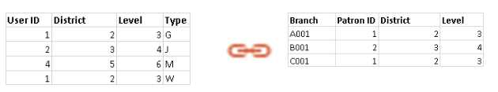

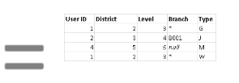

## MISMATCHES IN A JOIN

A common mismatch scenario when working with string data occurs when one of the fields on one side of the join condition is equivalent to two or more fields on the other side of the join condition. In this case, you can use a calculation to combine the two fields so that its format matches the other field in the join condition.

For example, suppose you want to join two tables that contain the following data:

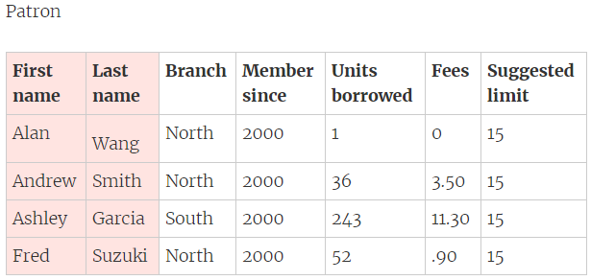

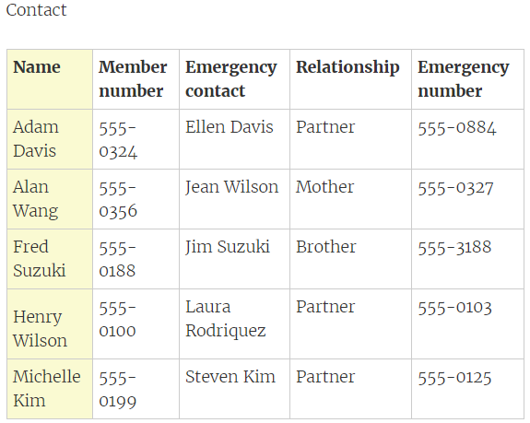

The common fields between the two tables appear to be name. However, in the Patron table the first and last names are in separate columns and in the Contact table the first and last names are in the same column. To join the tables on names, you can use a calculation in the left side of the join condition to merge the first name and last name columns together.

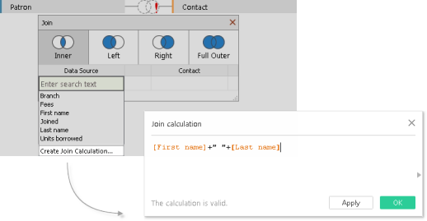

The result is a calculated field on the left side of the join condition that is accessible only from the join dialog. This calculation converts the field in the Patron table into a format that now matches the format of the field in the Contact table on the right side of the join condition.

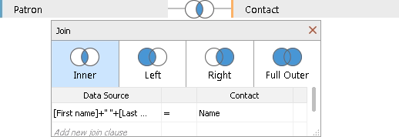

Using the calculation in the join produces the following combined table:

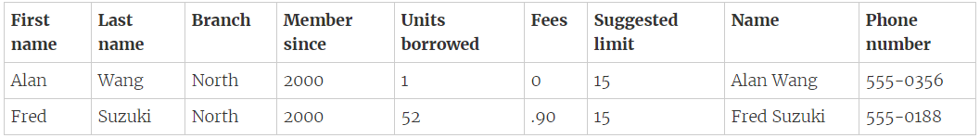

## MISMATCH IN THE UNION

When field names in the union do not match, fields in the union contain null values. You can merge the non-matching fields into a single field using the merge option to remove the null values.

When you use the merge option, the original fields are replaced by a new field that displays the first non-null value for each row in the non-matching fields.

You can also create your own calculation or, if possible, modify the underlying data to combine the non-matching fields.

For example, suppose a table, "August2016", is added to the underlying data. Instead of the standard "Customer" field name, it contains an abbreviated version called "Cust."

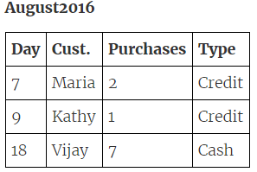

A union of these tables creates a single table that contains all rows from tables, with several null values. You can use the merge option to combine the related customer fields into a single field.

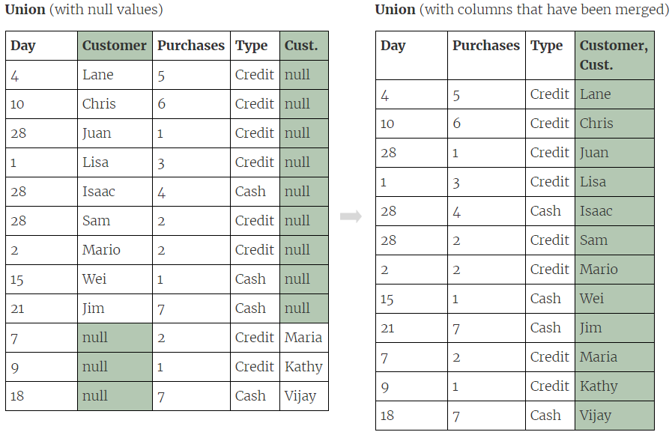

Merge mismatched fields

* Select two or more columns in the grid.
* Click the column drop-down arrow, and then select Merge mismatched fields.

To remove a merge

* Click the column drop-down arrow of the merged field and select Remove merge.

# DIMENSIONS & MEASURES

When you connect to a new data source, Tableau assigns each field in the data source to either the Dimensions area or the Measures area of the Data pane, depending on the type of data the field contains. You use these fields to build views of your data.

* Dimensions contain qualitative values (such as names, dates, or geographical data). We can use dimensions to categorize, segment, and reveal the details in your data. Dimensions affect the level of detail in the view.
* Measures contain numeric, quantitative values that we can measure. Measures can be aggregated. When we drag a measure into the view, Tableau applies an aggregation to that measure (by default).

The level of detail is set by the combination of Dimensions pills. Dimension pills on the Rows/Columns/Marks/Pages all impact the level of detail.

* Dimensions in the VIZ impact level of details.
* Dimension pills on the Filter do not impact the level of detail. Each Marks card can have a different level of detail when it has different Dimension pills.
* Discrete Measures do not impact partitioning, addressing or densification
* Discrete Dimensions partition the table calc
* Dimensions placed on marks card are used in addressing, and it will not cause densification because it is on just the Marks card, it can be either discrete or continuous.

## BLUE VERSUS GREEN

Tableau represents data differently in the view depending on whether the field is discrete (blue), or continuous (green). Continuous and discrete are mathematical terms. Continuous means "forming an unbroken whole, without interruption"; discrete means "individually separate and distinct."

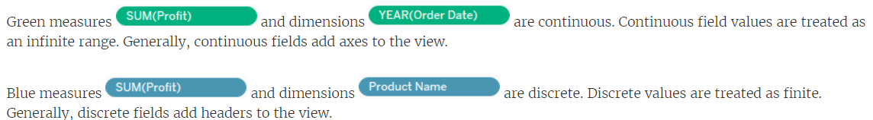

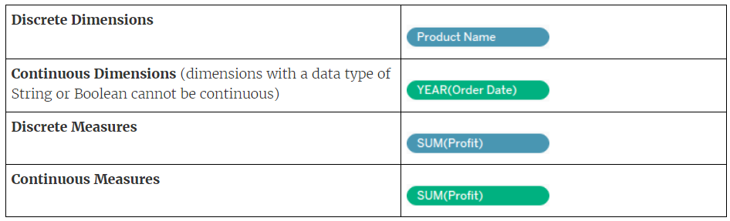

Examples of continuous and discrete fields used in a view

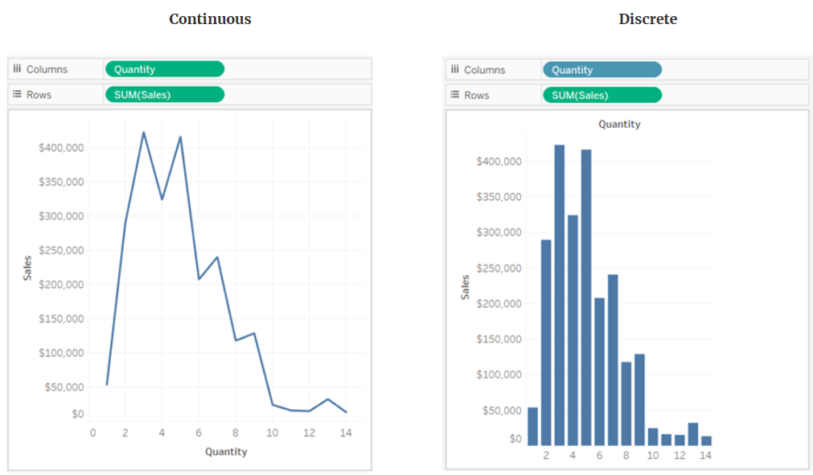

Measure values option for Dimensions

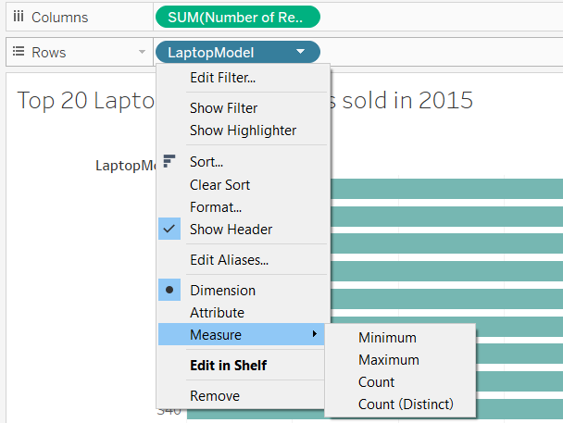

We can change the Measure type as shown below

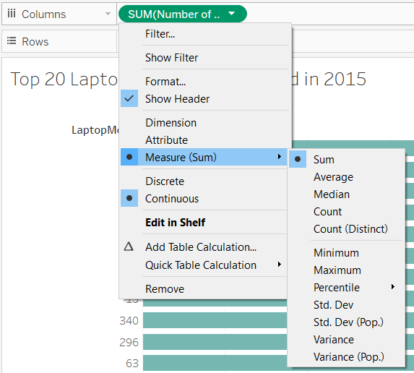

## DIMENSIONS & VIEW

The level of detail in a view refers to how granular the data is given the dimension and measure data in the view. When you drag a dimension field from the Dimensions area to Rows or Columns, Tableau creates a header for that field.

* As you add dimensions to Rows or Columns, the number of marks in the view increases.
* Dragging a dimension to a location on the Marks card such as Color or Size will also increase the number of marks, though it will not increase the number of headings in the view. The process of adding dimensions to the view to increase the number of marks is known as setting the level of detail.

Adding a dimension to any of the following locations in Tableau affects the level of detail:

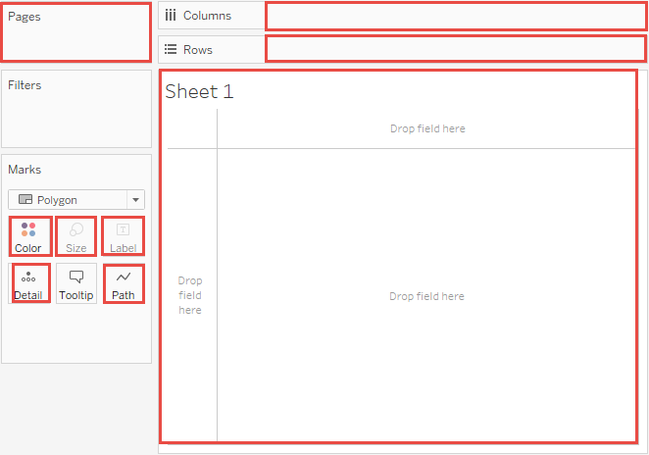

Notes

* In some cases, adding a measure to the view can increase the number of marks in the view. But this is not the same as changing the view's level of detail.
* The number of marks in the view is not guaranteed to correspond to the number you would get by multiplying the number of dimension values in each of the dimensions that make up the level of detail. There are multiple reasons why the number of marks could be lower. That is because if view contains empty rows then tableau will hide them by default. To see those values right click on one of the Date headers in the view and choose Show Missing Values.

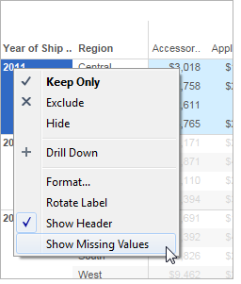

## MEASURES & VIEW

When you drag a measure to the view, it is aggregated by default. The type of aggregation will vary depending on the type of view. You should always check the aggregation and change it if necessary. For details, see "Change the default aggregation" in Edit Default Settings for Fields.

When you drag a continuous field from the Measures area to Rows or Columns, Tableau creates a continuous axis for that field.

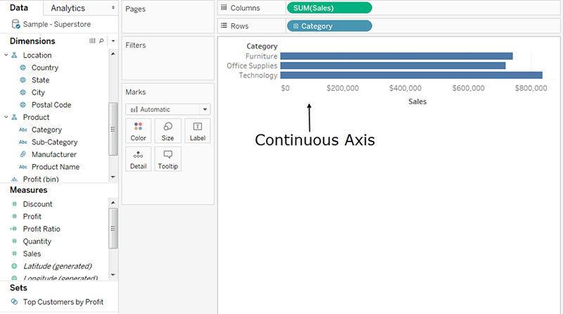

If you click the field and change it to Discrete, the values become column headers.

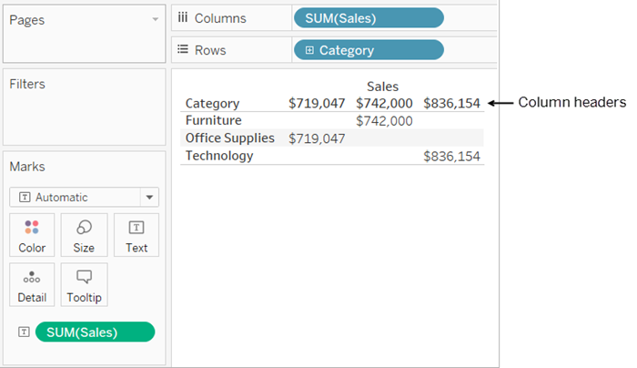

Tableau continues to aggregate values for the field, because even though the field is now discrete, it is still a measure, and Tableau aggregates measures by default.

In cases where Tableau has misclassified a field as a dimension or a measure, possibly because of the data type, you can convert it and change its role. If a measure contains numbers that don't need to be aggregated (such as a field that contains date values), you may want to convert it to be a dimension.

## CONTINUOUS AND DISCRETE FIELDS ON VIEW

In Tableau, fields can be either continuous or discrete.

Continuous and discrete are mathematical terms. Continuous means "forming an unbroken whole, without interruption"; discrete means "individually separate and distinct."

* When you drag a field from the Measures area to Columns or Rows, the values are continuous by default and Tableau creates an axis.
* When you drag a field from the Dimensions area of the Data pane to Columns or Rows, the values are discrete by default and Tableau creates column or row headers.
* Continuous fields produce axes.

If a field has values that are numbers that can be added, averaged, or otherwise aggregated, Tableau assigns that field to the Measures area of the Data pane when you first connect to a data source. Tableau is assuming that the values are continuous.

Tableau displays an axis when you drag a continuous field to Rows or Columns. An axis is a measuring line that shows values between a minimum and a maximum. Rulers and analog thermometers are examples of physical objects that display axes.

Tableau must be able to show a range of actual and potential values, because in addition to the initial values in the data source, it is always possible that new values will emerge as you work with a continuous field in the view.

While there are value labels on a continuous axis (0, 0.5, ... 3.0 in the following image), actual marks don't have to align with these labels as they would with column headers. For example, in the following image, the blue bar actually extends to a value of 6.940 on the horizontal axis, not 7.0 exactly.

## DISCRETE VERSUS CONTINUOUS FIELDS ON FILTERS

* When you drop a discrete dimension field on the Filters shelf, Tableau prompts you to choose which "members" of the discrete field to include in the view.

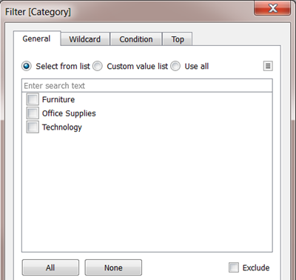

* When you drop a Date field on Filters, the result can be a discrete filter or a continuous filter. For more information, see Filter dates.
* When you drop a continuous measure on Filters, Tableau first prompts you to choose an aggregation for the filter, and then prompts you to specify how to filter the continuous range of values.
* When you drop a continuous dimension on Filters (other than a Date), Tableau prompts you to specify how to filter the continuous range of values.

## DISCRETE VERSUS CONTINUOUS FIELDS ON COLOR

* When you drop a discrete field on Color in the Marks card, Tableau displays a categorical palette and assigns a color to each value of the field.
* When you drop a continuous field on Color, Tableau displays a quantitative legend with a continuous range of colors.

## AGGREGATING DIMENSIONS

You can aggregate a dimension in the view as Minimum, Maximum, Count, or Count (Distinct). When you aggregate a dimension, you create a new temporary measure column, so the dimension actually takes on the characteristics of a measure.

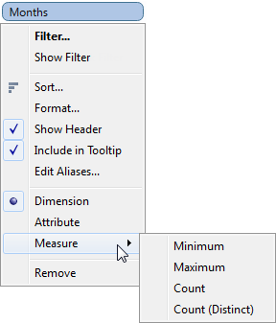

Another way to view a dimension is to treat it as an Attribute. Do this by choosing Attribute from the context menu for the dimension. By choosing a Dimension as an attribute we are telling Tableau to calculate the aggregation using Attribute dimension. The Attribute aggregation has several uses:

* It can ensure a consistent level of detail when blending multiple data sources.
* It can provide a way to aggregate dimensions when computing table calculations, which require an aggregate expression.
* It can improve query performance because it is computed locally.

ATTRIBUTE aggregation type uses below formula for calculating result:



Below is an example of using as dimension as attribute

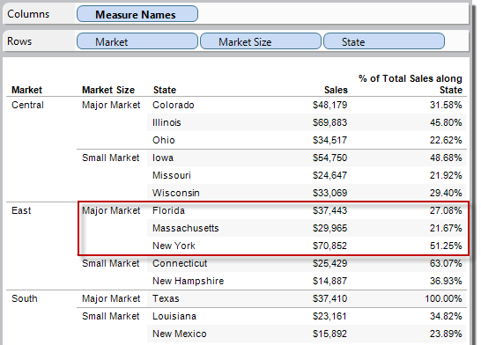

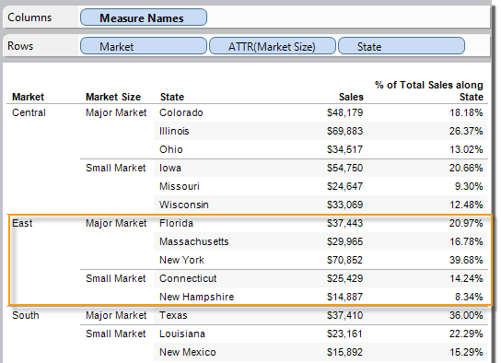

## PREDEFINED AGGREGATIONS

Tableau provides a set of predefined aggregations that are shown in the table below. You can set the default aggregation for any measure that is not a calculated field that itself contains an aggregation, such as AVG([Discount]).

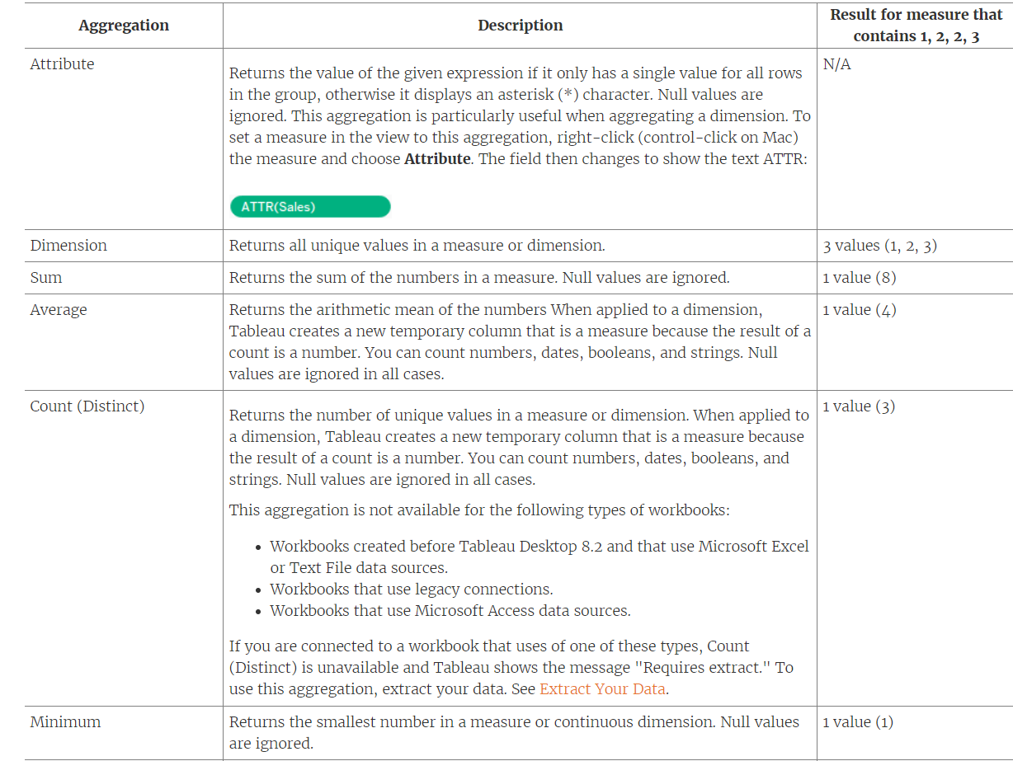

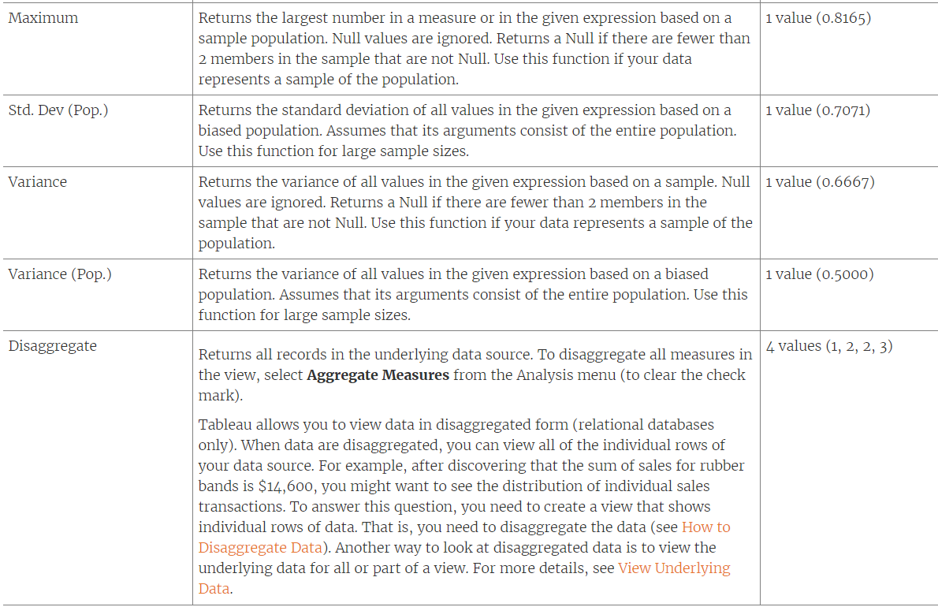

## DISAGGREGATE DATA

Whenever you add a measure to your view, an aggregation is applied to that measure by default. This default is controlled by the Aggregate Measures setting in the Analysis menu.

If you decide you want to see all of the marks in the view at the most detailed level of granularity, you can disaggregate the view. Disaggregating your data means that Tableau will display a separate mark for every data value in every row of your data source.

To disaggregate all measures in the view:

* Clear the Analysis >Aggregate Measures option. If it is already selected, click Aggregate Measures once to deselect it.

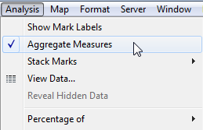

The different aggregations available for a measure determine how the individual values are collected: they can be added (SUM), averaged (AVG), or set to the maximum (MAX) or minimum (MIN) value from the individual row values.

Note: If your data source is very large, disaggregating the data can result in a significant performance degradation.

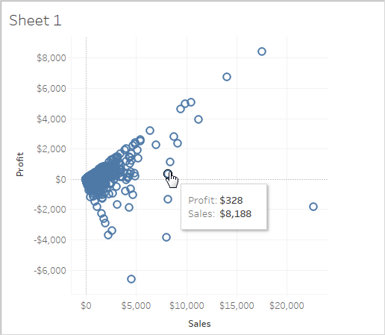

When you disaggregate measures, you no longer are looking at the average or sum for the values in the rows in the data source. Instead, the view shows a mark for every row in the data source. Disaggregating data is a way to look at the entire surface area of the data. It's a quick way to understand the shape of your data and to identify outliers. In this case, the disaggregated data shows that for many rows in the data, there is a consistent relationship between sales income and profit—this is indicated by the line of marks aligned at a forty-five-degree angle.

# GROUPS

Simplifies large numbers of dimension members by combining them into higher-level categories. These are mainly used to combine items and compare them with other values. Groups are useful for both correcting data errors as well as answering "what if" type questions.

If we remove an item which is a part of Group then the group does not become invalid. It still holds good. The item will not be displayed on the viz but it will still be a part of Group.

If a new item is added to a feature which is part of Group creation then if Group has Include Other option then the newly added category will be added to Others else a new entry is created.

## CREATE GROUP

There are multiple ways to create a group. You can create a group from a field in the Data pane, or by selecting data in the view and then clicking the group icon.

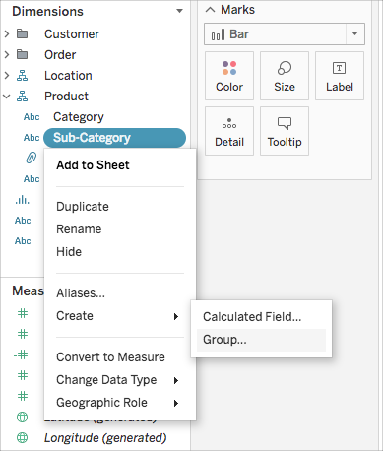

In the Create Group dialog box, select several members that you want to group, and then click Group.

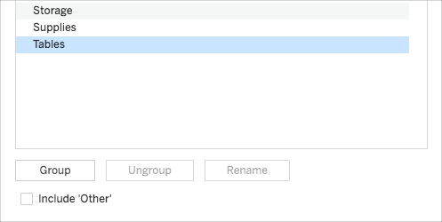

The selected members are combined into a single group. A default name is created using the combined member names.

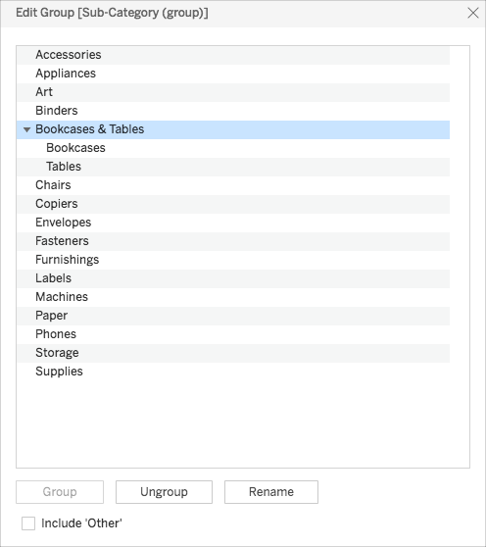

## INCLUDE OTHER

When you create groups in Tableau, you have the option to group all remaining, or non-grouped members in Other group.

The ‘Include Other’ option is useful for highlighting certain groups or comparing specific groups against everything else.

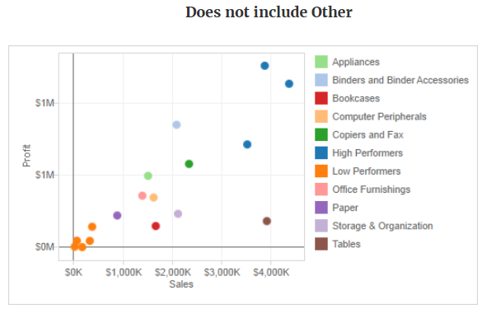

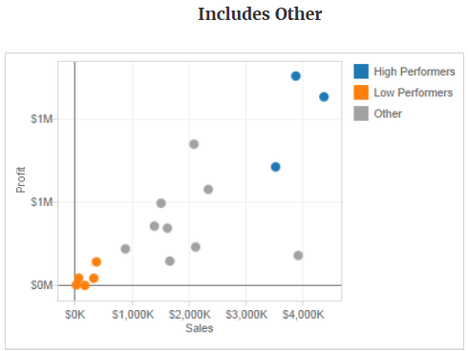

To include an ‘Other group’:

* In the Data pane, right-click the group field and select Edit Group.
* In the Edit Group dialog box, select Include 'Other'.

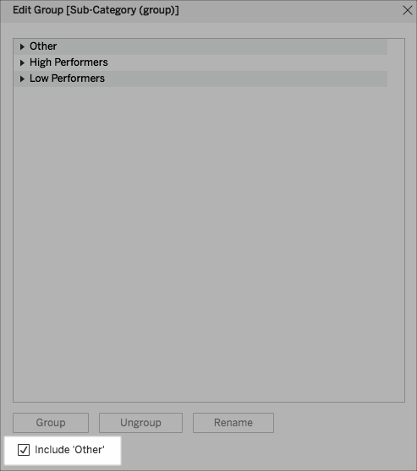

## MANUAL GROUPING

We can visually identify groups of related marks by selecting marks directly. This technique is especially useful when working with a scatter plot or a view that doesn't have headers that you can select when defining the group.

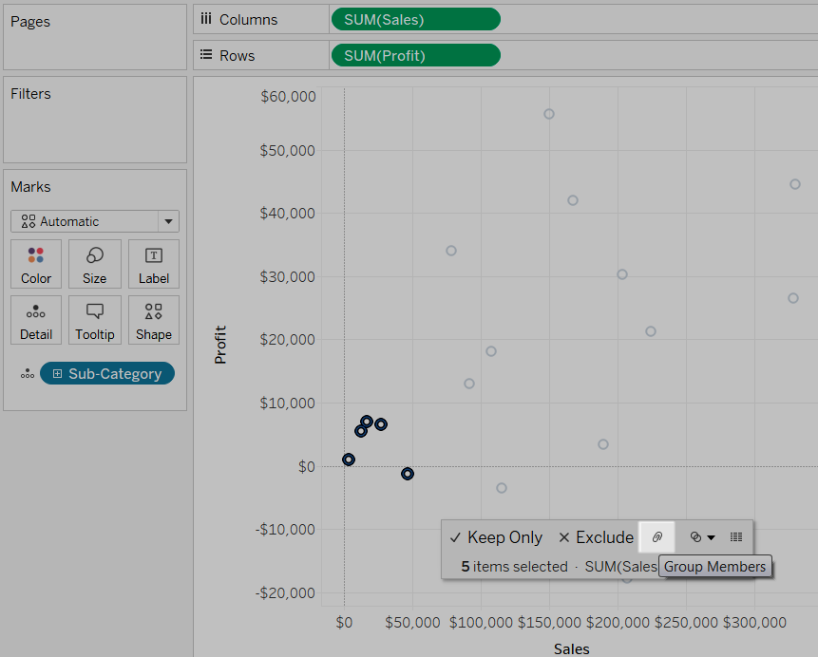

When we group manual grouping, the selected marks are grouped and all other members are combined into an "Other" category. The new group field is automatically added to Colour.

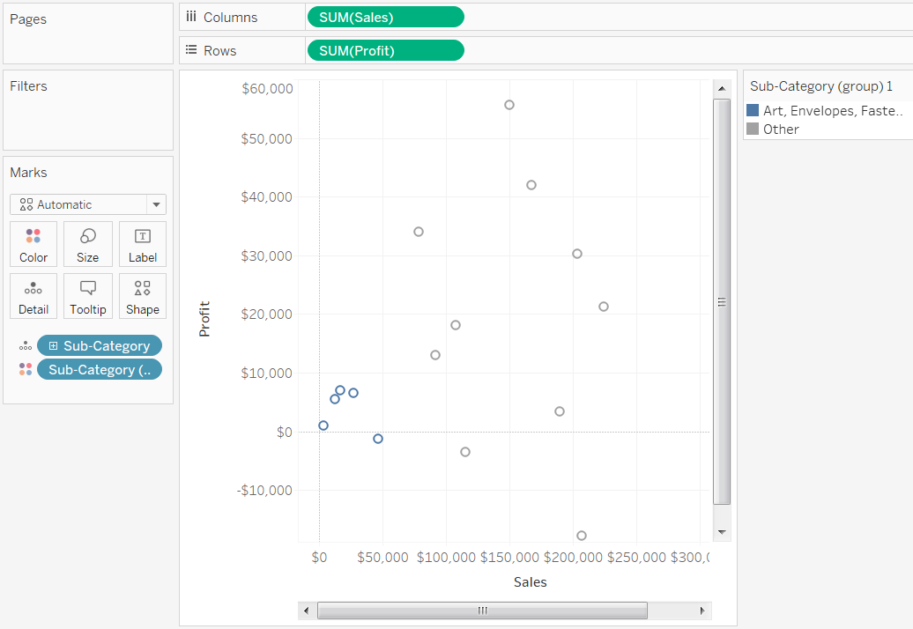

## GROUPING BASED ON MULTIPLE DIMESNIONS

When you create groups by selecting marks, it's possible that the marks will represent multiple dimensions. When the selection represents multiple dimensions, the Group menu lets you choose to group on All Dimensions or on a particular dimension.

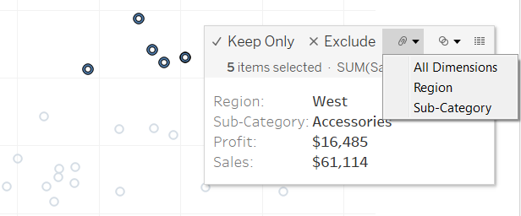

The views below show the results of grouping these measures on All Dimensions, Sub-Category, and Region.

The 5 marks are combined and the rest of the marks are added to an "Other" category

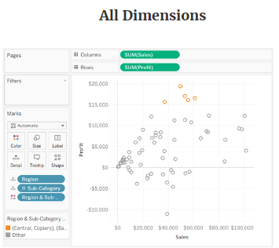

The 5 marks are combined and the rest of the marks are added to an "Other" category.

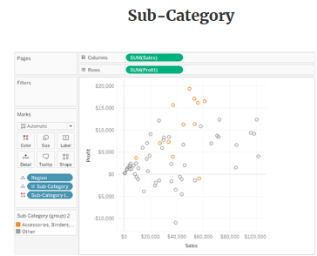

All marks associated with the four regions are combined and everything else is added to an "Other" category.

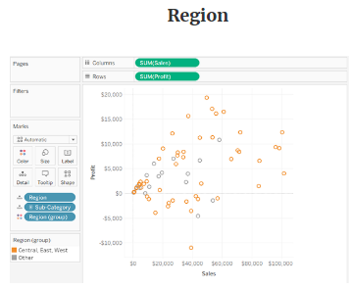

# SETS

You can use sets to compare and ask questions about a subset of data. Sets are custom fields that define a subset of data based on some conditions.

## DYNAMIC SET

The members of a dynamic set change when the underlying data changes. Dynamic sets can only be based on a single dimension. To create a dynamic set:

In the Data pane, under Dimensions, right-click a field and select Create > Set.

**GENERAL:** Use the General tab to select one or more values that will be considered when computing the set. You can alternatively select the Use all option to always consider all members even when new members are added or removed.

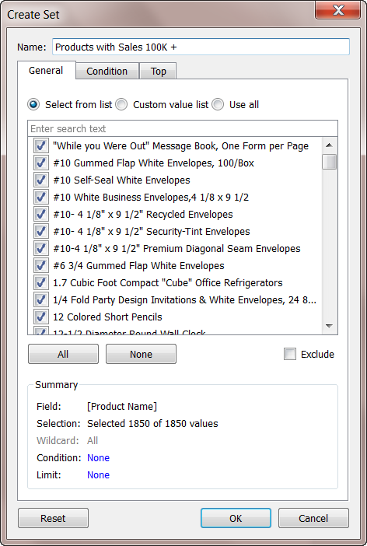

**CONDITION:** Use the Condition tab to define rules that determine what members to include in the set. For example, you might specify a condition that is based on total sales that only includes products with sales over $100,000.

Set conditions work the same as filter conditions.

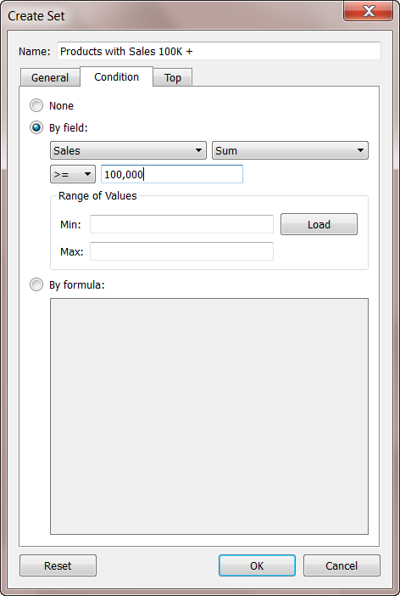

**TOP:** Use the Top tab to define limits on what members to include in the set.

For example, you might specify a limit that is based on total sales that only includes the top 5 products based on their sales.

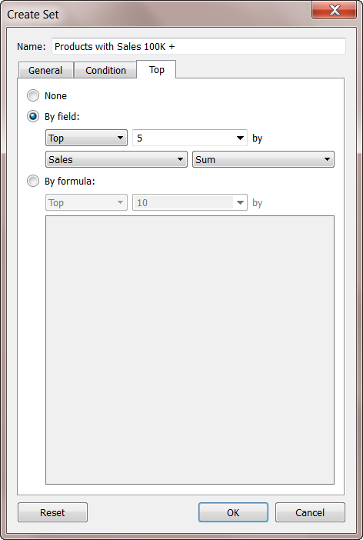

The new set is added to the bottom of the Data pane, under the Sets section. A set icon  indicates the field is a set.

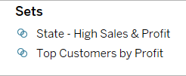

## FIXED SET

The members of a fixed set do not change. A fixed set can be based on a single dimension or multiple dimensions.

To create a fixed set:

* In the visualization, select one or more marks (or headers) in the view.
* Right-click the mark(s) and select Create Set.

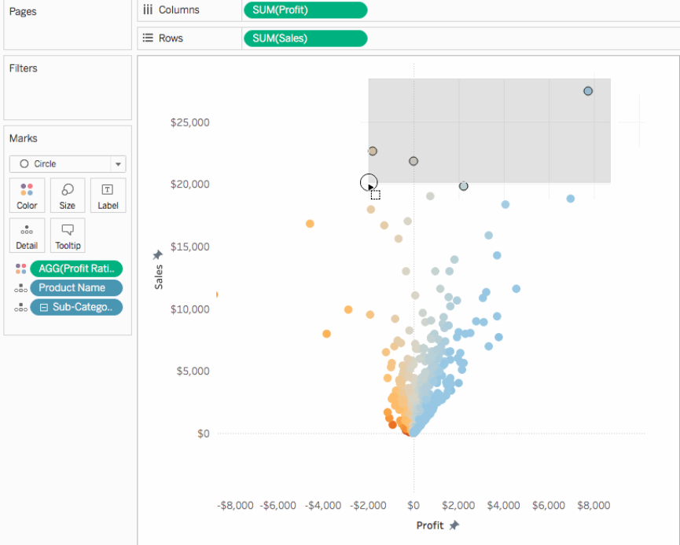

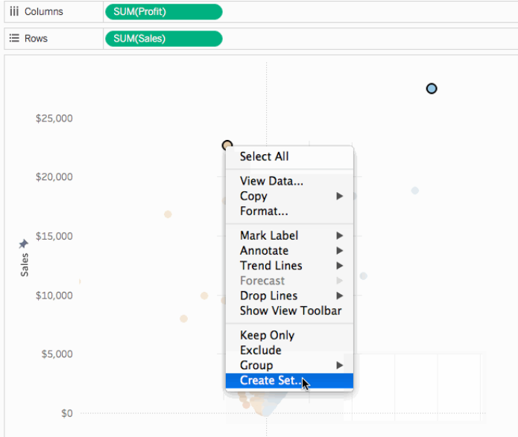

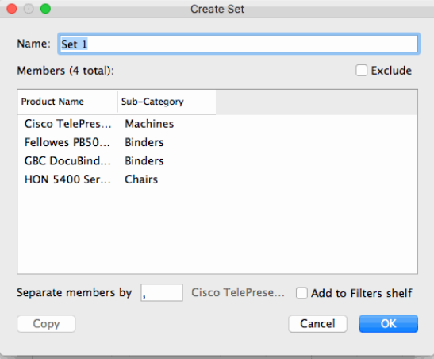

If you created a set using specific data points, you can add more data to or subtract data from the set.

Sets can also be used as filters (by dropping sets on the filter shelve).

After you create a set, it displays at the bottom of the Data pane in the Sets section. You can drag it into the viz like any other field.

## IN/OUT MEMBERS IN A SET

In most cases, when you drag a set to the viz, Tableau displays the set using the In/Out mode. This mode separates the set into two categories:

* In - The members in the set.
* Out - Any members that are not part of the set.

For example, in a set defined for the top 25 customers, the top customers would be part of the In category and all other customers would be part of the Out category. Using the In/Out mode makes it easy to compare the members in the set to everything else.

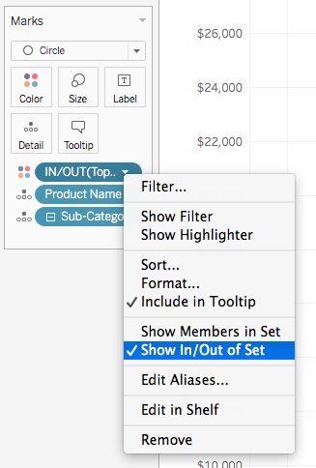

When a set is in In/Out mode, the field on the shelf is prefaced by the text, "IN/OUT" followed by the set name.

## COMBINE SETS

You can combine two sets to compare the members. When you combine sets, you create a new set containing either the combination of all members, just the members that exist in both, or members that exist in one set but not the other.

Combining sets allows you to answer complex questions and compare cohorts of your data. For example, to determine the percentage of customers who purchased both last year and this year, you can combine two sets containing the customers from each year and return only the customers that exist in both sets.

To combine two sets, they must be based on the same dimensions. That is, you can combine a set containing the top customers with another set containing the customers that purchased last year. However, you cannot combine the top customers set with a top products set.

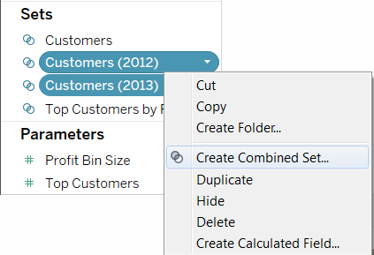

Select one of the following options for how to combine the sets:

* All Members in Both Sets - the combined set will contain all of the members from both sets.
* Shared Members in Both Sets - the combined set will only contain members that exist in both sets.
* Except Shared Members - the combined set will contain all members from the specified set that don't exist in the second set. These options are equivalent to subtracting one set from another. For example, if the first set contains Apples, Oranges, and Pears and the second set contains Pears and Nuts; combining the first set except the shared members would contain just Apples and Oranges. Pears is removed because it exists in the second set.

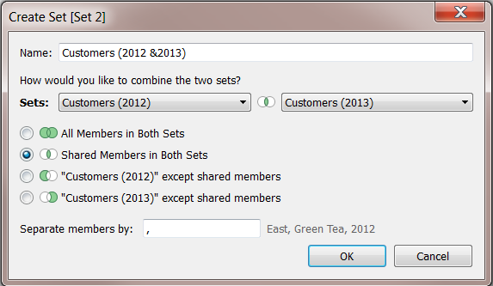

Optionally specify a character that will separate the members if the sets represent multiple dimensions.

# GROUPS VS SETS

**GROUP:** Simplifies large numbers of dimension members by combining them into higher-level categories.

A hierarchical collection based on a dimension. The cities San Diego and Los Angeles are part of the state California group, and no other.

**SET:** A subset of your data that meets certain conditions based on existing dimensions.

A collection based on a measure using IN/ Out. These salesmen are IN the top 3 based on sales, while these are OUT. These salesmen are IN the top 3 based on profit, while these are OUT.

* Grouping in Tableau is grouping multiple members in a SINGLE dimension into a higher category and creating a set is grouping members from MULTI dimensions and/or condition into a dynamic or constant group. So, sets are just a more complex and dynamic grouping.
* The most significant one is that sets are dynamic in nature while groups are not. Whenever the data changes the set will update, this is not an option for groups.
* Sets can be referenced directly in a calculation, and since they imply a filter, they can be quite useful in a hierarchy. For example, you might drop a set into a hierarchy so that when someone opens that level of the hierarchy up, the values are pre-filtered by what the set does.
* Groups can’t be used any Calculated fields where as Sets can be used in calculated Fields.
* We can combine sets created on different measures for the same dimension but we cant do the same in groups.
* One difference is that with sets you can choose "IN/OUT" or "Show Members in Set" but with groups there is no such option only group and ungroup

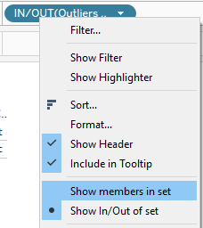

# PARAMETERS

Parameters are dynamic values that can replace constant values in calculations, filters, and reference lines. Parameters are used to accept an input from user. We can use parameters to control the data that is being showed on the viz. We can give this control to the user to decide what details he/she wants to see on the viz.

1. First create a calculated filed as desired.
2. Then show the calculated filed on sheet / workbook
3. Then create a calculated field using the calculated field or reference the parameter in the dimension if possible.
4. Use the calculated file on the viz

Note: You cannot create parameters or display parameter controls when you edit views on the web.

In the Data pane, click the drop-down arrow in the upper right corner and select Create Parameter.

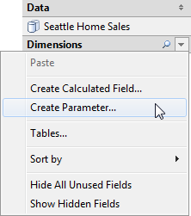

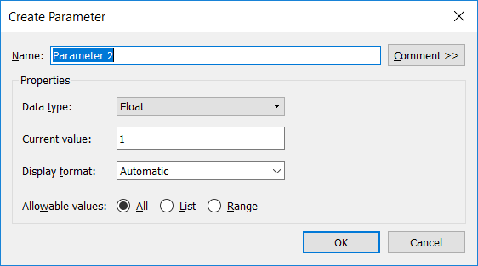

Specify the data type for the values it will accept:

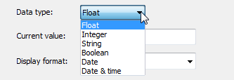

Specify a current value. This is the default value for the parameter.

Specify the display format to use in the parameter control.

Specify how the parameter will accept values. You can select from the following options:

* All - the parameter control is a simple type in field.
* List - the parameter control provides a list of possible values for you to select from.
* Range - the parameter control lets you select values within a specified range.

If you select List, you must specify the list of values. Click in the left column to type a value. Each value can also have a display alias. Alternatively, you can add the members of a field as the list of values by selecting Add from Field.

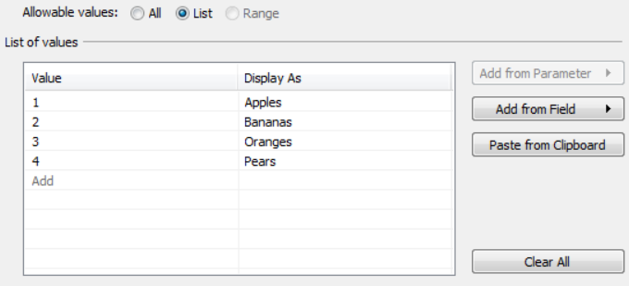

The parameter is listed in the Parameters section at the bottom of the Data pane.

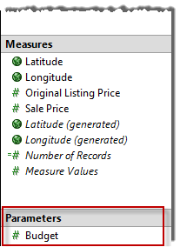

### PARAMETER IN CALCULATION

Parameters give you a way to dynamically modify values in a calculation. Rather than manually editing the calculation (and all dependent calculations), you can use a parameter. Then when you want to change the value, you open the parameter control, change the value, and all of the calculations that use that parameter are updated.

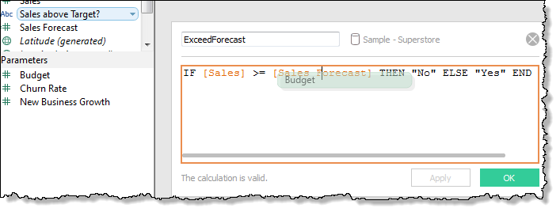

### PARAMETER IN A FILTER

Parameters give you a way to dynamically modify values in a TopN filters. Rather than manually setting the number of values you want to show in the filter, you can use a parameter. Then when you want to change the value, you open the parameter control and the filter updates. For example, when creating a filter to show the Top 10 products based on total profit, you may want to use a parameter instead of the fixed “10” value. That way, you can quickly update the filter to show the top 10, 20, or 30 products.

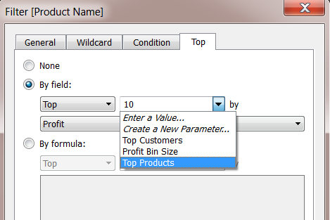

### PARAMETER IN A REFERENCE LINE

Parameters give you a way to dynamically modify a reference line, band, or box. For example, instead of showing a reference line at a fixed location on the axis, you can reference a parameter. Then you can use the parameter control to move the reference line.

A list of parameters is available in the Value drop-down list in the Add Reference Line, Band, or Box dialog box. Select the parameter you want to use.

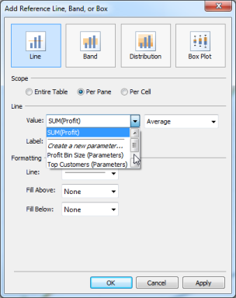

The reference line is drawn at the Current Value specified by the parameter. To open the parameter control, right-click (Control-click on a Mac) the parameter in the Data pane and then select Show Parameter Control. Use the parameter control to change where the reference line is drawn.

### PARAMETER CONTROL

The parameter control is a worksheet card that lets you modify the parameter value. Parameter controls are very similar to filter cards in that they contain controls that modify the view. You can open parameter controls on worksheets and dashboards and they are included when you save to the web or publish to Tableau Server.

To open the parameter control, right-click (Control-click) the parameter in the Data pane and select Show Parameter Control.

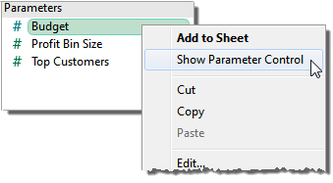

# TYPES OF CALCULATIONS IN TABLEAU

This article explains the types of calculations you can use in Tableau. You'll learn the difference between each calculation and how they are computed.

There are three main types of calculations you can use to create calculated fields in Tableau:

* Basic expressions
* ADHOC calculation
* Level of Detail (LOD) expressions
* Table calculations

## BASIC EXPRESSIONS

Basic expressions allow you to transform values or members at the data source level of detail (a row-level calculation) or at the visualization level of detail (an aggregate calculation).

### ROW LEVEL EXPRESSIONS

In Tableau, expressions referencing unaggregated datasource columns are computed for each row in the underlying table. In this case, the dimensionality of the expression is row level. An example of a row-level expression is:

[Sales] / [Profit]

This calculation will be evaluated in each row of the database. For each row, the Sales value in that row will be divided by the Profit value in that row, producing a new column with the result of the multiplication (a profit ratio).

If you create a calculation with this definition, save it with the name [ProfitRatio], and then drag it from the Data pane to a shelf, Tableau typically aggregates the calculated field for the view:

SUM[ProfitRatio]

### VIEW LEVEL EXPRESSIONS

By contrast, expressions referencing aggregated data source columns are computed at the dimensionality defined by the dimensions in the view. In this case, the dimensionality of the expression is view level. An example of a view-level expression is:

SUM(Sales) / SUM(Profit)

If you drag this calculation to a shelf (or type it directly on a shelf as an ad-hoc calculation), Tableau encloses it in an AGG function:

AGG(SUM(Sales) / SUM(Profit))

This is what is known as an aggregate calculation.

## AD-HOC CALCULATION

Ad-hoc calculations are calculations that you can create and update as you work with a field on a shelf in the view. Ad-hoc calculations are also known as type-in or in-line calculations.

Double-click on an existing field to start editing.

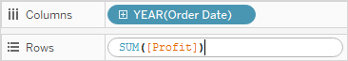

You can also double-click on an empty shelf or on an empty part of a shelf to create a new calculation.

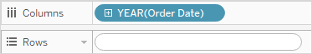

Type to update the expression, or drag new fields into the expression from the Data pane or elsewhere in the view.

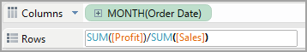

Press Enter, Tab, or click outside the expression to commit the expression, close the calculation, and update the view.



Ad-hoc calculations are supported on the Rows, Columns, Marks, and Measure Values shelves; they are not supported on the Filters or Pages shelves.

Note: Ad-hoc calculations are not named, but are saved when you close the workbook. If you want to save an ad-hoc calculation for use in other workbook sheets, copy it to the Data pane. You will be prompted to name the calculation.

The following rules govern the use of ad-hoc calculations.

* Only one ad-hoc calculation can be open at a time.
* If a field that has a geographic role or a fiscal year setting associated with it is added to an ad-hoc calculation, the ad-hoc calculation inherits that role or setting.
* The right-click context menu for an ad-hoc calculation supports the same options that would be available for any other field in the view of the same type, including the ability to change aggregation, show a filter, or format.
* Ad-hoc calculations are not available when you create groups, sets, hierarchies, or parameters.
* Ad-hoc calculations are valid for creating trend lines, forecasts, and reference lines, bands, and distributions.

## LEVEL OF DETAIL (LOD) EXPRESSIONS

Just like basic expressions, LOD expressions allow you to compute values at the data source level and the visualization level. However, LOD expressions give you even more control on the level of granularity you want to compute. They can be performed at a more granular level (INCLUDE), a less granular level (EXCLUDE), or an entirely independent level (FIXED).

Before level of detail expressions were supported in Tableau, it was not possible to create calculations at a level of detail other than the view level. For example, if you attempt to save the following expression, Tableau displays the error message: “Cannot mix aggregate and non-aggregate arguments with this function”:

[Sales] – AVG([Sales])

The user’s intent in this case was to compare store sales for each individual store to the average of sales for all stores. This can now be accomplished with a level of detail expression:

[Sales] - {AVG([Sales])}

This is what is known as a table-scoped level of detail expression.

When you save a level of detail expression, Tableau adds it to either the Dimensions or the Measures area in the Data pane.

* FIXED level of detail expressions can result in measures or dimensions, depending on the underlying field in the aggregate expression. So, MIN([Date])} will be a dimension because [Date] is a dimension, and {fixed Store: SUM([Sales])} will be a measure because [Sales] is a measure. When a FIXED level of detail expression is saved as a measure you have the option of moving it to dimensions.
* INCLUDE and EXCLUDE level of detail expressions are always measures.

LOD expressions can be nested.

## TABLE CALCULATIONS

Table calculations allow you to transform values at the level of detail of the visualization only.

A table calculation is a transformation you apply to the values in a visualization. Table calculations are a special type of calculated field that computes on the local data in Tableau. They are calculated based on what is currently in the visualization and do not consider any measures or dimensions that are filtered out of the visualization.

You can use table calculations for a variety of purposes, including:

* Transforming values to rankings
* Transforming values to show running totals
* Transforming values to show percent of total

All fields must be either aggregated or constant before using it in a table calculation function.

For example: Below calculation will give error as YEAR is an unaggregated value.

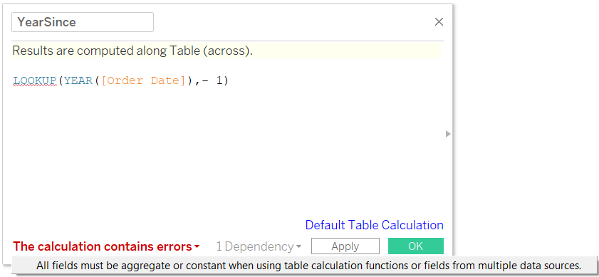

Hence, we can wrap it around in ATTR () to make it an aggregated value.

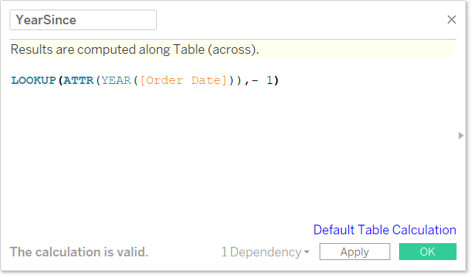

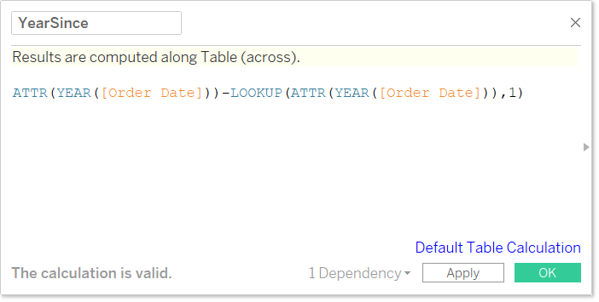

Also, it’s important to note that Measure option is not available for calculated fields.

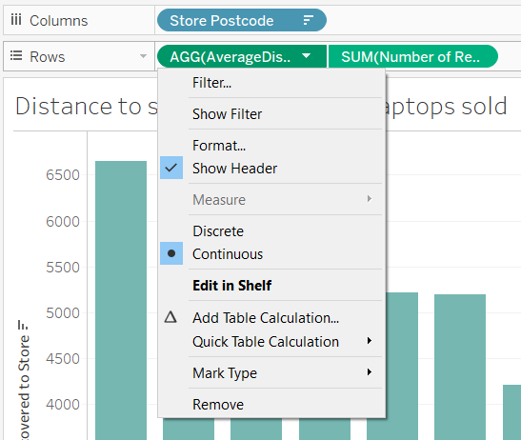

### ADDRESSING AND PARTITIONING

When you add a table calculation, you must use all dimensions in the level of detail either for partitioning (scoping) or for addressing (direction).

The dimensions that define how to group the calculation (the scope of data it is performed on) are called partitioning fields. The table calculation is performed separately within each partition.

The remaining dimensions, upon which the table calculation is performed, are called addressing fields, and determine the direction of the calculation.

Partitioning fields break the view up into multiple sub-views (or sub-tables), and then the table calculation is applied to the marks within each such partition. The direction in which the calculation moves (for example, in calculating a running sum, or computing the difference between values) is determined by the addressing fields. So, when you order the fields in the Specific Dimensions section of the Table Calculation dialog box from top to bottom, you are specifying the direction in which the calculation moves through the various marks in the partition.

When you add a table calculation using the Compute Using options, Tableau identifies some dimensions as addressing and others as partitioning automatically, as a result of your selections. But when you use Specific Dimensions, then it’s up to you to determine which dimensions are for addressing and which for partitioning.

### TABLE (ACROSS)

Computes across the length of the table and restarts after every partition.

For example, in the following table, the calculation is computed across columns (YEAR (Order Date)) for every row (MONTH (Order Date)).

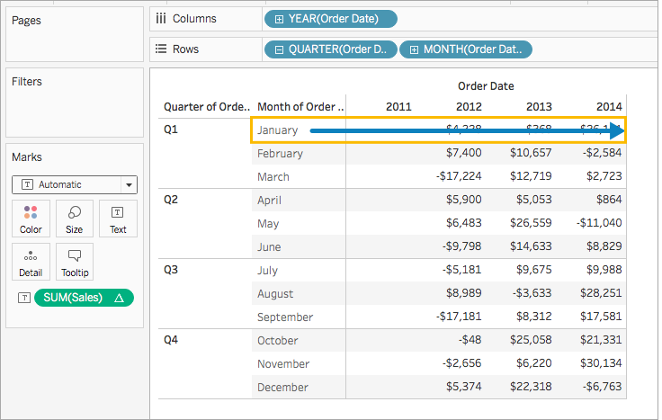

### TABLE (DOWN)

Computes down the length of the table and restarts after every partition.

For example, in the following table, the calculation is computed down rows (MONTH (Order Date)) for every column (YEAR (Order Date)).

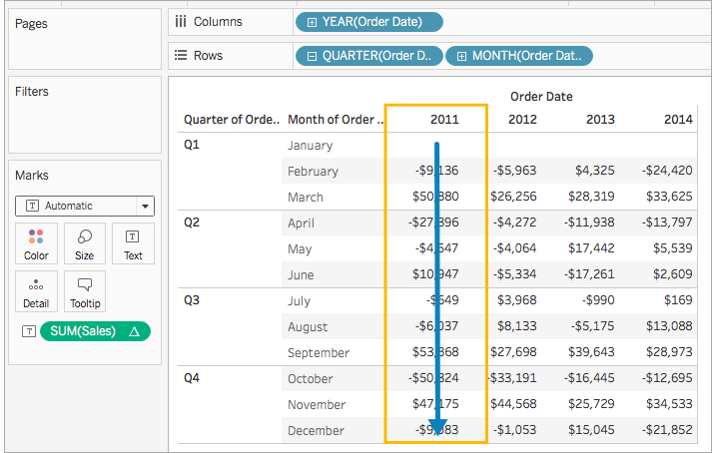

### TABLE (ACROSS THEN DOWN)

Computes across the length of the table, and then down the length of the table.

For example, in the following table, the calculation is computed across columns (YEAR (Order Date)), down a row (MONTH (Order Date)), and then across columns again for the entire table.

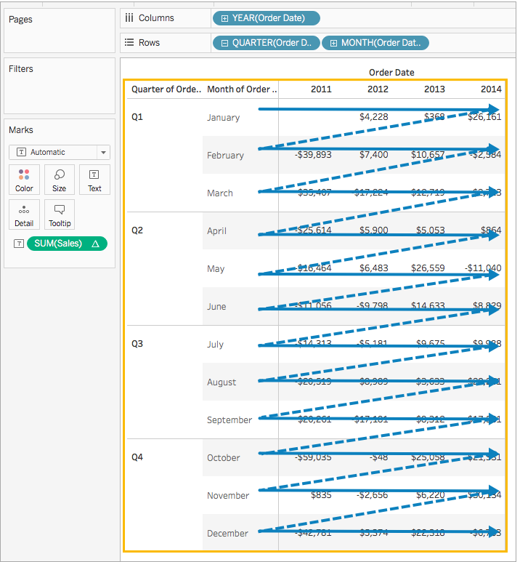

### TABLE (DOWN THEN ACROSS)

Computes down the length of the table, and then across the length of the table.

For example, in the following table, the calculation is computed down rows (MONTH (Order Date)), across a column (YEAR (Order Date), and then down rows again.

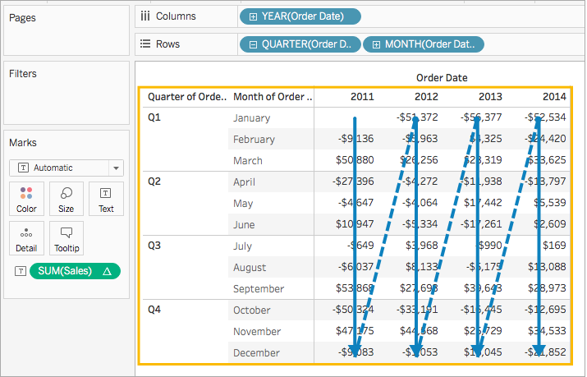

### PANE (DOWN)

Computes down an entire pane.

For example, in the following table, the calculation is computed down rows (MONTH (Order Date)) for a single pane.

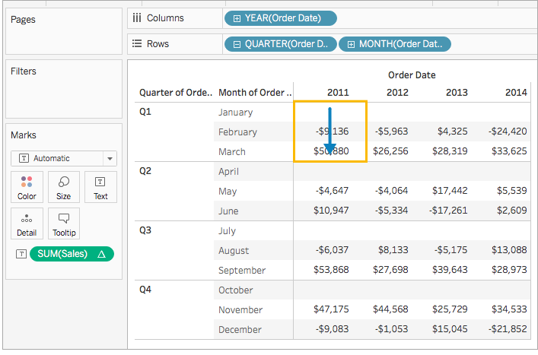

### PANE (ACROSS THEN DOWN)

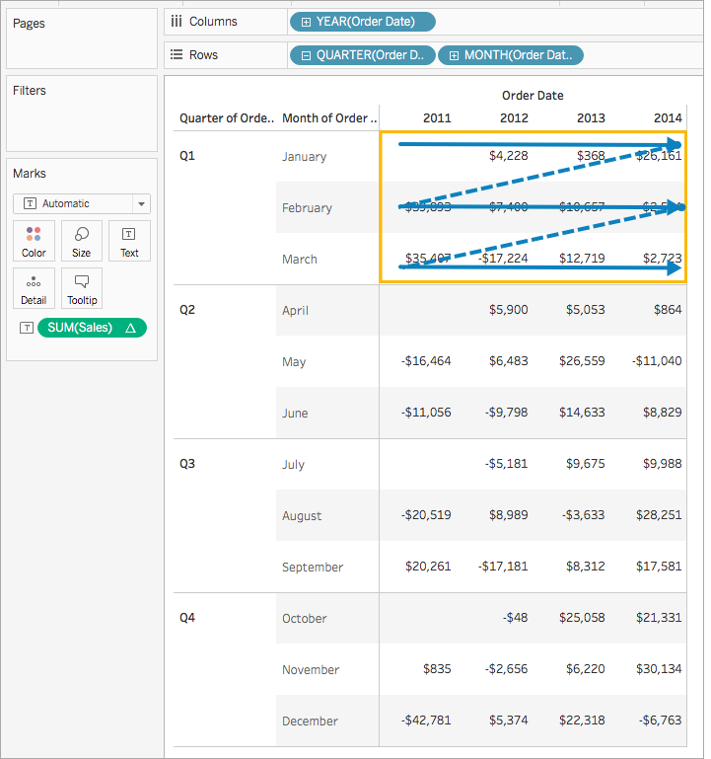

### PANE (DOWN THEN ACROSS)

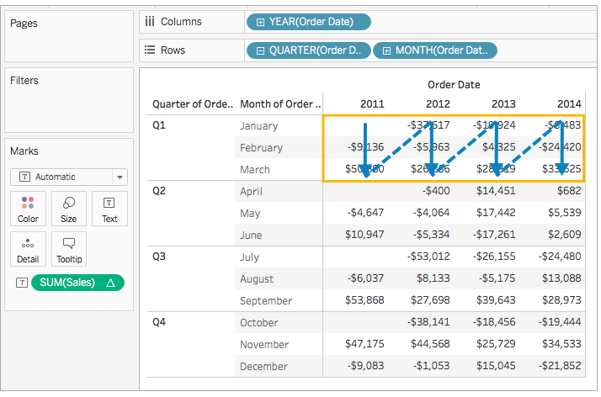

### CELL

Computes within a single cell.

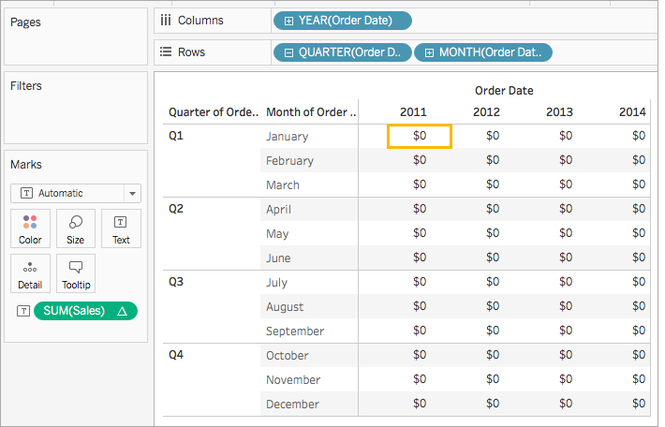

### PRIMARY CALCULATION

Below are some primary table calculations available:

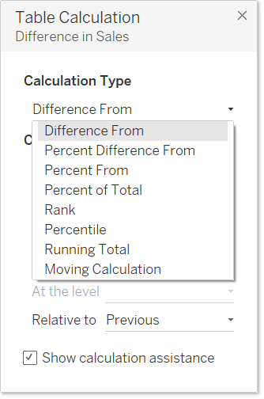

Quick table calculation has below options

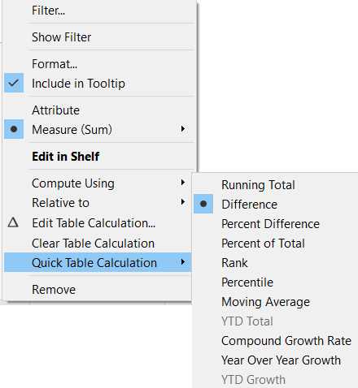

YTD Total, Year Over Year Growth and YTD Growth options will only be available if we have Year dimension with either Quarter or Months dimension in our view (they will be greyed out if we have Quarter, Months, weeks without YEAR).

### ADD SECONDARY CALCULATION

With Running Total and Moving Calculation table calculations, you have the option to transform values twice to obtain the result you want—that is, to add a secondary table calculation on top of the primary table calculation.

For example, you could add an initial table calculation to calculate the running total for sales per month within each individual year, and then a secondary calculation to calculate the year-over-year percent difference for each month from one year to the next.

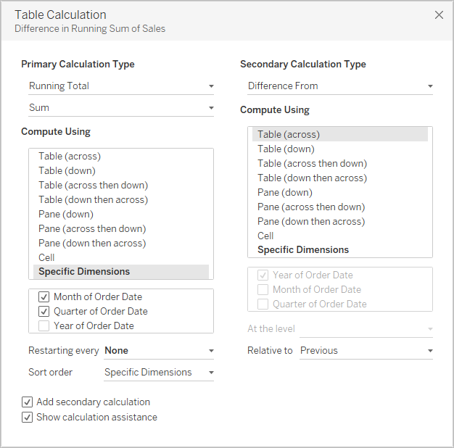

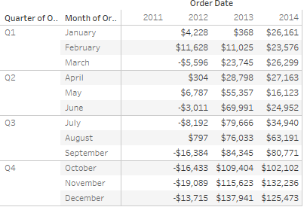

## RULES FOR AGGREGATE CALCULATIONS

The rules that apply to aggregate calculations are as follows:

* For any aggregate calculation, you cannot combine an aggregated value and a disaggregated value. For example, SUM(Price)*[Items] is not a valid expression because SUM(Price) is aggregated and Items is not. However, SUM(Price*Items) and SUM(Price)*SUM(Items) are both valid.
* Constant terms in an expression act as aggregated or disaggregated values as appropriate. For example: SUM(Price*7) and SUM(Price)*7 are both valid expressions.
* All of the functions can be evaluated on aggregated values. However, the arguments to any given function must either all be aggregated or all disaggregated. For example: MAX(SUM(Sales), Profit) is not a valid expression because Sales is aggregated and Profit is not. However, MAX(SUM(Sales), SUM(Profit)) is a valid expression.
* The result of an aggregate calculation is always a measure.
* Like predefined aggregations, aggregate calculations are computed correctly for grand totals. Refer to Grand Totals for more information.

# LOD

Level of Detail expressions (also known as LOD expressions) allow you to compute values at the data source level and the visualization level. However, LOD expressions give you even more control on the level of granularity you want to compute.

If you want to use the result as dimension then you should use fixed LOD calculation as there is nothing else (no aggregate other than LOD can be used as dimension) in tableau that gives result as dimension.

* They can be performed at a more granular level (INCLUDE), a less granular level (EXCLUDE), or an entirely independent level (FIXED).
* LOD Expressions allow you to determine the levels of detail (i.e., the dimensions) used in a calculation without actually dropping those dimensions into the visualization.
* More aggregated data is less granular and unaggregated is more granular as shown below

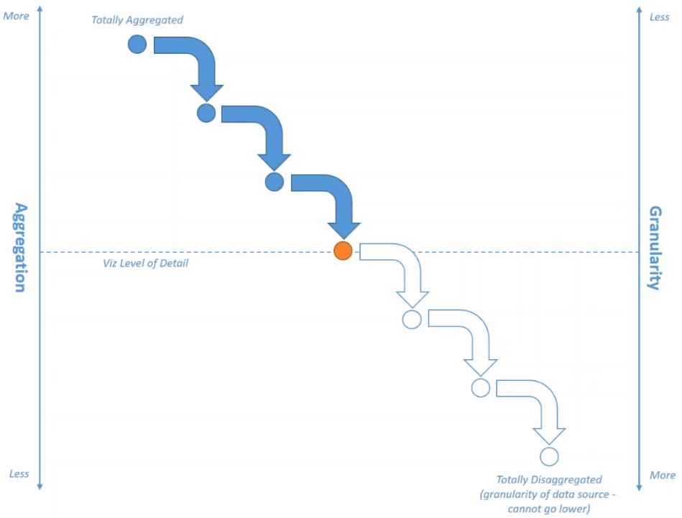

## FIXED LOD

FIXED level of detail expressions computes a value using the specified dimensions, without reference to the dimensions in the view.



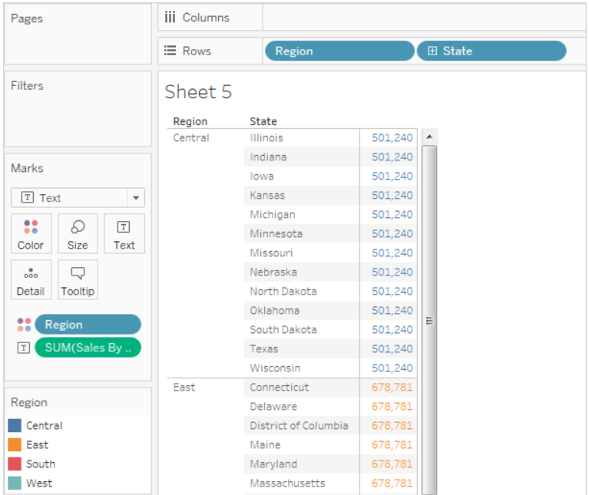

For fixed LOD the scenario is shown below:

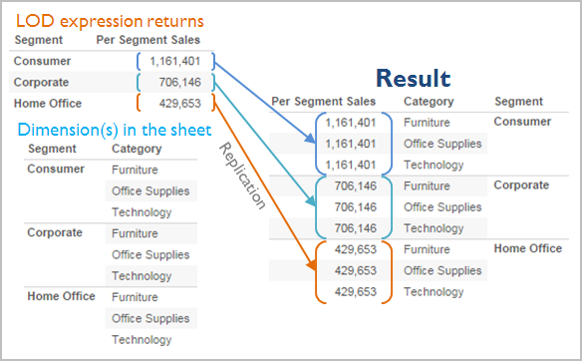

## INCLUDE LOD

INCLUDE level of detail expressions compute values using the specified dimensions in addition to whatever dimensions are in the view.

INCLUDE level of detail expressions can be useful when you want to calculate at a fine level of detail in the database and then re-aggregate and show at a coarser level of detail in your view. Fields based on INCLUDE level of detail expressions will change as you add or remove dimensions from the view.



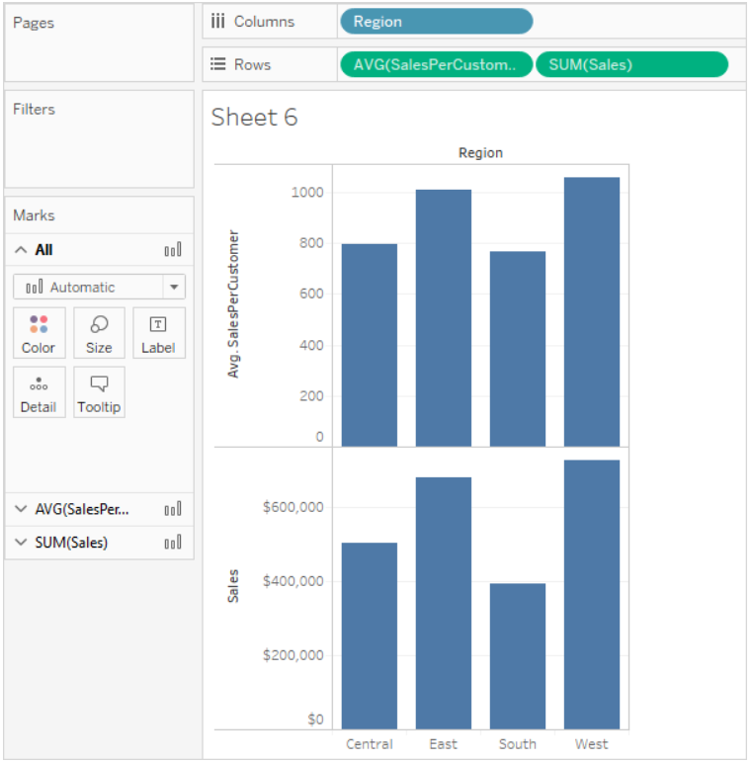

The result illustrates the difference between the total sale for each region and the average sale per customer for each region:

For INCLUDE LOD, the scenario is as shown below:

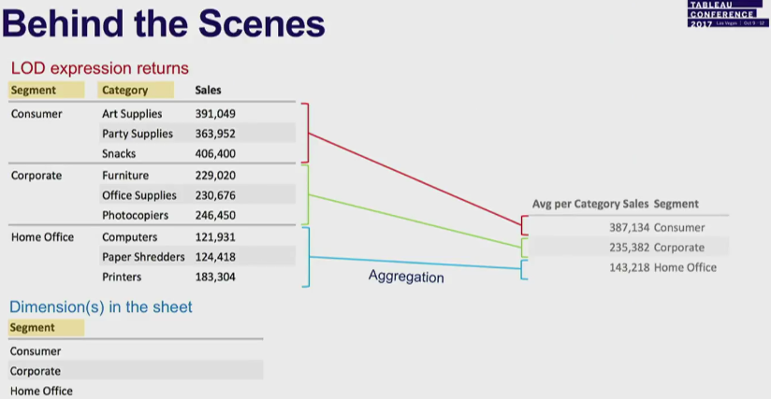

## EXCLUDE LOD

EXCLUDE level of detail expressions declare dimensions to omit from the view level of detail.

EXCLUDE level of detail expressions are useful for ‘percent of total’ or ‘difference from overall average’ scenarios. They are comparable to such features as Totals and Reference Lines.

EXCLUDE level of detail expression cannot be used in row-level expressions (where there are no dimensions to omit), but can be used to modify either a view level calculation or anything in between (that is, you can use an EXCLUDE calculation to remove dimension from some other level of detail expression).

For EXCLUDE LOD, scenario is given below

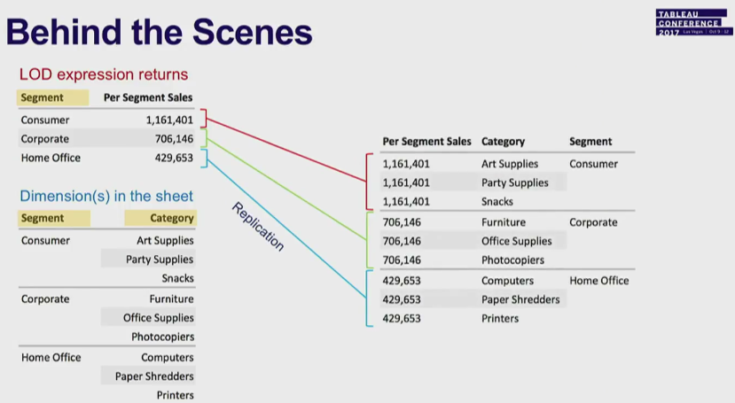

## TABLE-SCOPED LOD

It is possible to define a level of detail expression at the table level without using any of the scoping keywords. For example, the following expression returns the minimum (earliest) order date for the entire table:



This is equivalent to a FIXED level of detail expression with no dimension declaration:



## FILTERS AND LOD

There are several different kinds of filters in Tableau and they get executed in the following order from top to bottom.

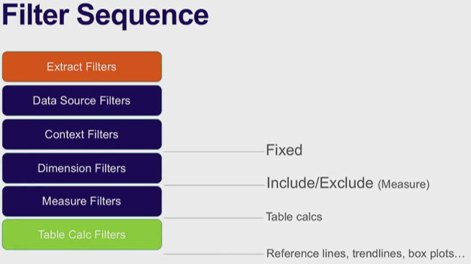

The text on the right shows where level of detail expression is evaluated in this sequence.

Extract Filters (in orange) are only relevant if you’re creating a Tableau Extract from a data source. Table calculations filters (dark blue) are applied after calculations are executed and therefore hide marks without filtering out the underlying data used in the calculations.

If you’re familiar with SQL, you can think of measure filters as equivalent to the HAVING clause in a query, and dimension filters as equivalent to the WHERE clause.

FIXED calculations are applied before dimension filters, so unless you promote the fields on your Filter shelf to Improve View Performance with Context Filters, they will be ignored. For example, consider if you have the following calculation on one shelf in a view, along with [State] on a different shelf:



This calculation will give you the ratio of a state’s sales to total sales.

If you then put [State] on the Filters shelf to hide some of the states, the filter will affect only the numerator in the calculation. Since the denominator is a FIXED level of detail expression, it will still divide the sales for the states still in the view against the total sales for all states—including the ones that have been filtered out of the view.

INCLUDE and EXCLUDE level of detail expressions are considered after Dimension filters. So, if you want filters to apply to your FIXED level of detail expression but don’t want to use Context Filters, consider rewriting them as INCLUDE or EXCLUDE expressions.

## AGGREGATION & LOD

The level of detail of the view determines the number of marks in your view. When you add a level of detail expression to the view, Tableau must reconcile two levels of detail—the one in the view, and the one in your expression.

The behaviour of a level of detail expression in the view varies depending on whether the expression's level of detail is coarser, finer, or the same as the level of detail in the view. What do we mean by “coarser” or “finer” in this case?

### LEVEL OF DETAIL EXPRESSION IS COARSER THAN VIEW LEVEL OF DETAIL

An expression has a coarser level of detail than the view when it references a subset of the dimensions in the view. For example, for a view that contained the dimensions [Category] and [Segment], you could create a level of detail expression that uses only one of these dimensions:



In this case, the expression has a coarser level of detail than the view. It bases its values on one dimension ([Segment]), whereas the view is basing its view on two dimensions ([Segment] and [Category]).

The result is that using the level of detail expression in the view causes certain values to be replicated—that is, to appear multiple times.

Replicated values are useful for comparing specific values against average values within a category. For example, the following calculation subtracts average sales for a customer from the average sales overall:

[Sales] - {FIXED [Customer Name]: AVG([Sales])}

When values are being replicated, changing the aggregation for the relevant field in the view (for example, from AVG to SUM) will not change the result of the aggregation.

### LEVEL OF DETAIL EXPRESSION IS FINER THAN VIEW LEVEL OF DETAIL

An expression has a finer level of detail than the view when it references a superset of the dimensions in the view. When you use such an expression in the view, Tableau will aggregate results up to the view level. For example, the following level of detail expression references two dimensions:



When this expression is used in a view that has only [Segment] as its level of detail, the values must be aggregated. Here’s what you would see if you dragged that expression to a shelf:



An aggregation—in this case, average—is automatically assigned by Tableau. You can change the aggregation as needed.

## ADDING A LOD TO VIEW

Whether a level of detail expression is aggregated or replicated in the view is determined by the expression type (FIXED, INCLUDE, or EXCLUDE) and whether the expression’s granularity is coarser or finer than the view’s.

* INCLUDE level of detail expressions will have either the same level of detail as the view or a finer level of detail than the view. Therefore, values will never be replicated.
* FIXED level of detail expressions can have a finer level of detail than the view, a coarser level of detail, or the same level of detail. The need to aggregate the results of a FIXED level of detail depends on what dimensions are in the view.
* EXCLUDE level of detail expressions always cause replicated values to appear in the view. When calculations including EXCLUDE level of detail expressions are placed on a shelf, Tableau defaults to the ATTR aggregation (as opposed to SUM or AVG) to indicate that the expression is not actually being aggregated and that changing the aggregation will have no effect on the view.

Level of detail expressions are always automatically wrapped in an aggregate when they are added to a shelf in the view unless they’re used as dimensions. So, if you double-click on a shelf and type



and then press Enter to commit the expression, what you now see on the shelf is



But if you double-click into the shelf to edit the expression, what you see in edit mode is the original expression.

* If you wrap a level of detail expression in an aggregation when you create it, Tableau will use the aggregation you specified rather than assigning one when any calculation including that expression is placed on a shelf.
* When no aggregation is needed (because the expression’s level of detail is coarser than the view’s), the aggregation you specified is still shown when the expression is on a shelf, but it is ignored.

## LIMITATIONS FOR LEVEL OF DETAIL EXPRESSIONS

The following limitations and constraints apply for level of detail expressions. Also see Data Source Constraints for Level of Detail Expressions.

* Level of detail expressions that reference floating-point measures can behave unreliably when used in a view that requires comparison of the values in the expression. Level of detail expressions are not shown on the Data Source page.
* When referencing a parameter in a dimensionality declaration, always use the parameter name, and not the parameter value.
* With data blending, the linking field from the primary data source must be in the view before you can use a level of detail expression from the secondary data source.
* When creating LOD expressions only dimensions to a single source can be used, we can not use dimensions from primary and secondary datasources to create a LOD.
* We cannot calculate RANK, RUNNING SUM() with LODs, instead we can use table calculation.

In addition, some data sources have complexity limits. Tableau will not disable calculations for these databases, but query errors are a possibility if calculations become too complex.

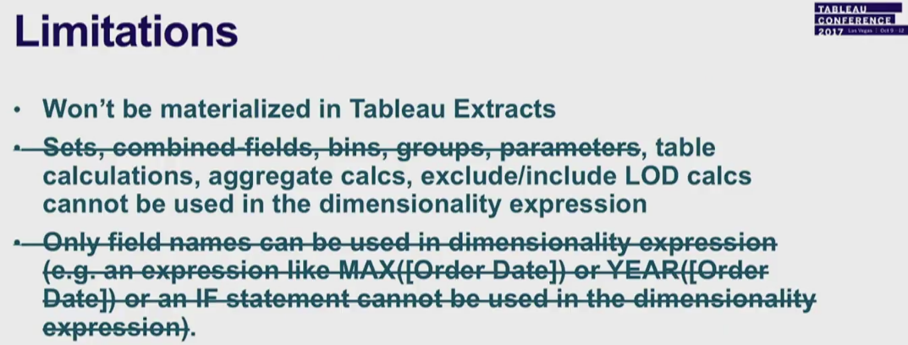



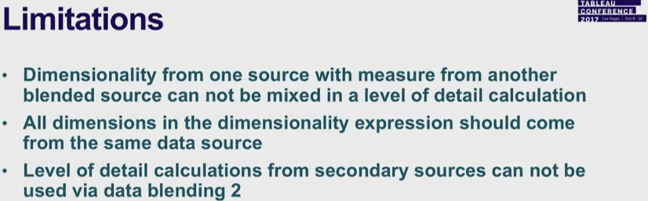

## WHEN SHOULD WE USE WHAT?

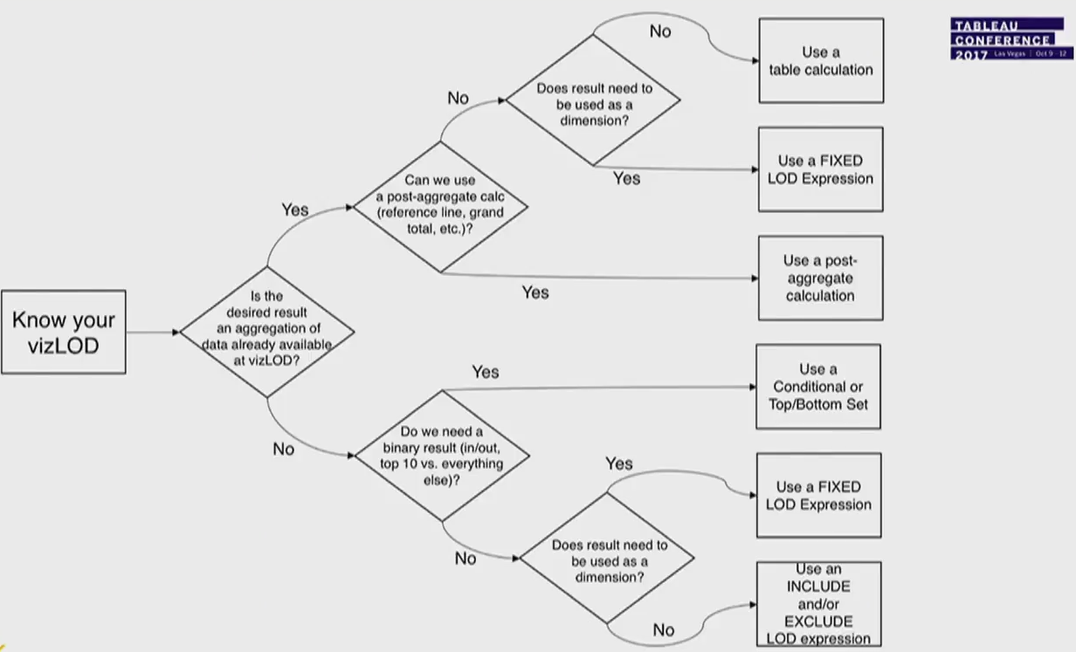

# FILTERS

Type of filters we get depends on whether we have filter for a green pill or a blue pill. If we have to create a filter for green pill then it will have a range slider. If we create a filter for a blue pill feature then it will have a list of values (checkbox or dropdown list).

We can broadly divide the filters in tableau into 2 categories

* Global filters
* Accessible filters

Global filters are applied to the complete workbook and includes:

* Extract filters
* Data source filters

Accessible filters are applied to each individual sheet and include:

* Context filters
* Dimension filters
* Measure filters

Tableau performs actions on your view in a very specific order; this is called the Order of Operations. Filters are executed in the following order:

1. Extract filters
2. Data source filters
3. Context filters
4. Filters on dimensions (whether on the Filters shelf or in filter cards in the view).
5. Filters on measures (whether on the Filters shelf or in filter cards in the view).

## EXTRACT FILTER

To extract a subset of data from the data source, you can create filters which will return only the relevant rows.

Let’s consider the Sample Superstore data set and create an extract. In the filter option, choose Select from list and tick mark the checkbox value for which you need to pull the data from the source.

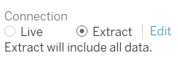

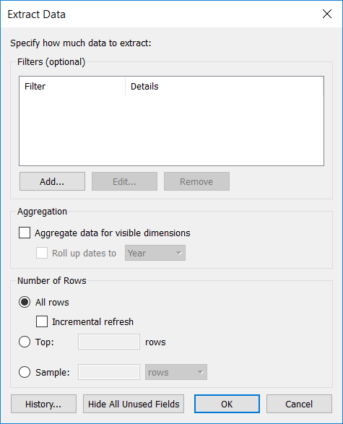

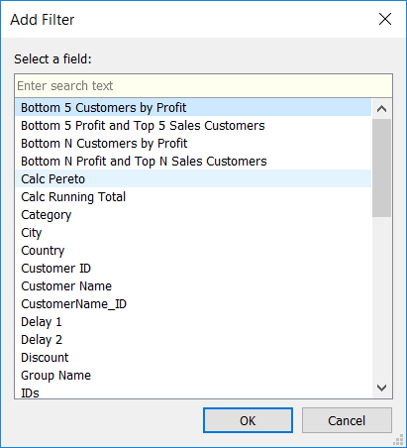

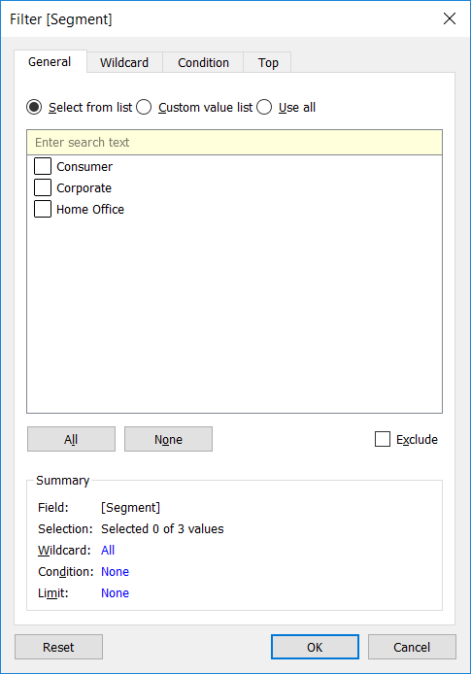

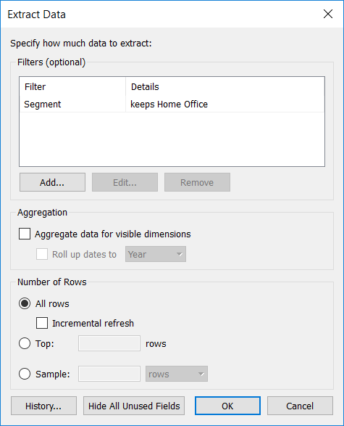

## DATA SOURCE FILTER

You can create filters on a data source, thereby reducing the amount of data in the data source.

* If you create an extract from a data source that already has data source filters in place, those filters are automatically recommended as extract filters, and will appear in the Extract dialog.
* Data source filters can be useful for restricting the data users can see when you publish a workbook or data source.
* When you publish a data source to Tableau Server, the data source and any associated files or extracts are transported in entirety to the Server. As you publish a data source you can define access permissions for downloading or modifying the data source, and you can also choose the users and groups who can remotely issue queries through Tableau Server against that data source.
* When users have query permission and no download permission, you can share a rich data model having calculated fields, aliases, groups, sets and more—but only for querying.

Furthermore, users who query published data source will never be able to see or modify any data source filters present on the originally published data source, but all of the users' queries will be subject to those data source filters.

This is a great way to offer a restricted subset of your data, for example by filtering dimensions for specific users and groups, or by defining data source filters based on a fixed or relative date range.

The primary way to create a data source filter is from the data source page.

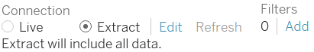

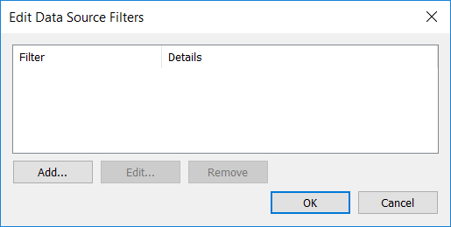

When you create a data source filter, any global filters that use that data source are displayed automatically in the Edit Data Source Filters dialog box to make it easy for you to promote a global filter to be a data source filter. To promote the global filter to be a data source filter, click OK.

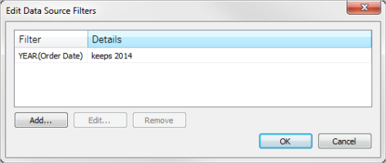

* If you promote a global filter to be a data source filter, that global filter will no longer be visible in worksheets of the workbook (because it becomes a data source filter).
* Be aware that you do not need to select a global filter in the Edit Data Source Filters dialog box to promote it. When you click OK, all global filters in the list will be promoted.
* To prevent a global filter from being promoted to a data source filter, select the global filter in the Edit Data Source Filters dialog box, and then click Remove.

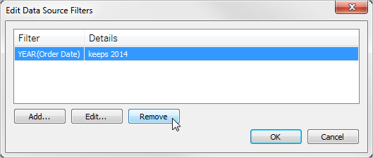

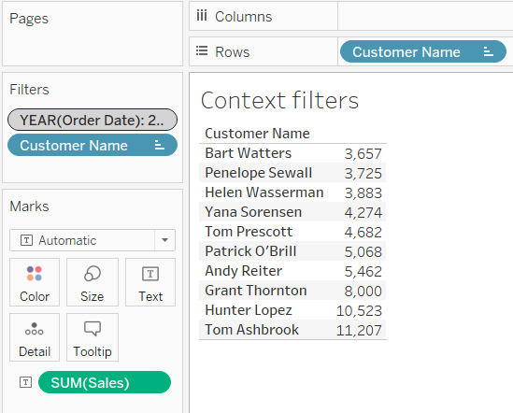

## CONTEXT FILTERS

By default, all filters that you set in Tableau are computed independently. That is, each filter accesses all rows in your data source without regard to other filters. However, you can set one or more categorical filters as context filters for the view. When you define a filter as context filter any other filters that you set are defined as dependent filters because they process only the data that passes through the context filter.

You may create a context filter to:

* Improve performance – If you set a lot of filters or have a large data source, the queries can be slow. You can set one or more context filters to improve performance.
* Create a dependent numerical or top N filter – You can set a context filter to include only the data of interest, and then set a numerical or a top N filter.

The below example shows a Context filter for Year (OrderDate). It is used to show top 10 customers by sales for each year.

## DIMENSION FILTER

Dimensions contain discrete categorical data, so filtering this type of field generally involves selecting the values to include or exclude.

When you drag a dimension from the Data pane to the Filters shelf in Tableau Desktop, the following Filter dialog box appears:

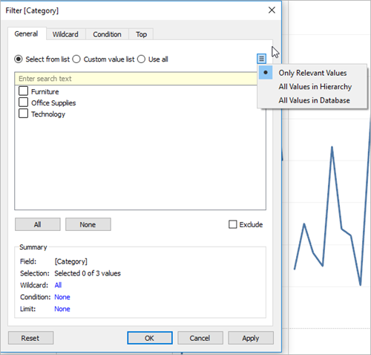

There are four tabs in the dialog box:

* **General**

Use the General tab to select the values you want to include or exclude.

* **Wilcard**

Use the Wildcard tab to define a pattern to filter on. For example, when filtering on email addresses you might want to only include emails from a specific domain. You can define a wildcard filter that ends with "@gmail.com" to only include Google email addresses.

* **Condition**

Use the Condition tab in the Filter dialog box to define rules to filter by. For example, in a view showing the average Unit Price for a collection of products, you may want to only show the Products that have an average unit price that is greater than or equal to $25. You can use the built-in controls to write a condition or you can write a custom formula.

* **Top**

Use the Top tab in the Filter dialog box to define a formula that computes the data that will be included in the view. For example, in a view that shows the average Time to Ship for a collection of products, you can decide to only show the top 15 products by Sales. Rather than having to define a specific range for Sales (e.g., greater than $100,000), you can define a limit (top 15) that is relative to the other members in the field (products).

## MEASURE FILTER

Measures contain quantitative data, so filtering this type of field generally involves selecting a range of values that you want to include.

When you drag a measure from the Data pane to the Filters shelf in Tableau Desktop, the following dialog box appears:

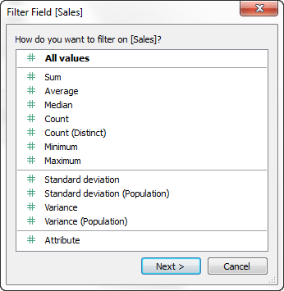

Select how you want to aggregate the field, and then click Next.

* **Range of Values**

Select the Range of Values option to specify the minimum and maximum values of the range to include in the view. The values you specify are included in the range.

* **At Least**

Select the At Least option to include all values that are greater than or equal to a specified minimum value. This type of filter is useful when the data changes often so specifying an upper limit may not be possible.

* **At Most**

Select the At Most option to include all values that are less than or equal to a specified maximum value. This type of filter is useful when the data changes often so specifying a lower limit may not be possible.

* **Special (Tableau Desktop only)**

Select the Special option to filter on Null values. Include only Null values, Non-null values, or All Values.

If you have a large data source, filtering measures can lead to a significant degradation in performance. It is sometimes much more efficient to filter by creating a set containing the measure and then apply a filter to the set

## DATES FILTER

When you drag a date field from the Data pane to the Filters shelf in Tableau Desktop, the following Filter Field dialog box appears:

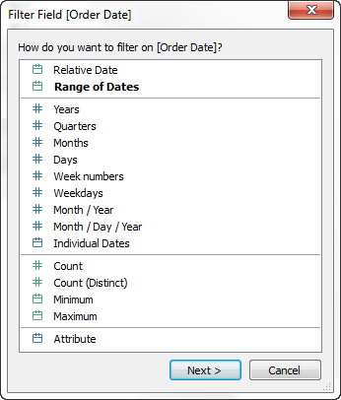

You can select whether you want to filter on a relative date; filter between a range of dates; or select discrete dates or individual dates to filter from the view.

* **Filter relative dates**

Click Relative dates to define a range of dates that updates based on the date and time you open the view. For example, you may want to see Year to Date sales, all records from the past 30 days, or bugs closed last week. Relative date filters can also be relative to a specific anchor date rather than today.

* **Filter a range of dates**

Select Range of dates to define a fixed range of dates to filter. For example, you may want to see all orders placed between March 1, 2009 and June 12, 2009.

* **Filter discrete dates**

Select a discrete date value in the dialog box if you want to include entire date levels. For example, if you select Quarters, you can choose to filter specific quarters (e.g. Q1, Q2, Q3, Q4) from your view, regardless of the year.

**Latest date preset:** If you want to ensure that only the most recent date in a data source is selected in the filter when the workbook is shared or opened, select a discrete date such as Month/Day/Year or Individual Dates and then, on the General tab, select Filter to latest date value when workbook is opened.

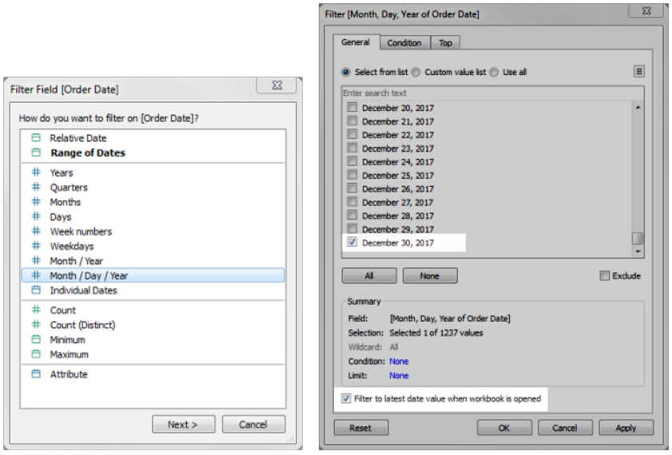

NOTE:

When you filter to the latest date value, this setting applies only to data source filters in a workbook.

In the order of operations, the latest date filter is global to the workbook, while context filters apply per worksheet. The latest date is determined just after the workbook opens for first use, after data source filters, but before context filters. At that point the date is set, and the latest date preset is used as a dimension filter.

If you are using additional filters in views (including relative date filters and context filters), the latest date value setting may result in an empty view with no data when those additional filters do not select data from the latest date in the database.

## TABLE CALCULATIONS FILTER

To create a table calculation filter, create a calculated field, and then place that field on the Filters shelf.

Filters based on table calculations do not filter out underlying data in the data set, because table calculation filters are applied last in the order of operations. This means Tableau evaluates any table calculations in the view first, and then applies table calculation filters on the results in the current view.

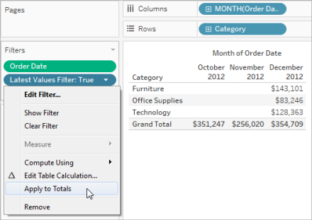

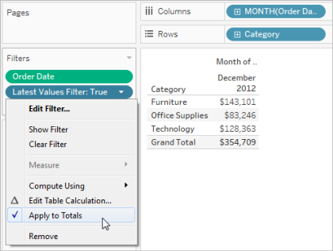

This option is available when you show totals in the view, and you add a table calculation filter to the view. Select Apply to totals to apply the table calculation filter to all of the results in the table, including the totals.

## SELECTION FILTER

When we save workbook, tableau saves a list of values in each column. So, if we want to filter a column such that only selected values appear, we can make use of this internal list by creating a selection filter.

Selection filter is same like dimension filter where in we add the dimension to the filter shelf and then select the feature values to show on the viz based on General tab (Select from list / Custom value list / Use all).

## MANUAL FILTERING

We can filter individual data points (marks), or a selection of data points from your view using Include and Exclude option. For example, if you have a scatter plot with outliers, you can exclude them from the view so you can better focus on the rest of the data.

To filter marks from the view, select a single mark (data point) or click and drag in the view to select several marks.

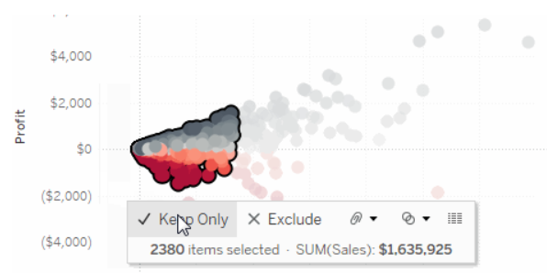

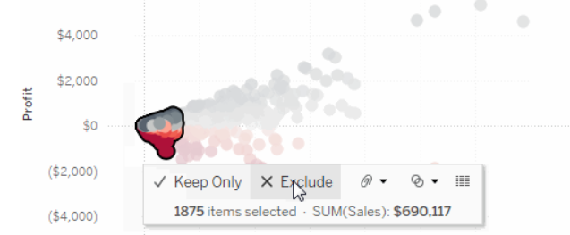

To filter entire rows or columns of data from your view, select the header in the view. On the tooltip that appears, select to Exclude or Keep Only the selected data.

## FILTER CARD OPTIONS

Here are some of the general filter card options:

* **Edit Filter** - This option opens the main Filter dialog box so you can further refine the filter by adding conditions and limits.
* **Remove Filter**- Removes the filter from the Filters shelf and removes the filter card from the view.
* **Apply to worksheets** - Allows you to specify whether the filter should apply to only the current worksheet or be shared across multiple worksheets. For more information, see Apply Filters to Multiple Worksheets.
* **Format Filters** - Customize the font and colors of all your filter cards in the view.
* **Only relevant values** - Specifies which values to show in the filter. When you select this option, other filters are considered and only values that pass these filters are shown. For example, a filter on State will only show the Eastern states when a filter on Region is set. You can use the toggle at the top of the filter card to switch between this option and the All Values in Database option.
* **All values in hierarchy** - Specifies which values to show in the filter. When you create a filter from a hierarchical field, this option is selected by default. Filter values are displayed based on relevance of the parent/child relationships in the hierarchy.
* **All values in database** - Specifies which values to show in the filter. When you select this option all values in the database are shown regardless of the other filters on the view.
* **All values in context** - When one of the filters in the view is a context filter, select this option on a different filter to only display values that pass through the context filter. For more information, see Improve View Performance with Context Filters.
* **Include values** - When this option is selected, the selections in the filter card are included in the view.
* **Exclude values** - When this option is selected, the selections in the filter card are excluded from the view.
* **Hide Card** - Hides the filter card but does not remove the filter from the Filters shelf.

## FILTERS ON WORKSHEET

This option only applies to the current worksheet. This option is selected by default when you create new filters. Filters that are local to the current worksheet are shown without any additional icons.

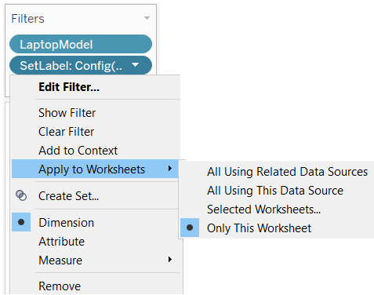

This option applies the filter to all worksheets in the dashboard that use the same data source or related data sources as their primary data source.

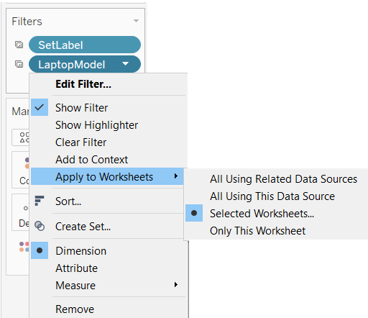

In previous versions of Tableau Desktop, the All Using This Data Source option was called Make Global and the Only This Worksheet option was Make Local.

## ALL USING RELATED DATA SOURCE

This is a new feature in tableau 10 wherein we can use this option to apply filters across multiple datasources. Earlier we used to achieve cross database filters using parameters and calculated fields but now we can use ‘All using related data sources’ option.

Suppose we have a

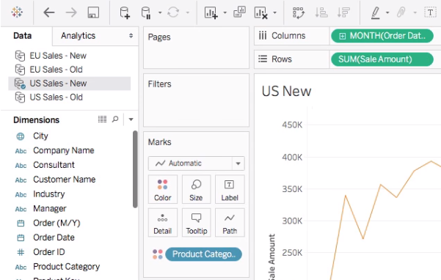

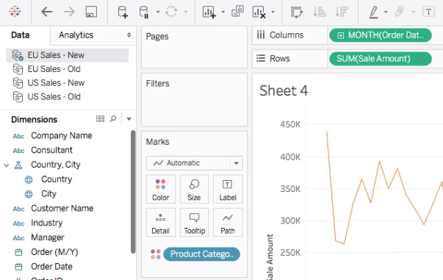

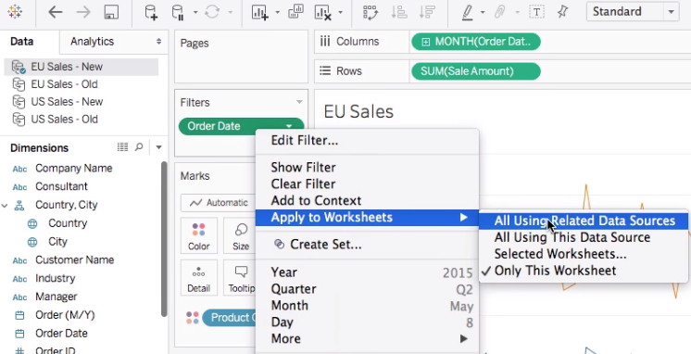

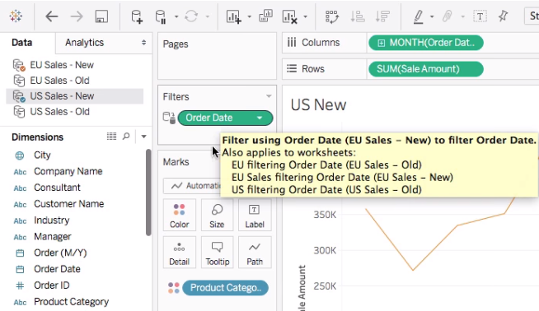

So, when these sheets are used on the dashboard, they have a common filter based on Order date and data on both the views works in sync.

## ALL USING THIS DATA SOURCE

When this option is used, filters is applied to all the sheets using the filed on the workbook.

# SETS VS FILETRS

**FILTER:** A dimension or measure that narrows the data shown in a view to focus on relevant information.

**SET:** A subset of your data that meets certain conditions based on existing dimensions.

Filters only apply to the current worksheet. Sets can be used again and again throughout the workbook. Since sets become part of the metadata, any workbook connected through that Saved Data Source (or .tds file) can also utilize its functionality. Using sets maintains consistency and saves time. They can also be combined to create an even more specific subset of the data.

# SORT DATA

There are many ways to sort data in a visualization in Tableau. This article demonstrates all the ways to sort data in a visualization.

## SORT DATA ON AN AXIS

A quick way to sort data is to use the sort buttons on an axis.

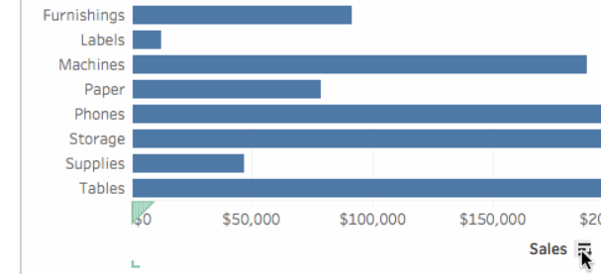

The sort will update correctly if the underlying data changes.

## CUSTOM SORT

To sort a specific field in the visualization:

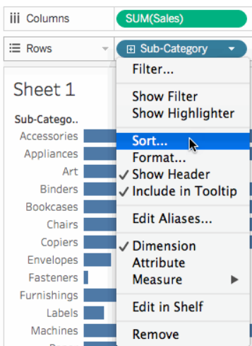

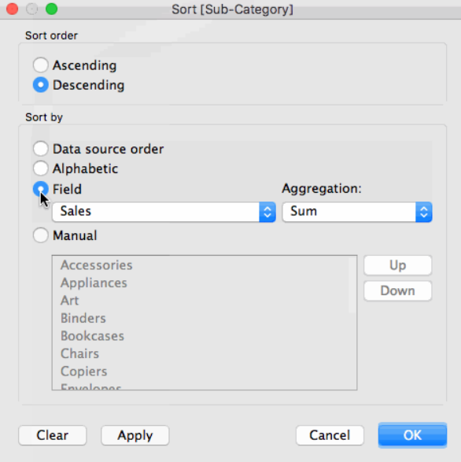

You should keep the following rules in mind when interpreting the sort results:

* Tableau computes the sort across the entire table using the specified criteria.
* Sorts do not break the dimension hierarchy. Sorted fields are always displayed within the ordered context already set forth by the fields on the Rows and Columns shelves. This means that Tableau will not rearrange any of the headers of the fields that appear before (to the left of) the sorted field.

If you want to break the dimension hierarchy when sorting a multidimensional data source, place only the hierarchy level that you want sorted on the Rows or Columns shelf.

Custom sort is retained.

## SORT USING TOOLBAR

You can quickly sort data in ascending or descending order using the toolbar

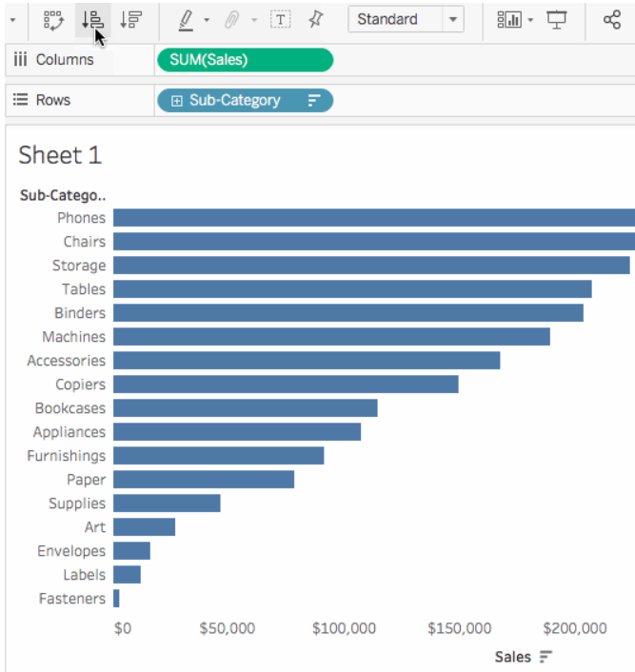

## MANUAL SORT

You can manually sort data in your visualization by dragging and dropping members in a header or legend, such as a color or shape legend.

To manually sort data using a header:

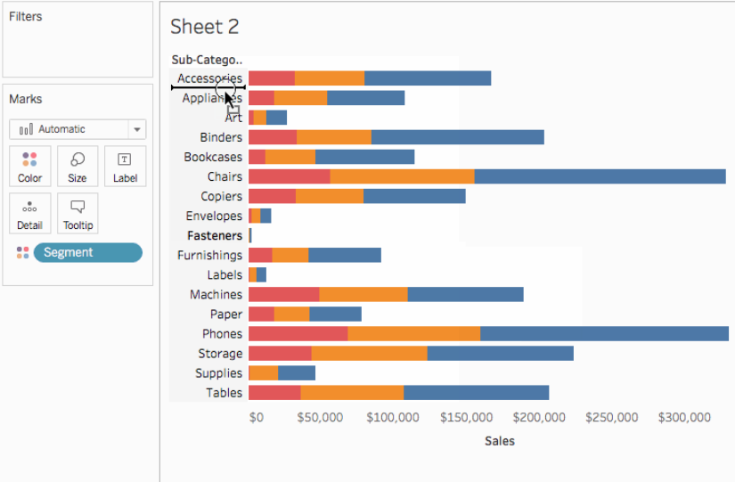

To manually sort data using a legend:

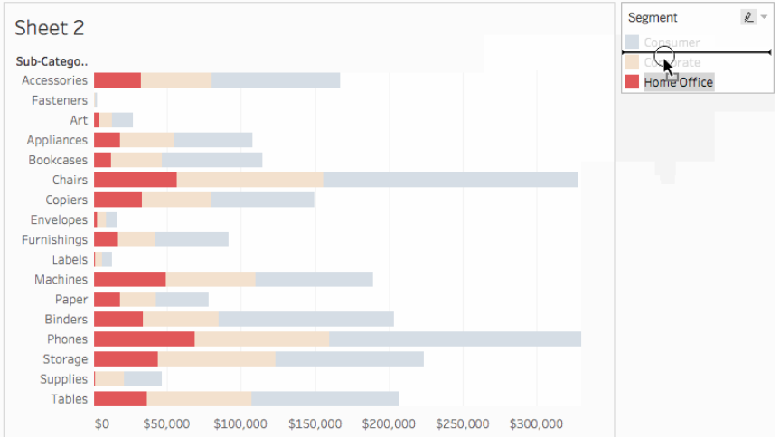

## NESTED SORT

With the release of Tableau Desktop 2018.2, you can now create a nested sort without any additional calculated fields or combined dimensions.

Suppose you are looking at sales sub-categories for all regions in your country. In the view below, you can see that the Central region sells more products in the Chairs subcategory than any other subcategory. However, it's harder to compare how Chairs ranked in other regions.

To see which subcategories ranked the highest in each region, you might want to sort the subcategories within each region instead. You can do this with nested sorting.

Click the sort icon that appears at the top of the view.

One click sorts the data in ascending order. Two clicks sort it in descending order. Three clicks clear the sort.

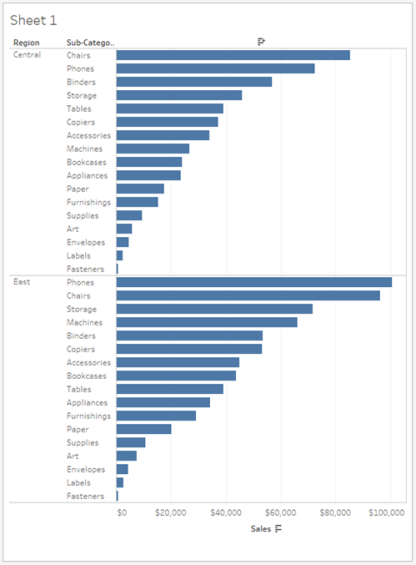

Now you have a nested sort where the subcategories are listed in descending order of sum of sales within each region. You can see that Chairs are the highest selling subcategory in the Central region, but in the East region, Phones are the bestselling product; Chairs are the second-best selling product.

# CALCULATED FIELDS

Calculated fields allow you to create new data from data that already exists in your data source. When you create a calculated field, you are essentially creating a new field (or column) in your data source, the values or members of which are determined by a calculation that you control. This new calculated field is saved to your data source in Tableau, and can be used to create more robust visualizations. But don't worry: your original data remains untouched.

You can use calculated fields for many, many reasons. Some examples might include:

* To segment data
* To convert the data type of a field, such as converting a string to a date.
* To aggregate data
* To filter results
* To calculate ratios

You create calculated fields using calculations. There are three main types of calculations you can use to create calculated fields in Tableau:

* Basic calculations - Basic calculations allow you to transform values or members at the data source level of detail (a row-level calculation) or at the visualization level of detail (an aggregate calculation).
* Level of Detail (LOD) expressions - Just like basic calculations, LOD calculations allow you to compute values at the data source level and the visualization level. However, LOD calculations give you even more control on the level of granularity you want to compute. They can be performed at a more granular level (INCLUDE), a less granular level (EXCLUDE), or an entirely independent level (FIXED) with respect to the granularity of the visualization.
* Table calculations - Table calculations allow you to transform values at the level of detail of the visualization only.

We can create calculated filed via 

This formula checks if sales is not equal to zero. If true, it returns the discount ratio (Discount/Sales); if false, it returns zero.

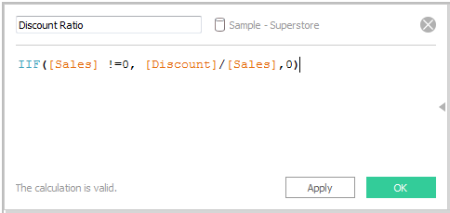

The new calculated field is added to Measures in the Data pane because it returns a number. An equal sign (=) appears next to the data type icon. All calculated fields have equal signs (=) next to them in the Data pane.

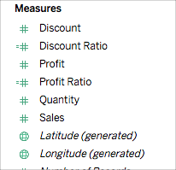

## WHICH CALCULATION IS RIGHT?

Choosing the type of calculation to use for your analysis is not always easy. When trying to decide, consider the following questions and examples.

* If the answer is yes: You can use a table calculation.
* If the answer is no: Use a basic calculation.

Basic expression or table calculation?

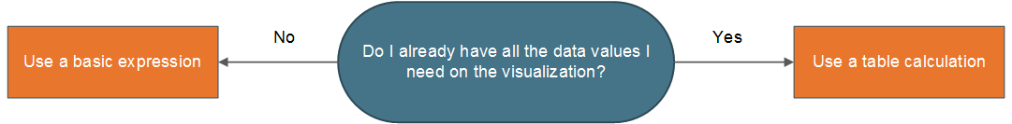

Basic expression or Level of Detail (LOD) expression?

Does the granularity of your question match either the granularity of the visualization or the granularity of the data source?

* If the answer is yes: Use a basic expression.
* If the answer is no: Use a Level of Detail (LOD) expression.

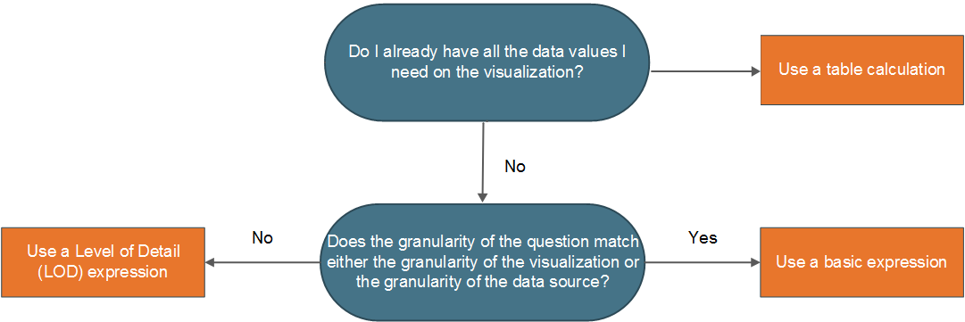

When choosing between a table calculation or an LOD calculation, the process is very similar to choosing between a table calculation and a basic expression. Ask yourself the following questions:

Do you already have all the data values you need on the visualization?

If the answer is Yes, then use a table calculation.

If the answer is No, then ask yourself: Does the granularity of the question match either the granularity of the visualization or the granularity of the data source? If the answer is No, then use an LOD calculation.



There are some scenarios where only a table calculation will do. These include:

* Ranking
* Recursion (e.g. cumulative totals)
* Moving calculations (e.g. rolling averages)
* Inter-row calculations (e.g. period vs. period calculations)

# FUNCTIONS

Tableau supports many functions for use in Tableau calculations.

## NUMBER FUNCTIONS

Returns the expression if it is not null, otherwise returns zero. Use this function to use zero values instead of null values.





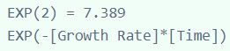



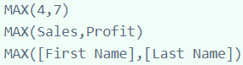

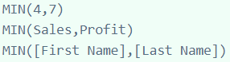

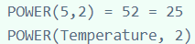







## STRING FUNCTIONS

String functions allow you to manipulate string data (i.e. data made of text).





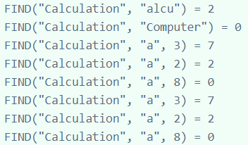













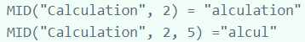









When -ve number is satisfied, tokens are counted from left

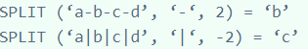







## DATE FUNCTIONS

We can find the date part for any existing date value using DATETRUNC



So, if the original date is '3/27/2011', using the above calculation would return '1/1/2011' to indicate that Q1 started on January 1. If the original date is '5/3/2011', then the calculation would return '4/1/2011' to indicate that Q2 started on April 1, four months into the year.







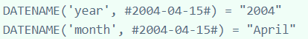

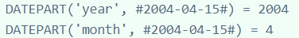



















## TYPE CONVERSION

Returns a date given a number, string, or date expression.

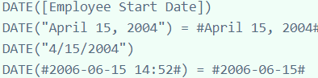

Returns a datetime given a number, string, or date expression.



Casts its argument as a floating-point number.



Casts its argument as an integer.

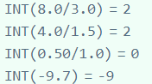

Casts its argument as a string.



## LOGICAL FUNCTIONS

Logical calculations allow you to determine if a certain condition is true or false (boolean logic).





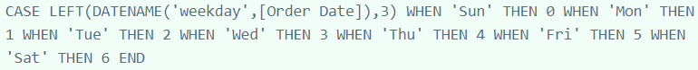





















## AGGREGATION FUNCTIONS

Other functions are already mentioned in the doc (like sum, avg, count etc).

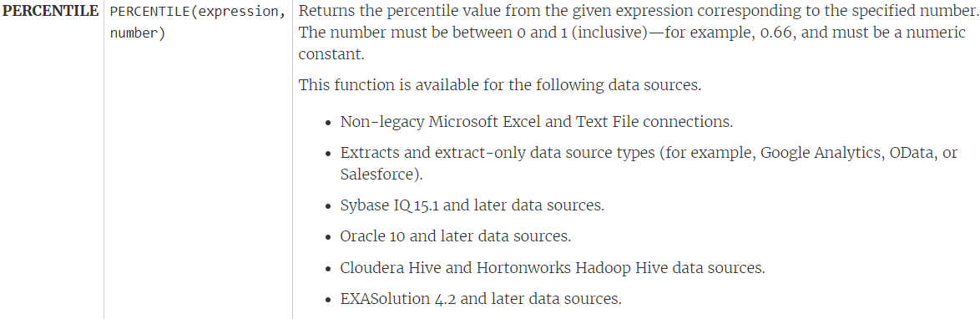

## TABLE CALCULATION FUNCTIONS

Table calculation functions allow you to perform computations on values in a table.

* FIRST ()

Returns the number of rows from the current row to the first row in the partition. For example, the view below shows quarterly sales. When FIRST () is computed within the Date partition, the offset of the first row from the second row is -1.

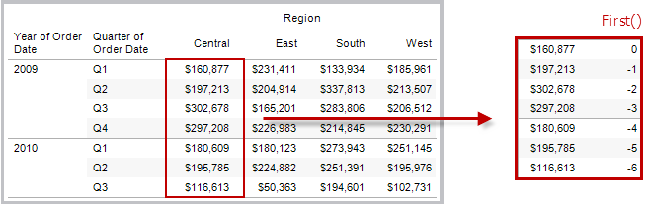

* INDEX ()

Returns the index of the current row in the partition, without any sorting with regard to value. The first-row index starts at 1. For example, the table below shows quarterly sales. When INDEX () is computed within the Date partition, the index of each row is 1, 2, 3, 4..., etc.

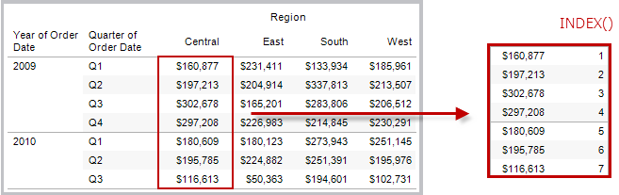

* LAST ()

Returns the number of rows from the current row to the last row in the partition. For example, the table below shows quarterly sales. When LAST () is computed within the Date partition, the offset of the last row from the second row is 5.

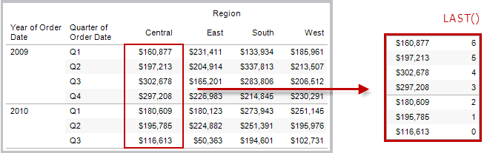

* LOOKUP (EXPRESSION, [OFFSET])

Returns the value of the expression in a target row, specified as a relative offset from the current row. Use FIRST () + n and LAST () - n as part of your offset definition for a target relative to the first/last rows in the partition. If offset is omitted, the row to compare to can be set on the field menu. This function returns NULL if the target row cannot be determined.

The view below shows quarterly sales. When LOOKUP (SUM(Sales), 2) is computed within the Date partition, each row shows the sales value from 2 quarters into the future.

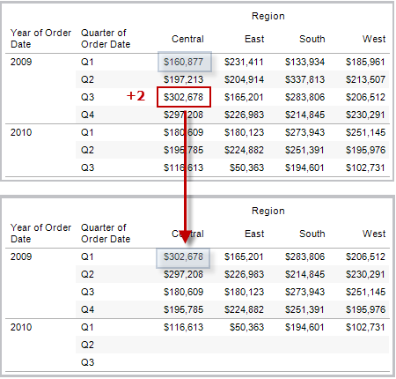

* PREVIOUS_VALUE

Returns the value of this calculation in the previous row. Returns the given expression if the current row is the first row of the partition.



* RANK ()

Returns the standard competition rank for the current row in the partition. Identical values are assigned an identical rank. Use the optional 'asc' | 'desc' argument to specify ascending or descending order. The default is descending.

With this function, the set of values (6, 9, 9, 14) would be ranked (4, 2, 2, 1).

Nulls are ignored in ranking functions. They are not numbered and they do not count against the total number of records in percentile rank calculations.

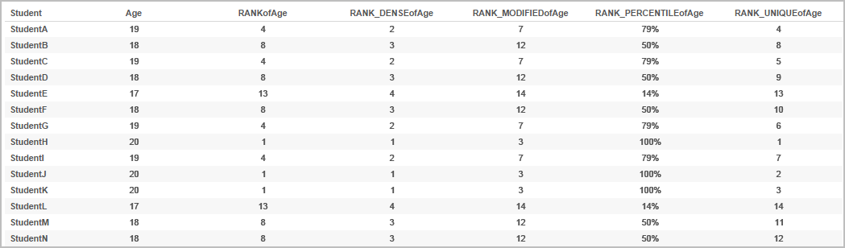

* RUNNING_AVG

Returns the running average of the given expression, from the first row in the partition to the current row.

The view below shows quarterly sales. When RUNNING_AVG(SUM([Sales]) is computed within the Date partition, the result is a running average of the sales values for each quarter.

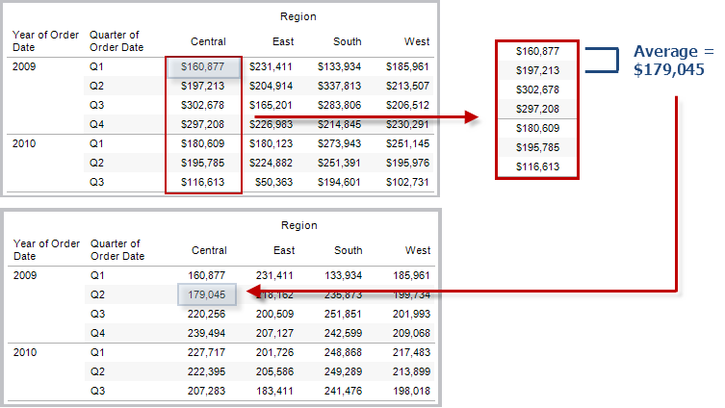

* RUNNING_COUNT

Returns the running count of the given expression, from the first row in the partition to the current row.

* RUNNING_MAX

Returns the running maximum of the given expression, from the first row in the partition to the current row.

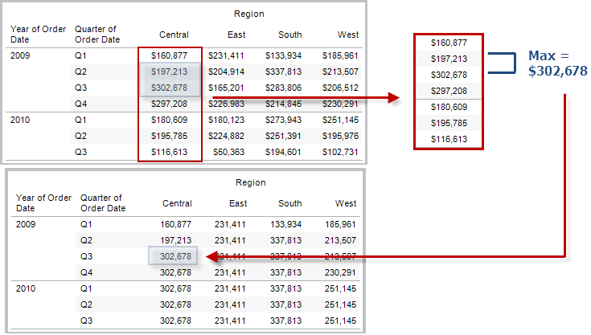

* RUNNING_MIN

Returns the running minimum of the given expression, from the first row in the partition to the current row.

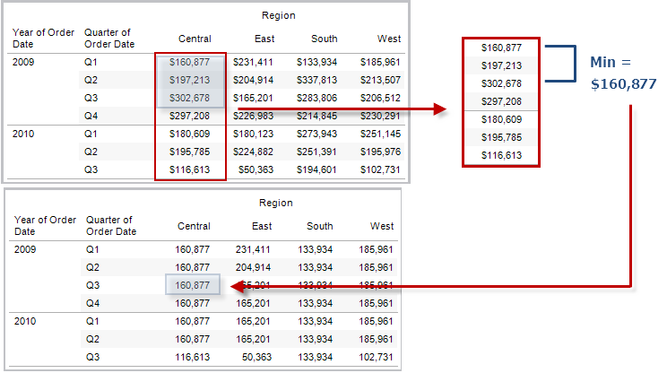

* RUNNING_SUM

Returns the running sum of the given expression, from the first row in the partition to the current row.

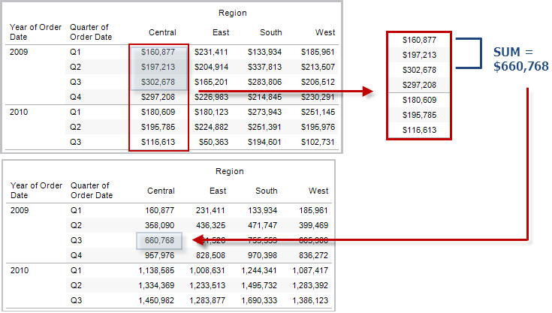

* TOTAL

Returns the total for the given expression in a table calculation partition.

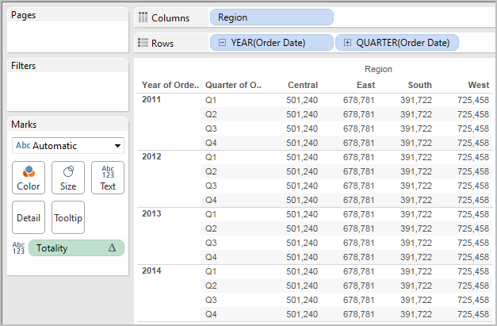

* WINDOW_AVG

Returns the average of the expression within the window. The window is defined by means of offsets from the current row. Use FIRST () + n and LAST () -n for offsets from the first or last row in the partition. If the start and end are omitted, the entire partition is used.

For example, the view below shows quarterly sales. A window average within the Date partition returns the average sales across all dates.

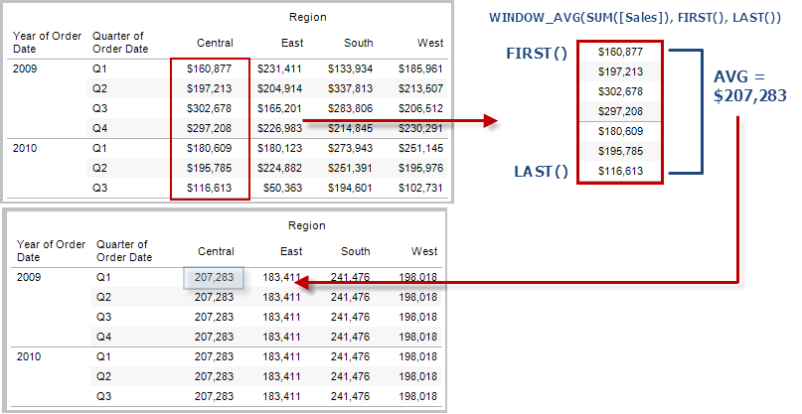

* WINDOW_COUNT

Returns the count of the expression within the window. The window is defined by means of offsets from the current row. Use FIRST () + n and LAST () - n for offsets from the first or last row in the partition. If the start and end are omitted, the entire partition is used.

* WINDOW_MEDIAN

Returns the median of the expression within the window. The window is defined by means of offsets from the current row. Use FIRST () + n and LAST () - n for offsets from the first or last row in the partition. If the start and end are omitted, the entire partition is used.

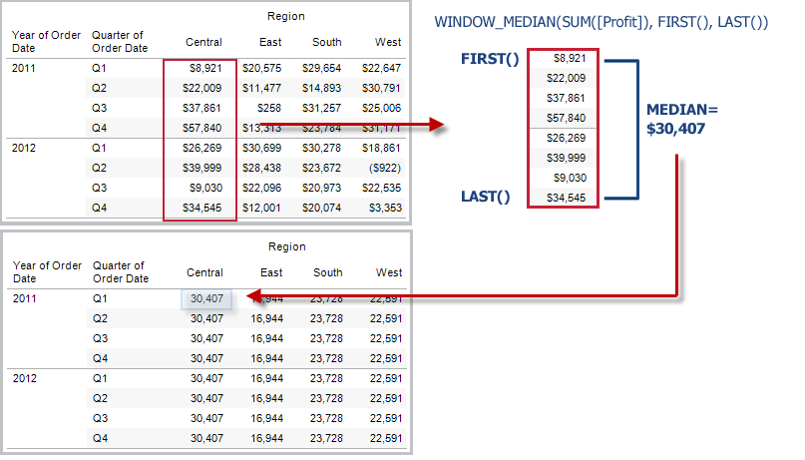

* WINDOW_MAX

Returns the maximum of the expression within the window. The window is defined by means of offsets from the current row. Use FIRST () + n and LAST () - n for offsets from the first or last row in the partition. If the start and end are omitted, the entire partition is used.

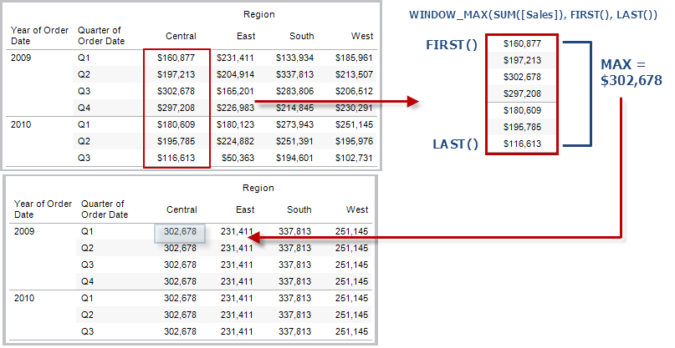

* WINDOW_MIN

Returns the minimum of the expression within the window. The window is defined by means of offsets from the current row. Use FIRST () + n and LAST ()-n for offsets from the first or last row in the partition. If the start and end are omitted, the entire partition is used.

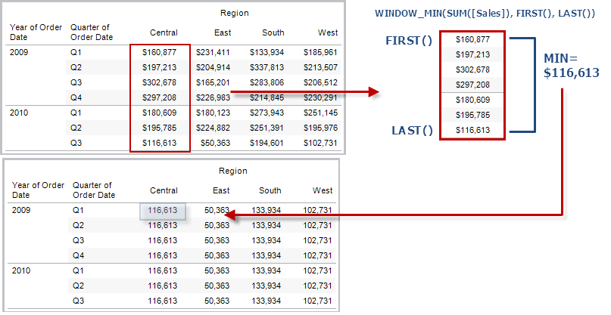

* WINDOW_SUM

Returns the sum of the expression within the window. The window is defined by means of offsets from the current row. Use FIRST () + n and LAST () - n for offsets from the first or last row in the partition. If the start and end are omitted, the entire partition is used.

For example, the view below shows quarterly sales. A window sum computed within the Date partition returns the summation of sales across all quarters.

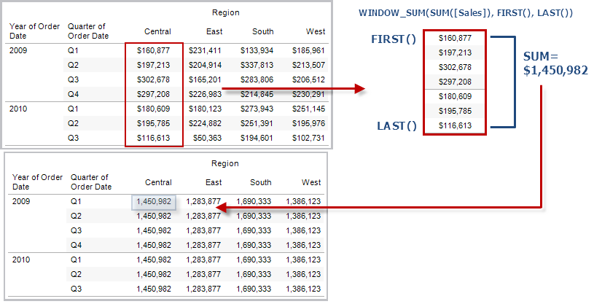

# PERCENTAGES

Any analysis in Tableau can be expressed in terms of percentages. For example, rather than viewing sales for every product, you might want to view each product’s sales as a percentage of the total sales for all products.

There are two factors that contribute to the percentage calculation:

* The data to which you compare all percentage calculations: - The comparison can be based on the entire table, a row, a pane, and so on. By default, Tableau uses the entire table. The figure below is an example of a text table with percentages. The percentages are calculated with the Sales measure aggregated as a summation, and are based on the entire table.

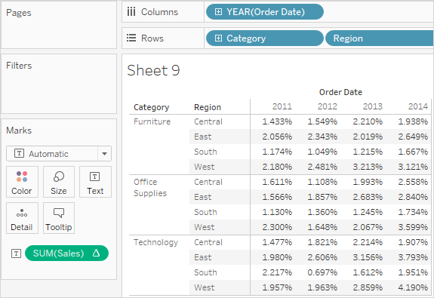

* The aggregation: - Percentages are computed on the basis of the aggregation for each measure. Standard aggregations include summation, average, and several others.

In addition to using predefined aggregations, you can use custom aggregations when calculating percentages. You define your own aggregations by creating a calculated field.

Computing a percentage involves specifying a total on which the percentage is based. The default percentage calculation is based on the entire table. You can also choose the following options:

* Percent of Table
* Percent of Column
* Percent of Row
* Percent of Pane
* Percent of Row in Pane
* Percent of Column in Pane
* Percent of Cell

## PERCENT OF TABLE

When you **select Percentage Of > Table** from the **Analysis menu**, each measure on the worksheet is expressed as a percentage of the total for the entire worksheet (table). For example, Technology in the East region accounts for 3.79% of total sales in 2014. The grand totals for rows show that 2014 accounts for 31.95% of the total sales. Summing the grand totals for rows or for columns yields 100% of the total.

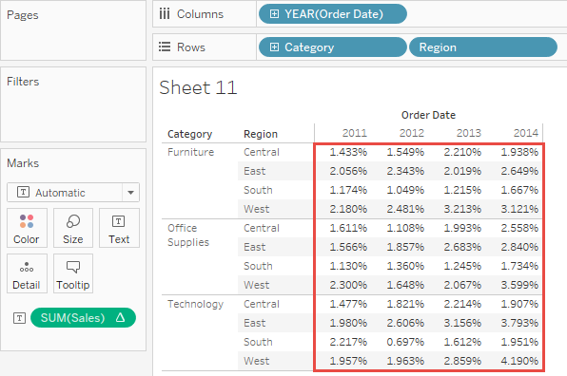

## PERCENT OF COLUMN

When you select Percentage of > Column from the Analysis menu, each measure on the worksheet is expressed as a percentage of the total for the column. The values within the red box add up to 100%.

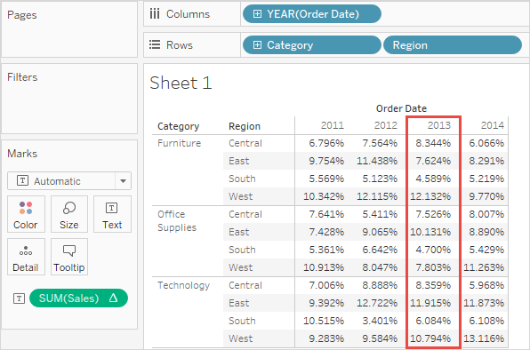

## PERCENT OF ROW

When you select Percentage of Row, each measure on the worksheet is expressed as a percentage of the total for the row. The values within the red box add up to 100%.

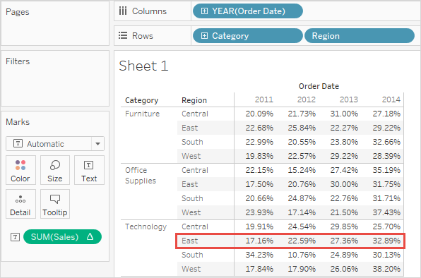

## PERCENT OF PANE

When you select Percentage of > Pane from the Analysis menu, each measure on the worksheet is expressed as a percentage of the total for the panes in the view. This option is equivalent to Percent of Table when the table consists of only a single pane.

In the following view, the red box constitutes a single pane; the values within the red box add up to 100%.

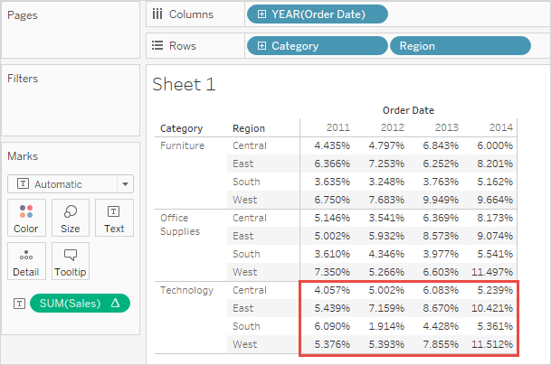

## PERCENT OF ROW IN PANE

When you select Percentage of > Row in Pane from the Analysis menu, each measure on the worksheet is expressed as a percentage of the total for a row within a pane. This option is equivalent to as Percent of Row when the table is only a single pane wide.

In the following view, the red box constitutes a row within a pane; the values within the red box add up to 100%.

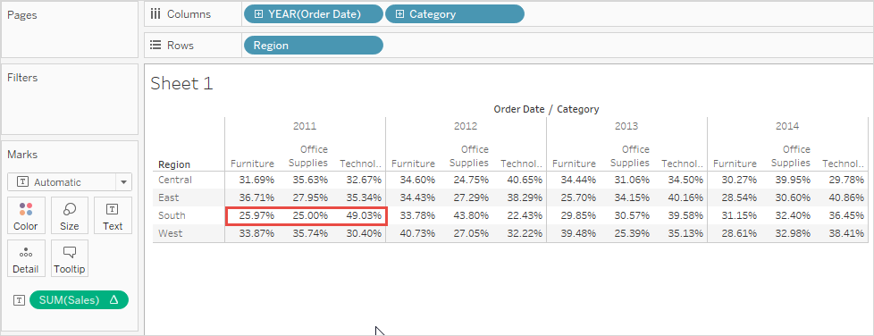

If you place Measure Names as the inner dimension on the Columns shelf (that is, the dimension farthest to the right), Tableau will return 100% for each mark because you cannot total up the values for multiple measure names. For example, you can’t total up the values for SUM(Sales) and SUM(Profit).

## PERCENT OF COLUMN IN PANE

When you select Percentage of > Column in Pane from the Analysis menu, each measure in the worksheet is expressed as a percentage of the total for a column within a pane. This option is equivalent to as Percent of Column when the table is only a single pane high.

In the following view, the red box constitutes a column within a pane; the values within the red box add up to 100%.

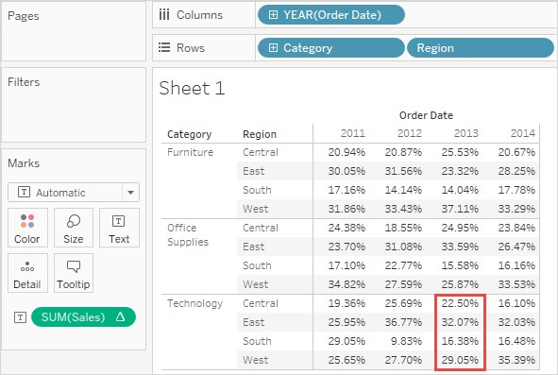

If you place Measure Names as the inner dimension on the Rows shelf (that is, the dimension farthest to the right on the shelf), Tableau will return 100% for each mark because you cannot total up the values for multiple measure names. For example, you can’t total up the values for SUM(Sales) and SUM(Profit).

## PERCENT OF CELL

When you select Percentage Of > Cell from the Analysis menu, each measure on the worksheet is expressed as a percentage of the total for each individual cell in the view. Most views show only one value per cell, in which case all cells show a percentage of 100%. But in some cases, as, for example, when you disaggregate data, a single cell can contain multiple values:

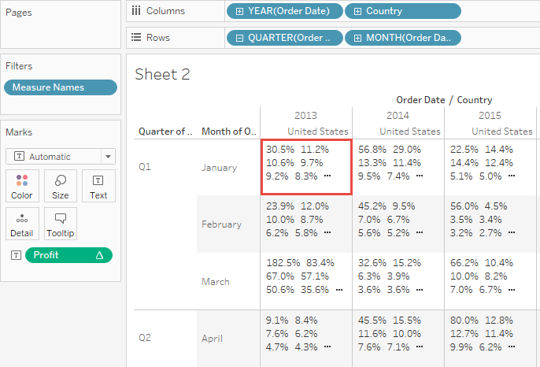

# ANALYTICS PANE

We can add constant line, average line, perform forecasting and clustering using analytics pane in Tableau.

You can add a reference line, band, distribution, or box plot to identify a specific value, region, or range on a continuous axis in a Tableau view. For example, if you are analyzing the monthly sales for several products, you can include a reference line at the average sales mark so you can see how each product performed against the average.

Tableau lets you add as many reference lines, bands, distributions, and box plots to a view as you require.

## REFERENCE LINES

You can add a reference line at a constant or computed value on the axis. Computed values can be based on a specified field. You can also include confidence intervals with a reference line.

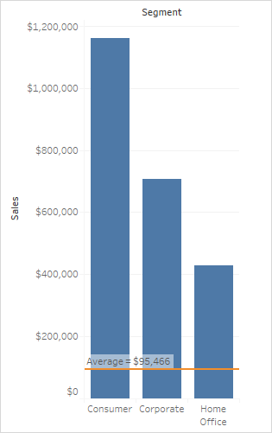

## REFERENCE BANDS

Reference bands shade an area behind the marks in the view between two constant or computed values on the axis.

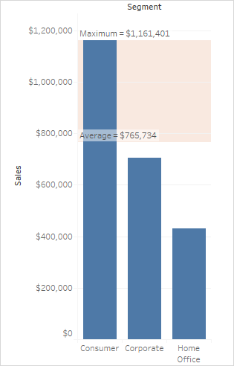

## REFERENCE DISTRIBUTIONS

Reference distributions add a gradient of shading to indicate the distribution of values along the axis. Distribution can be defined by percentages, percentiles, quantiles (as in the following image), or standard deviation.

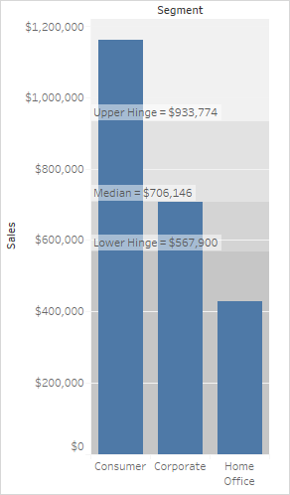

## BOX PLOTS

Box plots (also known as box and whisker charts) are a standardized graphic for describing the distribution of values along an axis. Box plots show quartiles (also known as hinges) and whiskers. Tableau provides different box plot styles, and allows you to configure the location of the whiskers and other details.

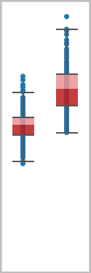

# DASHBOARD INTERACTIVE OPTIONS

There are a lot of great things you can do within Tableau Desktop to add interactivity. You can even add combinations of these elements for really cool features. They break down into four basic varieties: global filters, parameters, dashboard actions and tooltips.

* **GLOBAL FILTERS**: Let’s start with global filters, also known as universal filters. These are standard filters that are created from one of the views in your desktop and then applied to more than the original worksheet. The term global filter implies that the filter affects every single view in that dashboard, but that’s not necessarily the case. They could apply to as little as two views, the original view and another.
* **PARAMETERS:** Parameters are one of the most powerful elements in Tableau Desktop, because they can be used in a lot of different cases. Here are the main ones: calculated fields, histogram bins, reference lines, top N filters and customized table calculations. With all of these options, parameters can do all sorts of things, including completely swapping out the measures and dimensions in your view. This is how you can add multiple views within a single visualization with just a single parameter control.
* **DASHBOARD ACTIONS:** Dashboard actions are unique features for dashboards. They allow worksheets the ability to interact outside of just the domain of their view. There are three types of dashboard actions: filter actions, highlight actions and URL actions.

Filter actions allow the selections in one viz to affect others. This can even be used to navigate between different dashboards. Highlight actions allow you to emphasize the marks in other visualizations by interacting with the source worksheet. The highlight will appear in the same visual style as the Highlighter tool or clicking on a value in the color legend. Finally, a URL action will help the user navigate to a web address from within the dashboard.

Dashboard actions will run on three different runs on options: select (clicking with your mouse button), hover (moving your mouse cursor over a mark or header) and menu (a text link within the tooltip to activate the dashboard action).

* **TOOLTIPS:** Finally, tooltips are the last option for interactivity. They are also the most often ignored or forgotten. However, we can add a substantial amount of additional information into a tool tip to reward our user’s curiosity. Keep in mind that if the metric is essential to your interactor’s interests, it should probably be visualized in some format, as well as being included in the tool tip.

## ACTIONS

We have following actions available to make the dashboard interactive:

1. Filter
2. Highlight
3. URL

# NEW FEATURES IN TABLEAU 10

Below are few important features introduced in Tableau 10.

## HIGHLIGHTER

This feature was introduced in tableau 10. Suppose we have a scatter plot in which we have all the customers shown by quantity and profit.

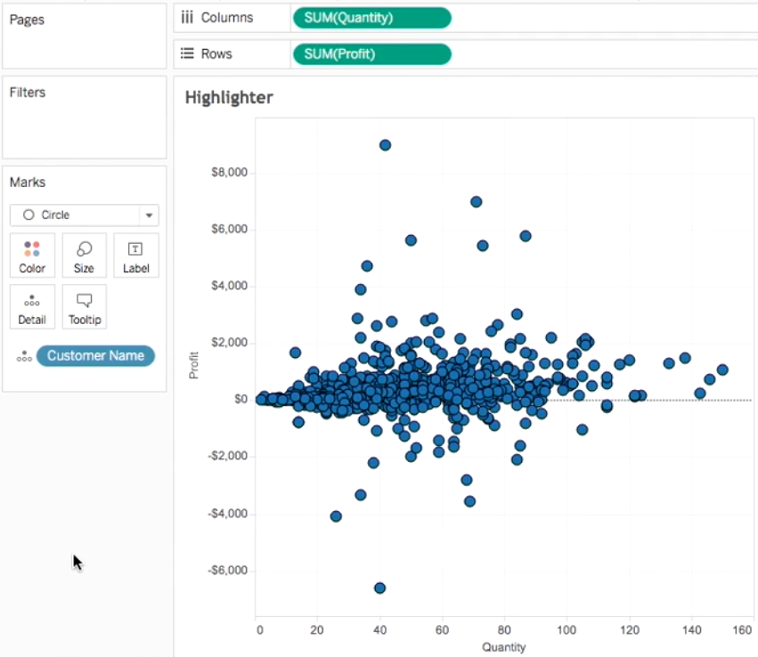

Now if we want to compare customers from a single state wrt all other states then we can use highlighter and get insights. For this we have to add states to details shelf and right click and choose show highlighter

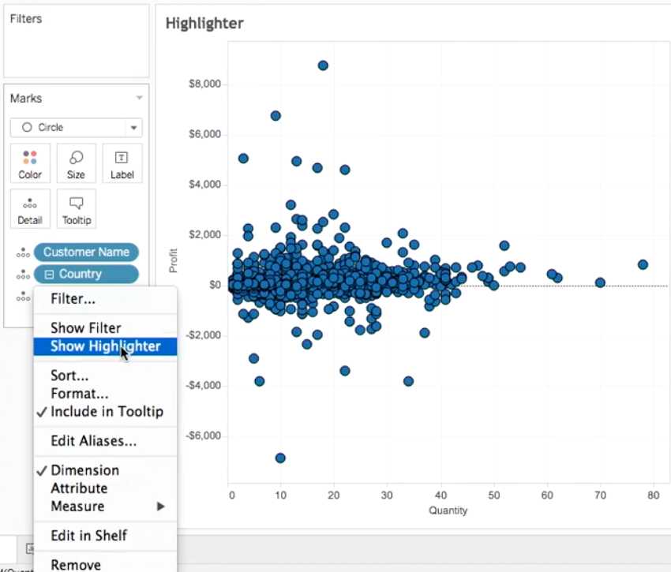

Now Ill be able to compare clients from one state wrt other states

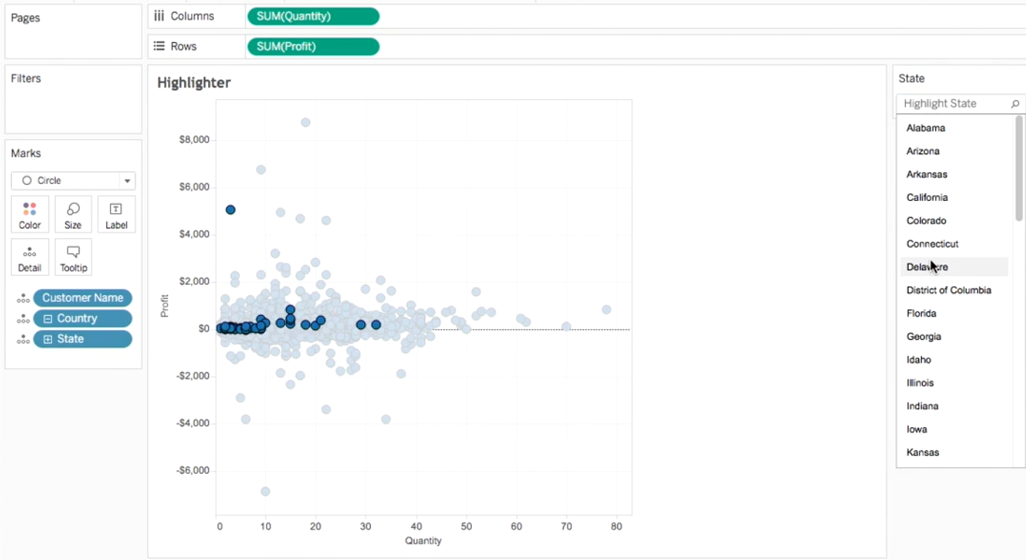

## CROSS DB FILTER

We can use relative dataset option to apply filters effect across diff sheets using diff datasources to filter data that effects both sheets even though they are getting data from diff sources having a common filed.

## CUSTOM TERRITORY

We can Group states and then create custom territories to see details at custom territory level.

## CUSTOM JOINS CALCULATION

If we want to join two data sources with no common field by default, then we can create a custom join calculation and use that field to join the sources.

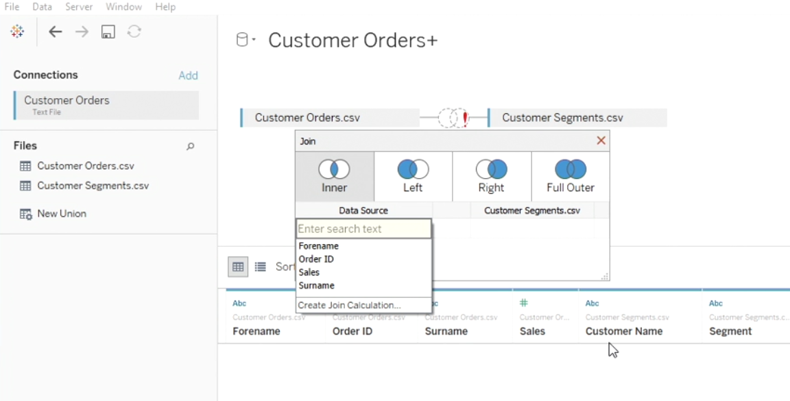

## EXPORT TRANSFORMED DATA TO CSV

In tableau 10 we can export the data to csv. It will contain all the new calculated fields that we have created as a part of the project.

## DIFFERENT COLOUR LEGENDS FOR EACH MEASURE

In tableau 10 we can have different colour legends for each measure. For this we have to choose below option as shown in the figure:

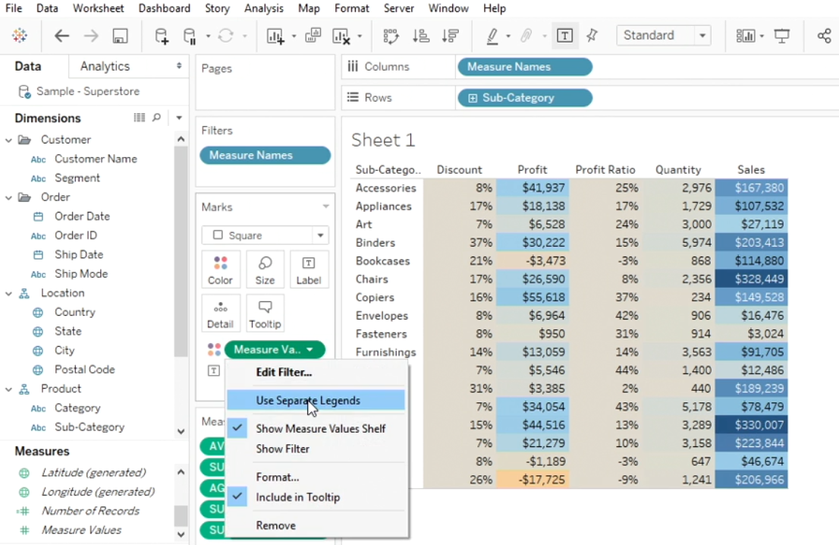

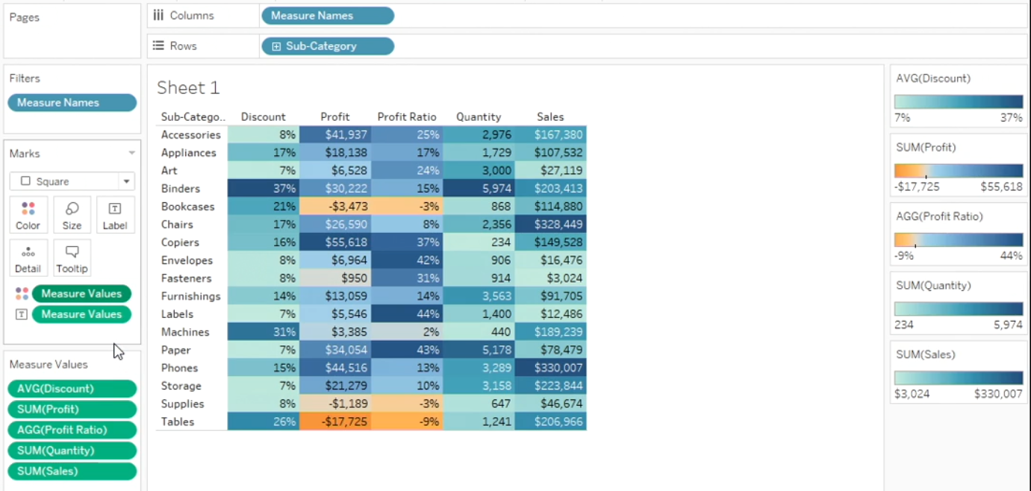

## DATA CLUSTERS

We can identify and format data clusters in tableau 10.

# MISC TOPICS

Some of imp topics related to work.

## REPLACING NULL IN TABLEAU

We can replace null literals in tableau using following methods:

### USING ALIASING

* Right click the dimension field containing Null members Select 'Edit Aliases…'
* Locate Null and change to the expected string value. Type a space for a blank.

Alternately, to right click the Null value in view and select 'Edit alias'

### IN PRIMARY DATA SOURCE

* Select Analysis > Create Calculated Field
* Name the field, enter the following calculation, and click OK:

IFNULL ([Field Containing the Null Literal], 'string to replace the null literal')

For example,

IFNULL ([Customer Name], '')

* Use the new field you created in place of the original field.

### IN SECONDARY DATA SOURCE

* From the view, select the primary data source.
* Select Analysis > Create Calculated Field
* Name the calculation, enter the following formula, then click OK:

IFNULL (ATTR ([Data Source Name].[Field Name])), 'string to replace the null literal')

For example,

IFNULL (ATTR ([Sample - Coffee Chain (Access)].[State]), '')

* Use the new field you created in place of the original field.

If asterisks are shown in the view when blending with the secondary data source, see Troubleshooting Data Blending for more information.

## SPOTLIGHTING

Spotlighting is a technique for showing discrete thresholds based on the values of a measure. For instance, you might want to colour - code sales so that those over 10,000 appear green and those below 10,000 appear red. A spotlighting calculation is just a special case of a calculation that results in a discrete measure. A discrete measure is a calculation that is a dependent variable (and therefore a measure), but which results in a discrete result (as opposed to a continuous result). Thus, the name discrete measure. Here is an example:

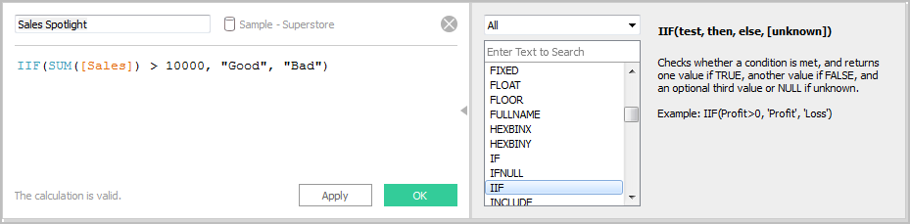

The formula in this example defines a discrete measure named Sales Spotlight. Discrete measures always appear with a blue abc icon in the Data pane. Sales Spotlight is classified as a measure in Tableau because it is a function of another measure; it is discrete because it produces discrete values (“Good” and “Bad”). Here is an example of this categorical measure in use:

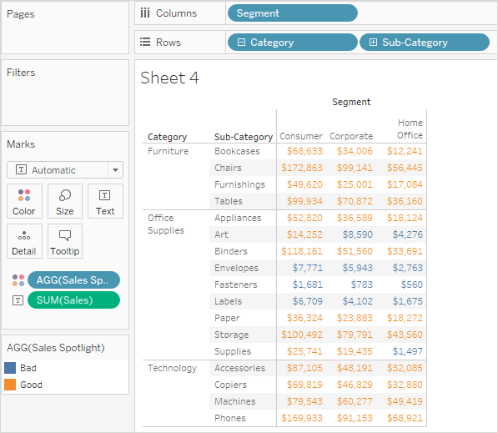

Here, Sales Spotlight is on Color in the Marks card. It appears with the AGG prefix because it is an aggregate calculation. Values above 10,000 and below 10,000 are assigned different colors.

## HEADER FOR SINGLE MEASURE

By default, if we have a single measure in tableau text table, the header for same in not displayed. To show the header, we can follow below steps:

1. Below is the view with one measure value in the text table

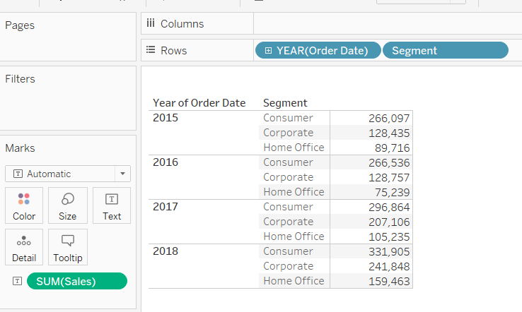

1. Add Measure Names to filter shelf, select the measure name you want to display

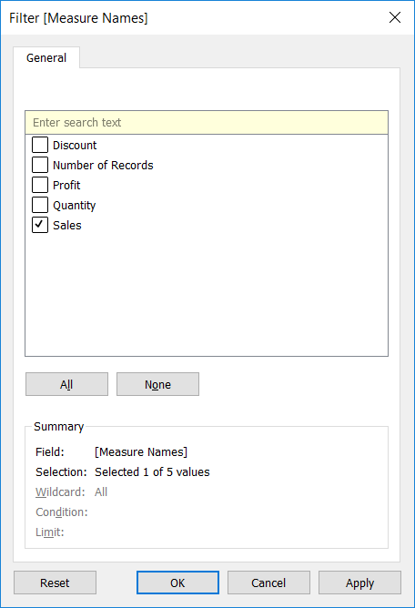

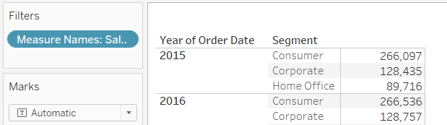

1. Add the Measure Names to column shelf

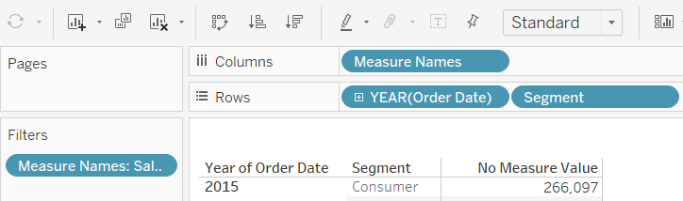

1. As the last step, add Measure Values to Tooltip shelf available under Marks Card

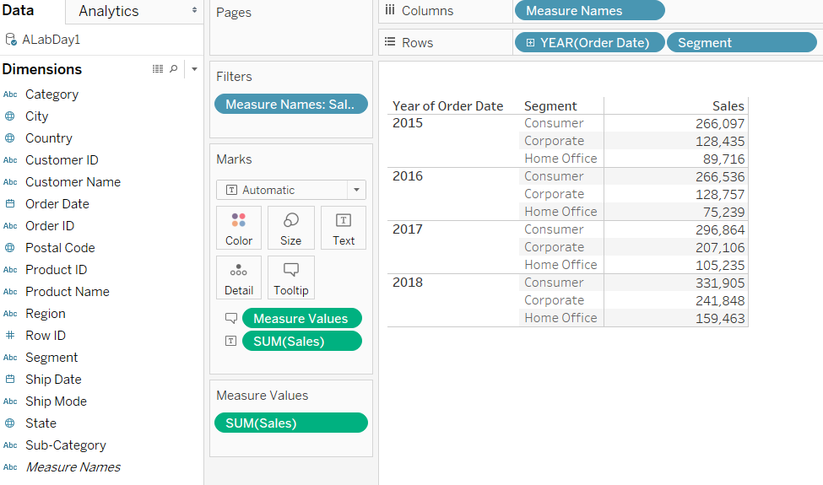

## SALES & PROFIT RELATIONSHIP

Scatterplots are a useful tool to help visualize relationships between quantitative (numerical) variables.

In Tableau, you create a scatterplot by placing at least one measure on the Columns shelf and at least one measure on the Rows shelf. We will create a simple scatter plot to find out relationship between sales and profit.

Double click on sales and profit measures under Measures Pane.

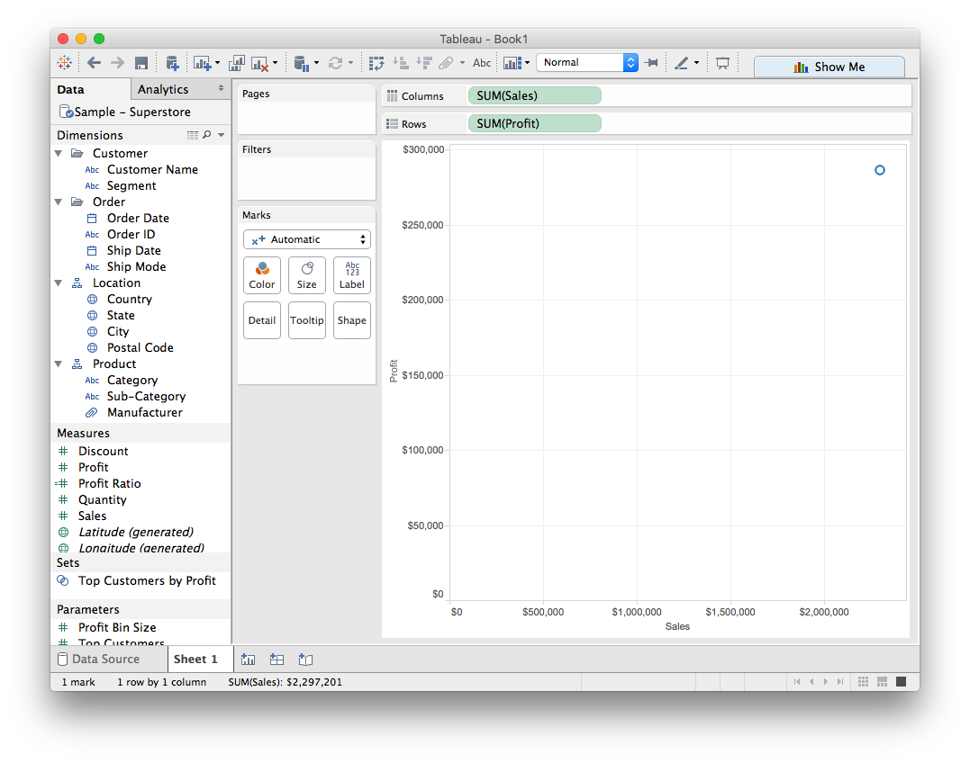

This initial view is a little disappointing — a single mark, showing the sum for all values for the two measures. Again, this is because the measures were automatically aggregated as sums. The default aggregation SUM() is indicated in the field names. If we hover over the single point in the chart, the values shown in the tooltip show the sum of sales and profit values across every row in the data source.

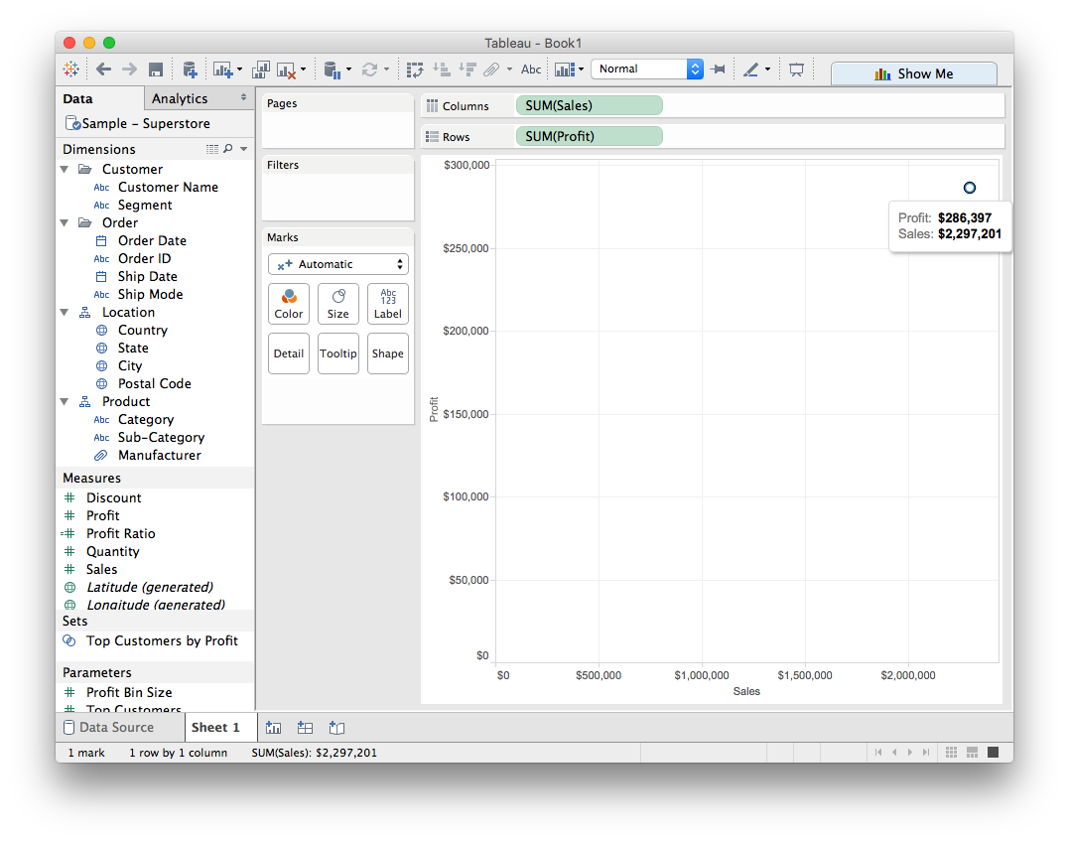

Let's see what happens if we disaggregate the data. To do this, we'll go to Analysis >Aggregate Measures and de-select.

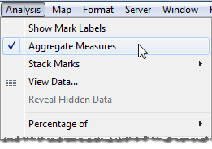

Now we see a lot of marks--one for each row in your original data source:

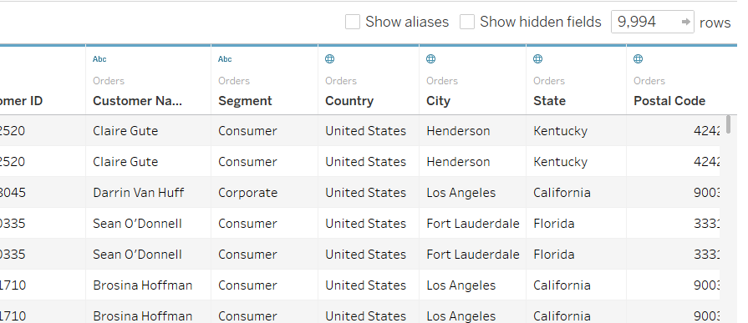

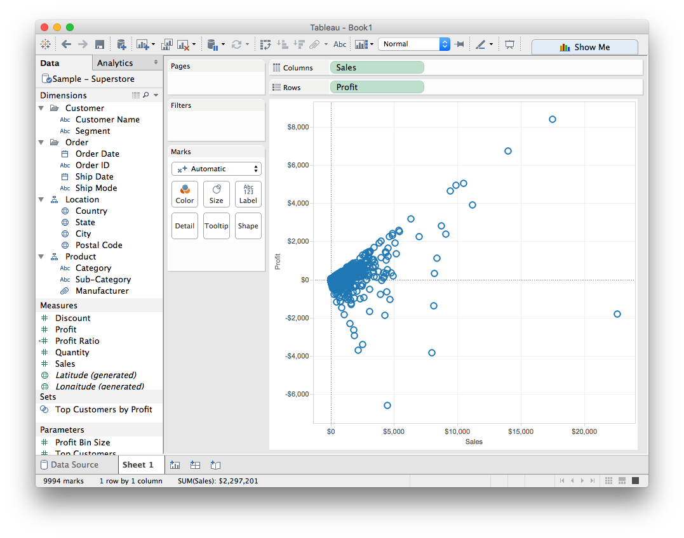

Sometimes it's useful to capture our intuitions about the relationships we're seeing mathematically. A trend line can provide a statistical definition of the relationship between two numerical values. To add trend lines to a view, both axes must contain a field that can be interpreted as a number—by definition, that is always the case with a scatterplot.

To add a trend line, first we'll switch to the Analytics tab on the lefthand side of the screen and select TredLine. Drag it to the viz and select liner. Trend lines will be added to the viz

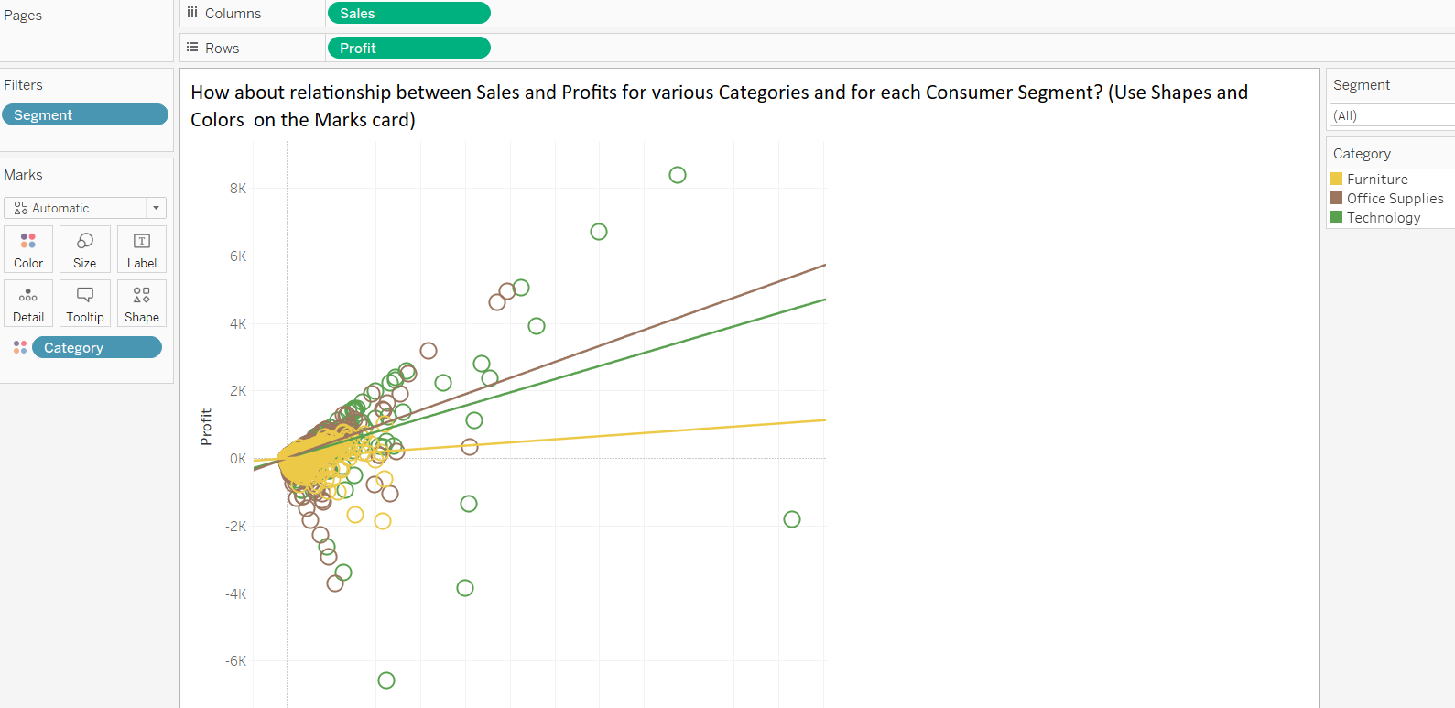

## MOVING COLUMN HEADERS DOWN

https://www.theinformationlab.co.uk/2012/12/03/moving-table-headers-to-the-bottom-making-a-table-look-like-a-chart/

## TOOLTIP

Double click on Tooltip edit the default text labels.

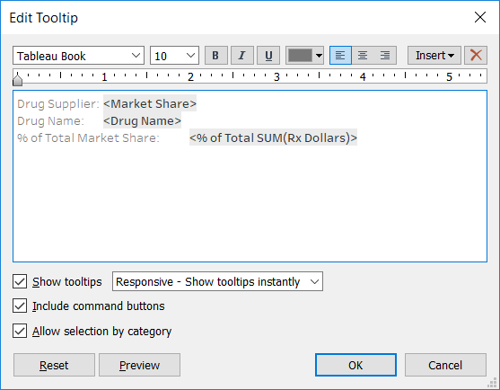

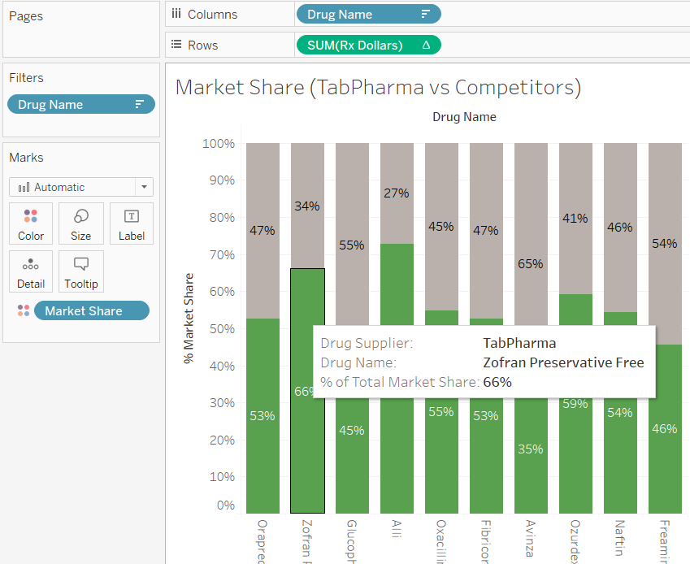

## FORMAT FIELDS AND FIELD LABELS

Format Header, Row / Column field labels and field(s).

https://onlinehelp.tableau.com/current/pro/desktop/en-us/formatting_specific_fields.html#Format_a_field

## DYNAMIC SHEET TITLE

We can insert the parameter or any other calculated field in the title so that it can change at runtime

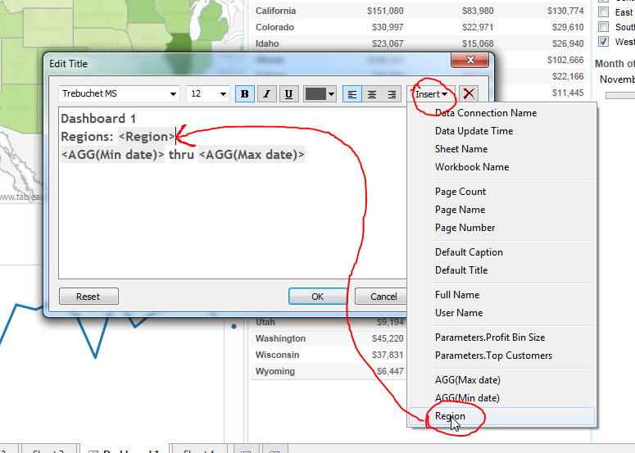

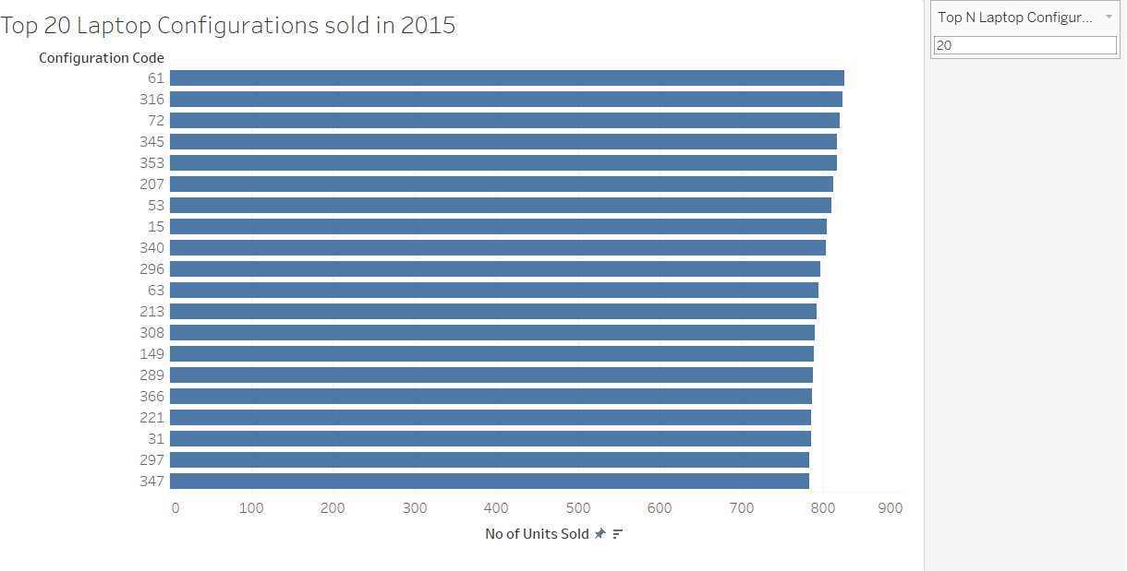

## ADD ANNOTATION

https://onlinehelp.tableau.com/current/pro/desktop/en-us/annotations_annotations_add.html

## DIFFERENT COLOUR SCHEME FOR MEASURE VALUES

Select the “Use Separate Legends” option for assigning different colours for each measure value.

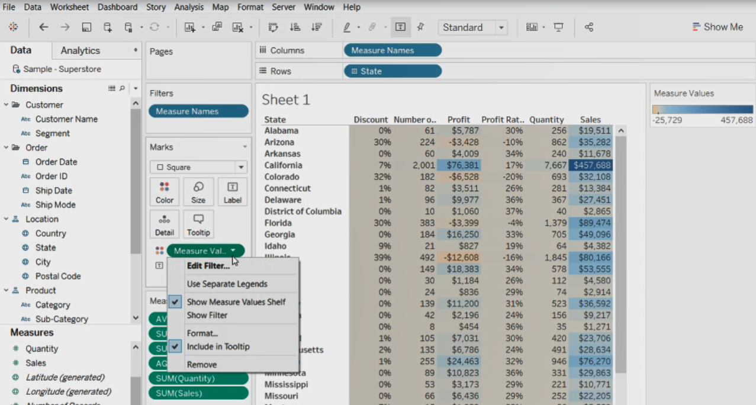

Then it will look like

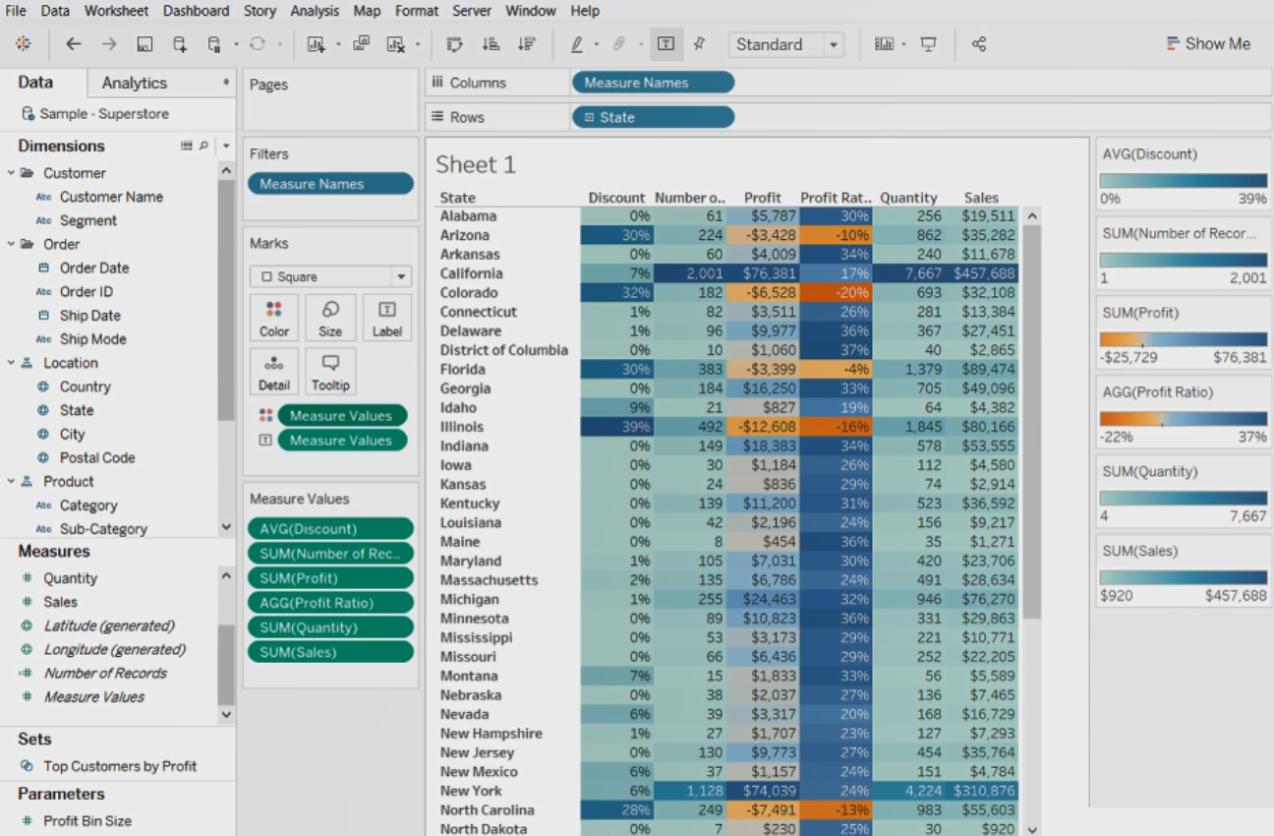

## ADDING COMMENT IN TABLEAU

We can add comment in tableau using //

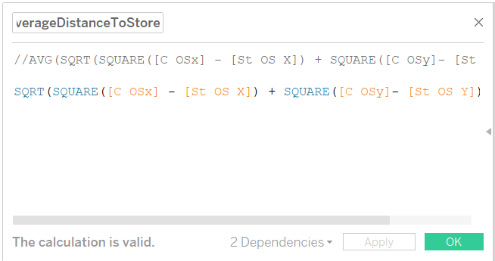

## RANK

We can use rank function in a graph as shown below

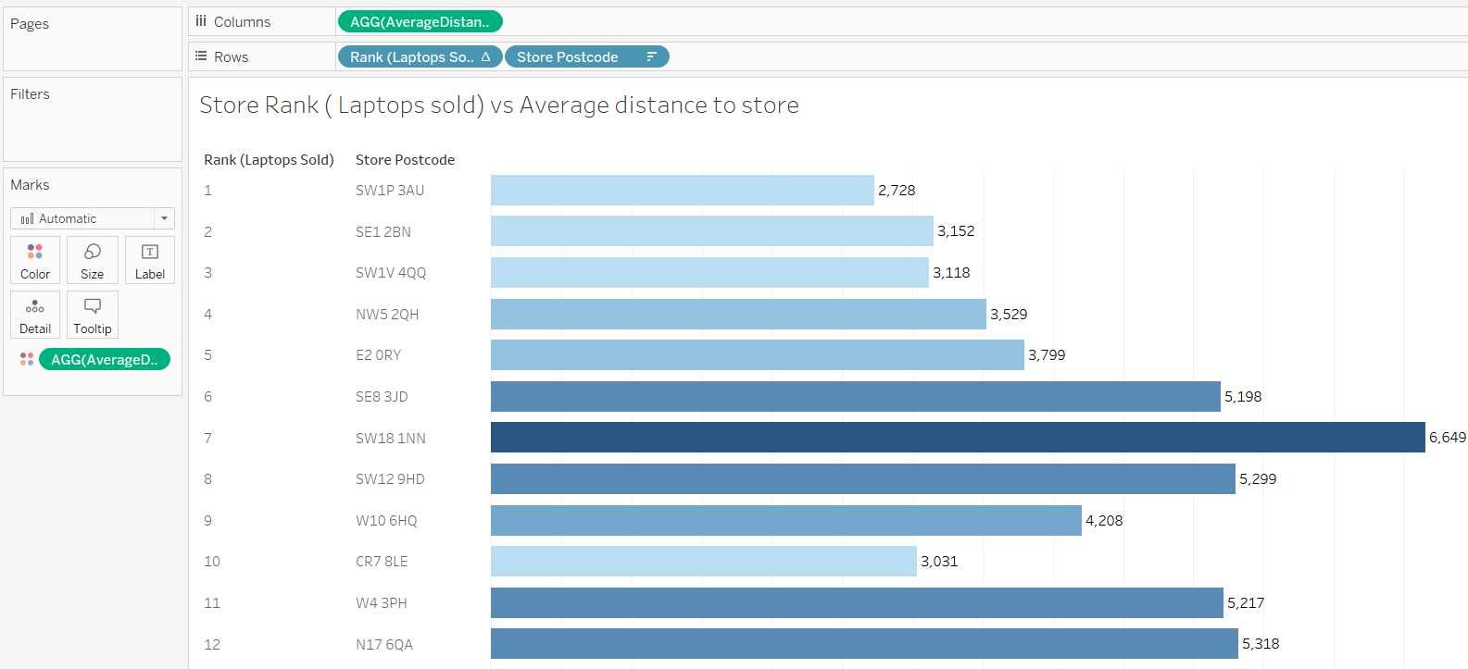

## SLICER WITH TABLEAU

Using parameter, calculated field

## DISCRETE VS CONTINUOUS

Discrete: individual. Show me the sales for January, March and April

Continuous: a range, has a beginning and end. Show me the sales from January to April.

## QUADRANT ANALYSIS

If we have a requirement of comparing a measure value (e.g. sales, profit etc) of current year with previous years (or two specific years) then we can use Quadrant analysis.

## DATABASE TOTALS

We can find the database totals which will not change with the filters on the view using LOD expressions. If we are using data blending then only fields from same source can be used in LOD expressions. LOD expression returns non-aggregated values.

An aggregated function cannot be used within other aggregated function.

To fetch total count of records from datasource we can use below calculated field. This count will not change depending on the filters and level of details on the view.

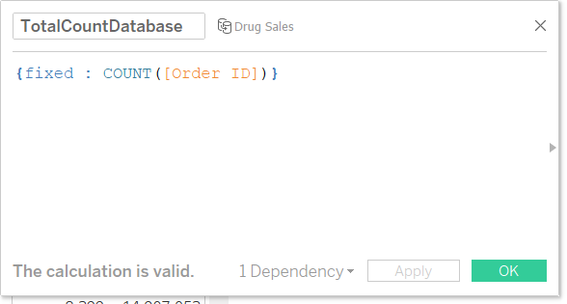

To fetch total sum of sales we can use below calculated field.

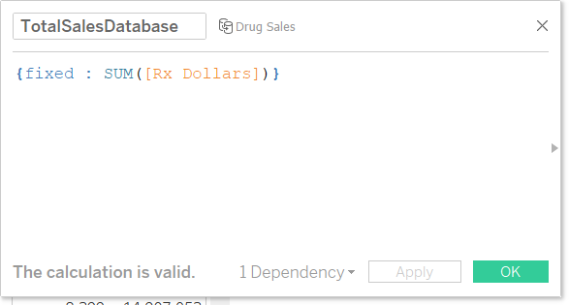

If # Number of Records is not available in the measures then we can create same using below calculated below:

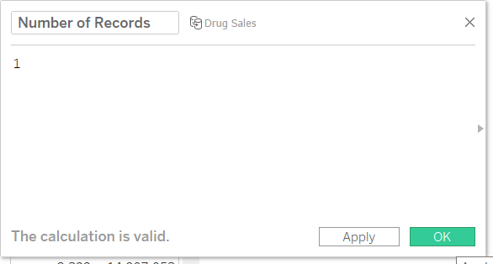

## ATTR ()

The ATTR function filters the View, not the underlying date, and can be an important tool in certain situations especially for working with views based on data blending. ATTR works at the row level and its purpose is to identify if the row is unique. If the row is unique it returns the value, else it returns "*". In its simplest form, the formula reads like this:

IF MIN ([dimension]) = MAX ([dimension]) THEN MIN ([dimension]) ELSE "*” END

ATTR function can be accessed via the menu as shown below

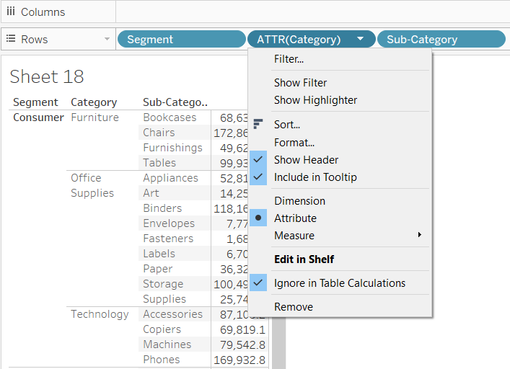

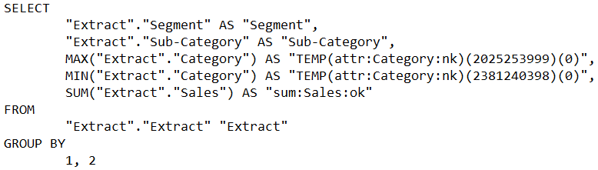

This is the SQL tableau uses to fetch the result for the view.

The ATTR function evaluates all the members within the field and returns a value if 1) there is only a single value (MIN = MAX) or 2) all members are identical (MIN = MAX) else it returns "*". Which can be interpreted as "there is more than one value".

You can build out the basic ATTR function by adding conditions for when the ATTR function should be triggered, for example:

IF ISNULL ([dimension]) THEN NULL

ELSEIF MIN ([dimension]) = MAX ([dimension]) THEN MIN ([dimension])

ELSE "*"

END

ATTR () is performing an aggregation, like SUM (), MIN (), MAX (), they all roll up, or aggregate data to a level of detail.

Limitations

* The ATTR function will not work in the same manner as other aggregations such as MIN, MAX, or SUM.
* ATTR cannot be used as a sorting dimension in a crosstab.

Let’s look at an example

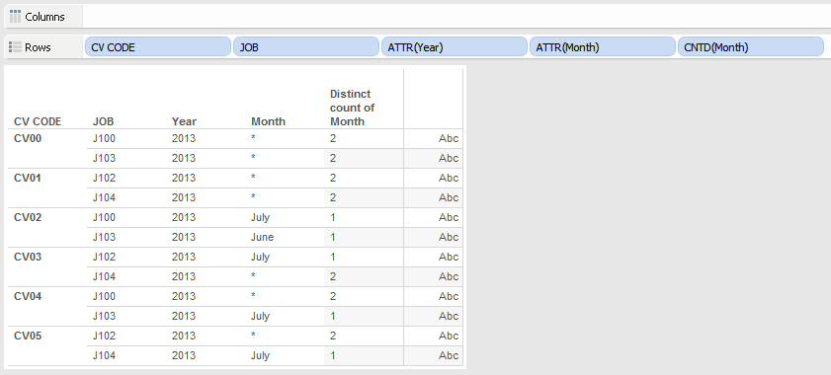

What's happening is that in those first views, Tableau is aggregating (using ATTR) Year and Month for the distinct values of CV Code and Job (the dimensions). There's only one year being returned, 2013, so that is returned in the ATTR(Year). There's only one value of month for CV Code CV02 and Job J100, so that returns a value for July for ATTR(Month). There's only one value of Month for CV Code CV02 and Job J103, so that returns June for ATTR(Month). For CV Code CV00 and Job J100, there are multiple months (June and July), so ATTR(Month) returns * for that (and every other combination of CV Code and Job that has multiple months).

When you put the **DATETRUNC** version of MONTH(OPEN_TIME) in the view, that's adding the dimension to the view. With that, now there's a fine enough granularity that there's only one month per CV Code/Job/MONTH(OPEN_TIME), and ATTR(Month) always returns the month and not *:

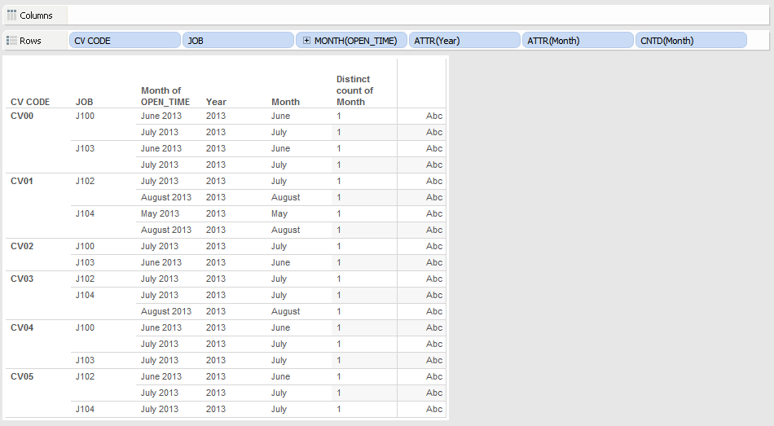

The "trick" here is to look at the pill and understand whether it's a dimension or measure, and then to have enough knowledge of the underlying data to know its granularity and relationships to be able to decipher what Tableau has done. So, for example, in a one to many hierarchy such as the Product hierarchy in Superstore Sales we can bring out ATTR(Department) for a Category and it will work fine:

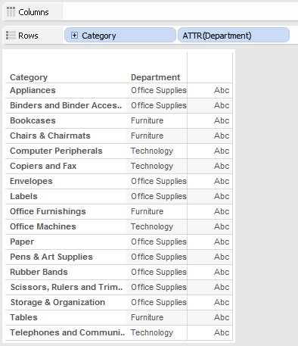

But if we use ATTR(Category) for Department then we get a bunch of *:

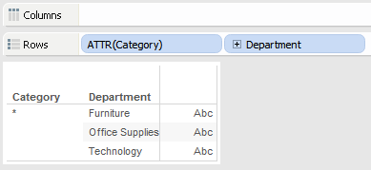

TABLE CALCULATIONS VS CALCULATED FIELD

Calculated field is pushed to database and it will be a part of SQL statement to fetch the result

Table calculations are not part of SQL statements and are calculated locally on tableau.